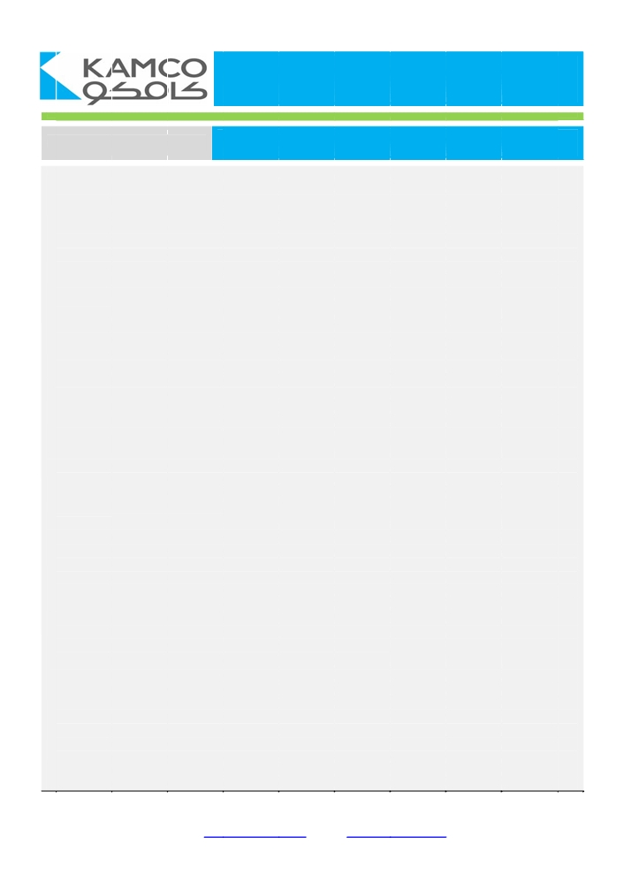
KAMCO Research

September-2012 Issue GCC Equity Markets Review

 Global markets are being driven by a deceleration in global economic growth, progress in the European debt
crisis and the further deterioration in its members’ economic prospects along with the central banks’
accommodative monetary policy stance to calm financial markets and strengthen their economies. The low
volatility suggests that risks are low; however, rapidly shifting sentiment is fuelling uneven patterns in financial
markets. The outlook is for slow progress in Europe, a soft landing in China, loose G4 central banks’ policy and
modest global growth.. Investors remain concerned over further deceleration in the global growth outlook, an
escalation in the European crisis, a drop in investor and business confidence; and additional central bank
interventions. Nevertheless, the majority of the GCC equity markets found support from global cues after Europe
began to take steps to tackle the debt crisis despite the uncertain outlook. This added to investor sentiment in the
region amid scarce local market catalysts as many wait for Q3-12 earnings season to begin.
 Despite the political events in some MENA region countries, equity markets in the GCC region have been
remarkably resilient since the beginning of the year. The combined market capitalization of the 7 GCC equity
markets added around USD 37 bn until October 8, 2012, to reach USD 756 bn driven by the USD 25.3 bn
increase in TADAWUL market cap which recorded USD 364.1 bn. ADX also advanced by USD 8.8 bn over the
same period to record USD 79.4 bn aided by the recovery in economic activity and the continuous backup of the
government to the core economic sectors. Even throughout the recent period of political uncertainty in the MENA
region, GCC states continue to deliver strong and sustainable growth in their economies supported by robust oil
prices, government backup of key economic sectors and the attractive investment opportunities driven by the
favourable demographic profile (young population) and solid stocks that are trading at attractive valuation
multiples.
 GCC economies continue to benefit from strong oil price environment allowing countries such as UAE, Qatar and
Saudi Arabia to invest heavily in infrastructure projects and develop key economic sectors, which are essential to
supporting economic and population growth. In the medium-term, the political instability in the region is expected
to remain elevated. However, business environment in the GCC region is improving and confidence in financial
markets is gradually restoring.
 Despite the increase witnessed in the majority of the regional bourses, the fall in heavyweight TADAWUL
pressured the combined market cap of the 7 GCC markets to decrease by USD 3.9 bn during Sep-12 after rising
by USD 19.5 bn during August-12 on the back of a diminishing risk appetite in Saudi Arabia along with volatility in
int’l financial markets. Saudi’s TADAWUL was the sole loser during the month and lost USD 11.8 bn from its
market cap. Kuwait Stock Exchange (KSE), the third largest market in the GCC region, helped limit the loss
adding 4.5% or USD 4.4 bn to the aggregate market cap followed by Abu Dhabi Securities Exchange (ADX)
gaining 3.1% or USD 2.4 bn. Nevertheless during 9M-12, TADAWUL lead the GCC bourses on the upside with
an increase in its market cap of USD 25.8 bn to USD 364.5 bn as of 30-Sep-12, fuelled by the positive outlook on
the Kingdom’s economy, massive public spending on infrastructure assets, healthy corporate earnings along with
issuing new regulations to boost the financial and real estate markets.
 After a short month witnessed in August due to the Holy Month of Ramadan and the Eid Holidays, liquidity flowed
once again into the markets with aggregate value traded in the 7 GCC bourses increasing 20% to USD 40 bn
during September-12 after falling 17% the prior month to USD 33 bn. Markets ended the month of September
positively with only the TADAWUL Index losing value by 4.19% and drop below the 7,000 mark to 6,839.83 as all
other 6 bourses gained. KSE lead the list of gainers with the Weighted Index posting a monthly gain of 4.45%
followed by the Dubai Financial Market and ADX gaining 2% and 1.71%, respectively; furthermore the Omani
Bourse and Qatar Exchange achieved moderate gains of 0.99% and 0.31%, respectively. In Kuwait, the bourse
found support after orders form the Amir to accelerate the economic development and reforms that will benefit the
country in the short and long term along with the direct intervention of the government in the local market through
taking positions in potentially good stocks for the national portfolio managed by the Kuwait Investment Authority.
KAMCO Investment Research Department
M2, Al-Shaheed Tower, Khalid Bin Al-Waleed Street- Sharq,P.O. BOX : 28873, Safat 13149, Kuwait
Tel : +(965) 1 852 626 , Fax : +(965) 2249 2395
Email: Kamcoird@kamconline.com Website: http://www.kamconline.com


Table of Contents Pages

GCC Equity Markets Overview ... ... 1-5

Saudi Stock Exchange ... . 6-9

Kuwait Stock Exchange ... .. 10-12

Abu Dhabi Securities Exchange ... . 13-16

Dubai Financial Market ... ... 17-19

Qatar Exchange ... . 20-23

Bahrain Bourse ... .. 24-26

Muscat Securities Market ... .. 27-29

Appendices ... .. 30-44
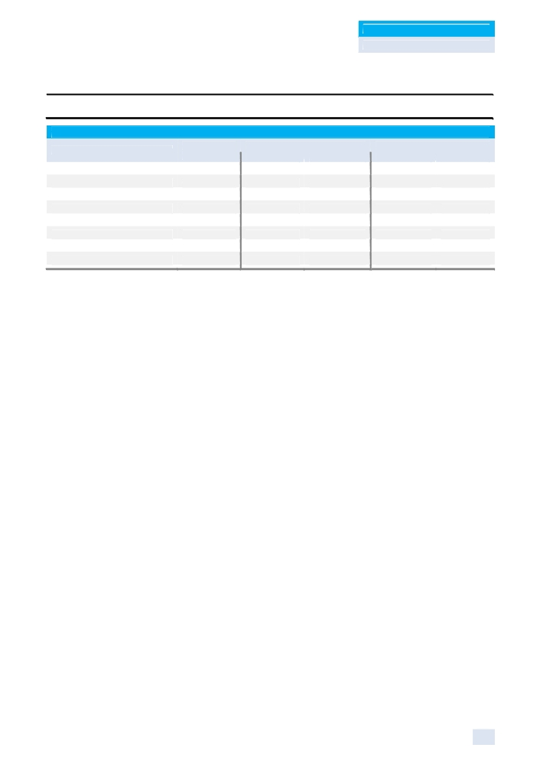

KAMCO Research
GCC Equity Markets Review

GCC Equity Markets Overview

GCC Equity Markets Benchmark Return & Volatility
Closing Return Volatility
Value Sep-12 YTD-12 Sep-12 YTD-12
Tadawul All Share Index 6,839.83 (4.19%) 6.58% 9.13% 13.26%
KAMCO KSE TRW Index 2,650.36 3.00% 2.52% 8.75% 5.57%
KSE Weighted Index 417.97 4.45% 3.04% 12.12% 8.10%
ADX General Index 2,605.41 1.71% 8.46% 5.55% 8.17%
DFM General Index 1,578.79 2.00% 16.65% 12.51% 18.37%
QE 20 Index 8,510.21 0.31% (3.06%) 5.59% 6.87%
Bahrain All Share Index 1,087.33 0.09% (4.93%) 6.13% 5.89%
MSM 30 Index 5,534.38 0.99% (2.82%) 5.79% 8.15%
Source: KAMCO Research

Global markets are being driven by a deceleration in global economic growth, progress in the
European debt crisis and the further deterioration in its members’ economic prospects along with
the central banks’ accommodative monetary policy stance to calm financial markets and
strengthen their economies. The low volatility suggests that risks are low; however, rapidly shifting
sentiment is fuelling uneven patterns in financial markets. The outlook is for slow progress in
Europe, a soft landing in China, loose G4 central banks’ policy and modest global growth.
Investors remain concerned over further deceleration in the global growth outlook, an escalation in
the European crisis, a drop in investor and business confidence; and additional central bank
interventions. Nevertheless, the majority of the GCC equity markets found support from global
cues after Europe began to take steps to tackle the debt crisis despite the uncertain outlook. This
added to investor sentiment in the region amid scarce local market catalysts as many wait for Q3-
12 earnings season to begin.
Despite the political events in some MENA region countries, equity markets in the GCC region have been remarkably resilient since the beginning of the year. The combined market capitalization of the 7 GCC equity markets added around USD 37 billion until October 8, 2012, to reach USD 756 bn driven by the USD 25.3 billion increase in TADAWUL market cap which recorded USD 364.1 billion. ADX also advanced by USD 8.8 billion over the same period to record USD 79.4 billion aided by the recovery in economic activity and the continuous backup of the government to the core economic sectors. Even throughout the recent period of political uncertainty in the MENA region, GCC states continue to deliver strong and sustainable growth in their economies supported by robust oil prices, government backup of key economic sectors and the attractive investment opportunities driven by the favourable demographic profile (young population) and solid stocks that are trading at attractive valuation multiples.

GCC economies continue to benefit from strong oil price environment allowing countries such as
UAE, Qatar and Saudi Arabia to invest heavily in infrastructure projects and develop key economic
sectors, which are essential to supporting economic and population growth. In the medium-term,
the political instability in the region is expected to remain elevated. However, business environment
in the GCC region is improving and confidence in financial markets is gradually restoring.

Despite the increase witnessed in the majority of the regional bourses, the fall in heavyweight
TADAWUL pressured the combined market cap of the 7 GCC markets to decrease by USD 3.9 bn
during Sep-12 after rising by USD 19.5 bn during August-12 on the back of a diminishing risk
appetite in Saudi Arabia along with volatility in int’l financial markets. Saudi’s TADAWUL was the
sole loser during the month and lost USD 11.8 bn from its market cap. Kuwait Stock Exchange

1
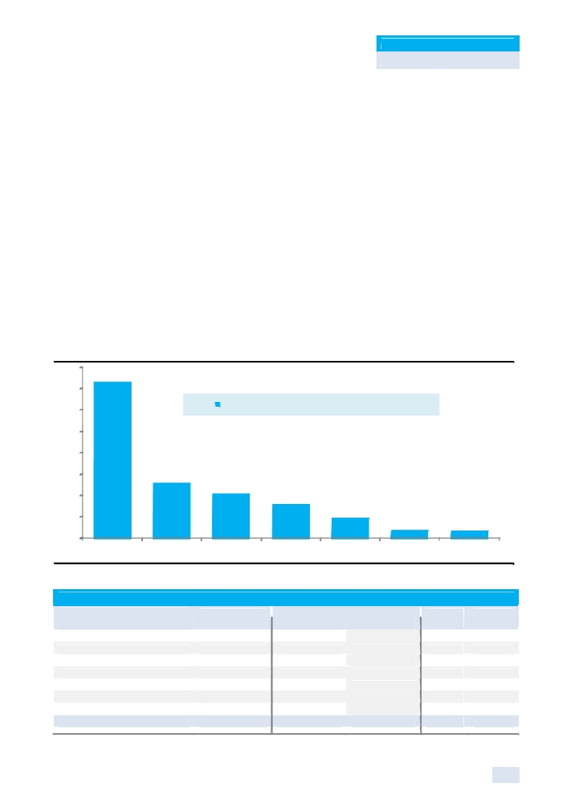

KAMCO Research
GCC Equity Markets Review

(KSE), the third largest market in the GCC region, helped limit the loss adding 4.5% or USD 4.4 bn
to the aggregate market cap followed by Abu Dhabi Securities Exchange (ADX) gaining 3.1% or
USD 2.4 bn. Nevertheless during 9M-12, TADAWUL lead the GCC bourses on the upside with an
increase in its market cap of USD 25.8 bn to USD 364.5 bn as of 30-Sep-12, fuelled by the positive
outlook on the Kingdom’s economy, massive public spending on infrastructure assets, healthy
corporate earnings along with issuing new regulations to boost the financial and real estate
markets.
After a short month witnessed in August due to the Holy Month of Ramadan and the Eid Holidays,
liquidity flowed once again into the markets with aggregate value traded in the 7 GCC bourses
increasing 20% to USD 40 bn after falling 17% the prior month to USD 33 bn. Markets ended the
month of September positively with only the TADAWUL Index losing value by 4.19% and drop
below the 7,000 mark to 6,839.83 as all other 6 bourses gained. KSE lead the list of gainers with
the Weighted Index posting a monthly gain of 4.45% followed by the Dubai Financial Market and
ADX gaining 2% and 1.71%, respectively; furthermore the Omani Bourse and Qatar Exchange
achieved moderate gains of 0.99% and 0.31%, respectively. In Kuwait, the bourse found support
after orders form the Amir to accelerate the economic development and reforms that will benefit the
country in the short and long term along with the direct intervention of the government in the local
market through taking positions in potentially good stocks for the national portfolio managed by the
Kuwait Investment Authority.

Market Capitalization of the GCC Equity Markets as of 30 September 2012
400
365
350

300

250

200

150 129

100

50

-
TADAWUL QE

Source: KAMCO Research

Saudi Stock Exchange
Kuwait Stock Exchange
Abu Dhabi Securities Exchange Dubai Financial Market
Qatar Exchange
Bahrain Bourse
Muscat Securities Market
Total GCC Equity Markets
Source: KAMCO Research
Market Cap as of 3 0-September -20 12 (USD Bln)

103
79
47
18 16

KSE ADX DFM MSM BHB

Market Capitalization by Country
# of Listed Market Cap (Mln USD) as of: M-T-M % of
Stocks 30-Aug-12 30-Sep-12 % Chg Total
155 376,297 364,509 (3.13%) 48.25%
203 98,378 102,797 4.49% 13.61%
65 76,631 79,005 3.10% 10.46%
65 46,469 47,147 1.46% 6.24%
42 128,407 128,579 0.13% 17.02%
40 15,767 15,802 0.23% 2.09%
62 17,491 17,669 1.02% 2.34%
632 759,440 755,508 (0.52%) 100.00%

2

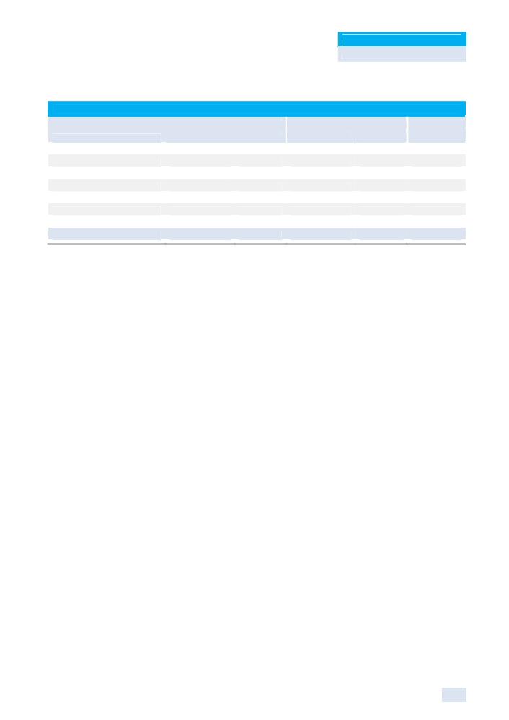

KAMCO Research
GCC Equity Markets Review

Trading Activity Indicators (September-2012)
Traded Volume Traded Value Trades
Mln Shares % of Total Mln USD % of Total ‘000
Saudi Stock Exchange 4,646 30.4% 34,146 85.6% 2,805
Kuwait Stock Exchange 6,091 39.9% 2,202 5.5% 112
Abu Dhabi Securities Exchange 1,105 7.2% 444 1.1% 19
Dubai Financial Market 2,715 17.8% 835 2.1% 37
Qatar Exchange 260 1.7% 1,995 5.0% 71
Bahrain Bourse 41 0.3% 2 0.005% 1
Muscat Securities Market 419 2.7% 277 0.7% 29
Total GCC Equity Markets 15,276 100.0% 39,900 100.00% 3,074

In Saudi Arabia, despite the strong economic fundamentals and bright economic outlook, weak
investor sentiment in Saudi Arabia and global market turbulence were the main factors behind the
TASI’s drop in September. The TASI registered a 4.19% decrease to return to levels below the
7,000 mark to close at 6,839.83 points and end the month as the sole loser in the GCC region and
worst performing market among its peers; while narrowing its YTD-12 gains to 6.58%. In
September, TADAWUL market capitalization shed 3.13% of its value to SAR 1.37 trillion (USD 365
bn) as compared to SAR 1.41 trillion (USD 376 bn) recorded at the end of August-12, as the
majority of the sectors in the market fell with the exception of Insurance and Multi-Investment
sectors. Market heavyweight Petrochemical Industries lost 2.56% of its market cap to reach SAR
444 bn (USD 118 bn) while the Banks and Financial sector slumped 5.12% to SAR 317 bn (USD
85 bn). Trading indicators improved during the month with volume and value traded rising 13% and
24.6%, respectively. During September, total traded volume reached 4.6 bn shares distributed over
2.8 mn transactions while value traded gained to SAR 128 bn up from SAR 103 bn in Aug-2012.
While in Kuwait, the easing of the political deadlock coupled with government intervention in the
market drove the Kuwaiti Bourse to a 15 week high and outperformed its GCC peers to end as the
best performing market. Investor sentiment picked up during the month on hopes that a solution
has been found for the political and economic situation in the country. Accordingly, the KSE
Weighted Index jumped 4.45% to 417.97 points, while the KAMCO TRW Index gained 3%, to close
at 2,650.36 points and reverse its YTD-12 loss to record a 2.52% gain during the 9M-12. During
the month of September 2012, the market capitalization of Kuwait Stock Exchanged grew 4.5% or
around KWD 1.25 bn (USD 4.4 bn) to record KWD 29 billion (USD 102.8 bn) at the end of the
month, driven by healthy increase in blue chips and majority of sectors including the Banking
sector which added around KWD 465 million to its market cap and the Industrial and Telecom
sectors which added KWD 244 mn and KWD 219 mn, respectively. Compared to August-12,
trading indicators improved during September driven by the partial restoration of investor
confidence in the stock market with volume traded increasing 86% to 6.1 bn shares from 3.3 bn
shares in August-12; while value traded surged 125% to KWD 621 mn up from KWD 276 mn in
August-12.
As for Abu Dhabi, the ADX General Index advanced 1.7% to 2,605.41, marking the fourth
consecutive month of gains on the back of positive 1H-12 earnings, strong oil prices, and improved
investor sentiment towards the local economy. Liquidity dropped during the month as the heavy
buying on the real estate sector from the past couple months diminished, with volume and value
decreasing 21% and 8%, respectively, to 1.1 bn shares and AED 1.63 bn (USD 444 mn). Total
market capitalization increased 3.10% to AED 290.17 bn (USD 79 bn) in September on the back of
a 5.15% and a 2.46% increase in the telecommunication and the banking sectors, respectively, to
AED 114.2 bn (USD 31.09 bn) and AED 125.83 bn (USD 34.26 bn); while the real estate sector
also recorded an increase of 5.59% to AED 9.4 bn (USD 2.55 bn). The ADX General Index’s 9M-

3


KAMCO Research
GCC Equity Markets Review

12 return stands at 8.46% as the bourse has recovered from last year’s slump with the local economy showing resilience and growth, while the government has managed successfully with well-studied interventions and reforms helping revive business activity.
In Dubai, the DFM General Index gained 2% to 1,578.79 to record the third consecutive month of gains and lifting its YTD-12 return to 16.65%. The market’s performance was supported by the improving economic fundamentals in the country as Dubai continues to shake off the effects of the 2009 debt crisis. Business activity continues to pick up in the Emirate due to the successful restructuring of debt-strapped government related entities, along with a recovery in the real estate market and an increase in foreign direct investment and non-oil exports. The bourse’s return was supported by gains in the investment & financial, telecommunication, real estate, and banking sectors, increasing 4.51%, 2.88%, 1.71%, and 1.16%, respectively. Total market capitalization gained 1.46% to AED 173.2 bn (USD 48.1 bn) from last month’s AED 170.7 bn (USD 46.47 bn). Liquidity surged during the month due to a return to normal trading following the summer season and Ramadan, volume and value increased 39% and 37%, respectively, to 2.72 bn shares and AED 3.07 bn, respectively, over 37,471 transactions.
In Qatar, the Qatar Exchange posted gains for the third consecutive month to increase 0.31% to
8,510.21 to set the highest monthly close since April-12; however the bourse’s YTD-12 return
remains negative at a loss of 3.06%. The market performance was supported by increases in the
heavyweight Banking & Finance and Industrial sectors, along with a strong month for the
Consumer Goods & Services sector which jumped 6.36% in September. Liquidity plummeted in
comparison to last month as volume decreased 54% to 260 mn shares, while value traded
decreased 44% to QAR 7.26 bn; however, transactions increased 19% to 70,948. Liquidity
slumped on the back of the Real Estate sector, which captured 75% of traded value last month, but
saw its value traded plunge 62% in September. The country’s strong underlying economic
fundamentals with real GDP forecasted by the IMF to grow at 6% per annum over the next six
years promises returns to investors starved for options amid the negative sentiment dominating the
regional and international markets resulted from the Euro-Zone crisis and a global economic
deceleration.
Whereas in Bahrain, the Bahrain Stock Exchange snapped a four month losing streak after posting marginal gains of 0.09% closing at 1,087.33.Trading indicators also increased in the Bahrain Bourse as the number of shares exchanging hands totalled 40.55 mn shares, a rise of 121% from the previous month; spread over 804 deals with a total value traded of BHD 5.12 mn. The Investment sector captured the majority of market trading at 67.1% and 47.7% of volume and value, respectively. Total market capitalization increased 0.23% to BHD 5.96 bn (USD 15.79 bn) in September on the back of a 4.42% increase in the market heavyweight ALBA to BHD 738.40 mn (USD1.95 bn). Whereas other market heavyweight Ahli United bank, inspite of good volume, remained unchanged and closed at USD 0.545.
Finally in Oman, extending last month’s gains, the MSM 30 Index increased 0.99% to close the
month of September at 5,534.38 points and narrowed its YTD-12 losses to 2.82% despite finding
difficulty amid scarce local market catalysts to help support the index higher. Corresponding to the
gain witnessed, trading indicators increased with volume rising 43% during the month to 419 mn
shares compared to 293 mn in Aug-12, while value traded was up 73% to OMR 107 mn versus
OMR 62 mn in the previous month. Market heavyweight banking & investment sector was the sole
loser during the month as it shed 1.05% of its market cap to reach OMR 3.12 bn; while the
industrial sector rose 4% to OMR 1.23 bn and the services & insurance sector gained 2.26% to
OMR 2.5 bn from OMR 2.3 bn.

4
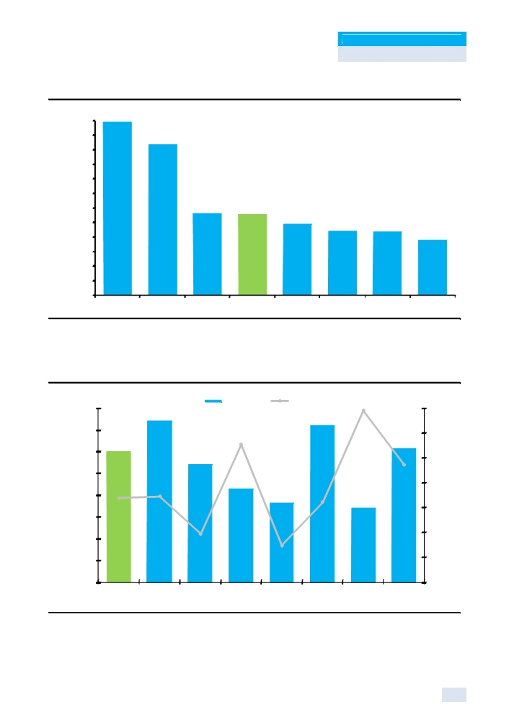

KAMCO Research
GCC Equity Markets Review

GCC Equity Markets P/E Ratios

30.0

27.5
25.0
22.5
20.0
17.5
15.0
12.5
10.0
7.5
5.0
2.5
-

29.8

25.9

14.0

KSE DFM Tadawul

13.9
12.1 11.0 10.9

Avg. GCC QE MSM BHB

9.4

ADX

Source : KAMCO Research

GCC Equity Markets P/B Ratio versus Dividend Yield

2.00

1.75

1.50

1.25
3.7%
3.7%
1.00

0.75
3.0%
0.50

0.25
1.50 1.86 1.35
-
GCC Tadawul KSE

Source : KAMCO Research

P/B (X) Yield 2 011

4.8%

3.6%

2.7%

1.07 0.91 1.80
ADX DFM QE

5.5%
5.5%

5.0%

4.5%
4.4%
4.0%

3.5%

3.0%

2.5%
0.85 1.54
2.0%
BHB MSM

5

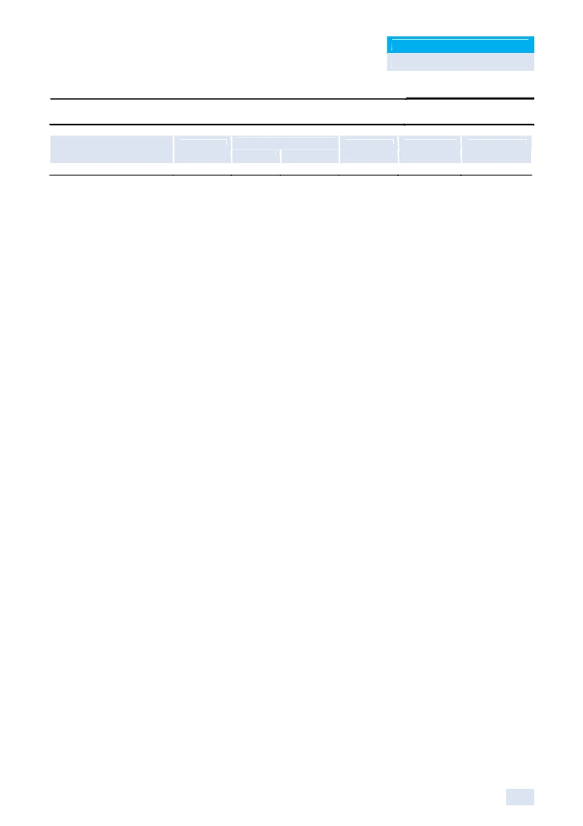

KAMCO Research
GCC Equity Markets Review

Saudi Stock Exchange

Benchmark Return
Tadawul All Share Index

Market Review

Closing Sep-12
Value Point (%)
6,839.83 (299.18) (4.19%)

60 Day 90 Day Closing
(%) (%) Value
(0.77%) 1.45% 6.58%

Despite the strong economic fundamentals and bright economic outlook, weak investor sentiment
in Saudi Arabia and global market turbulence were the main factors behind the TASI’s drop in
September. The TASI registered a 4.19% decrease to return to levels below the 7,000 mark to
close at 6,839.83 points and end the month as the sole loser in the GCC region and worst
performing market among its peers; while narrowing its YTD-12 gains to 6.58%. In September,
TADAWUL market capitalization shed 3.13% of its value to SAR 1.37 trillion (USD 365 bn) as
compared to SAR 1.41 trillion (USD 376 bn) recorded at the end of August-12, as the majority of
the sectors in the market fell with the exception of Insurance and Multi-Investment sectors. Market
heavyweight Petrochemical Industries lost 2.56% of its market cap to reach SAR 444 bn (USD 118
bn) while the Banks and Financial sector slumped 5.12% to SAR 317 bn (USD 85 bn). Trading
indicators improved during the month with volume and value traded rising 13% and 24.6%,
respectively. During September, total traded volume reached 4.6 bn shares distributed over 2.8 mn
transactions while value traded gained to SAR 128 bn up from SAR 103 bn in Aug-2012.
The TASI began the month to the downside, slipping from a 16 week high, as investors cut
positions in large-caps after the U.S. Federal Reserve put off further monetary easing indicating
that the global economy may still be heading for a soft landing. Last month, the TASI had gone
above 7,000, a key psychological level, but it was mainly driven by speculative stocks while blue-
chips underperformed significantly, indicating that the uptrend may not be sustainable. Investors
sold small-cap stocks that drove a recent rally and fears of an aggressive pull-back pushed many
to remain on the side-lines. The lack of local market catalysts resulted in traders and investors to
eye global cues ahead of Q3-12 earnings season as caution on the global front is keeping risk
appetite minimal. Markets have been expecting the European Central Bank (ECB) to unveil a bold
plan to tackle the euro zone's debt crisis but public disputes among policymakers over the extent of
the measures have increased doubt.

Trading remained sideways around the 7,000 psychological mark as investors cashed in on any
short term gains, specifically in the banking and petrochemical sectors. Banks’ 2H-12 revenues are
expected to lag behind 1H-12 due to moderation in lending. The bank sector reported strong
lending and deposit growth earlier this year, but this is expected to slow in 2H-12. According to
SAMA, Saudi banks netted more than SAR 21 bn in the first seven months of 2012 as lending
continued to gain momentum and allow them to net one of their highest incomes in many years.
Banks’ net earnings stood at SAR 21.34 bn during January-July, an average of more than SAR 3
bn a month. Nevertheless, as the market lacked local drivers, the TASI extend gains, tracking
advances in world stocks after Germany's top court ruled in favor of the Euro Zone's new EUR 700
bn bailout fund. The gain in global equity markets supported a rise in oil prices which in return was
reflected in the petrochemical sector that pushed the index higher on Sept. 15 to reach a 4 month
high of 7,165.86 points. However, the recent slide in oil prices, coupled with Q3-12 earnings
concerns outweighing global market sentiment, the TASI index reversed back to the downside to
break below the 7,000 mark led by heavyweight banking and petrochemical sectors. By the end of
the month, renewed fears concerning Spain’s debt crisis negatively pressured the market to the
downside and took the TASI to a two month low on Sept. 16 to close at 6,879 points, marking the
lowest close since July 31.

6

KAMCO Research
GCC Equity Markets Review

During the month, Zain Saudi has for a second time extended the maturity of a SAR 9.75 bn (USD
2.6 bn) loan by two months, it said in a bourse statement. The firm announced that on September
26 it has received approval from lenders to extend the maturity date for the joint Murabaha by two
additional months, changing the maturity date to November 28. The loan was initially due in July-
12 but was extended to September 27. The firm said it had already paid back part of the loan, SAR
750 mn, on August 27 and is in the process of finalizing a long-term finance agreement to replace
its current loan. In other news, Saudi Arabian construction company Mohammed al-Mojil Group
(MMG) called for an emergency general meeting in November to discuss breaking up, saying its
losses now exceeded 75% of its capital. External auditors called in by the company also found its
liabilities exceeded its assets, leaving shareholders with a deficit of SAR 279.8 mn (USD 74.6 mn).
In a statement on the Saudi bourse website, MMG said its net losses after Q2-12 came to SAR
1.53 bn and its net liabilities exceeded its assets by SAR 1.36 bn. To avert dissolution, MMG would need to raise capital so that its losses were back below 75% of the total. It attributed its losses to difficulties in large projects it was working on.
Furthermore, Saudi Ground Services, a unit of national carrier Saudi Arabian Airlines, has hired
HSBC Holdings to advise it on a planned initial public offering (IPO) of 30% of its shares. The unit
would be the second of six - including catering, cargo, maintenance, airlines and flight academy -
to pursue a stock market listing following Saudi Arabian’s decision in 2006 to privatise them.
However, the ground services unit may not list until early 2013 or later. The first of the units to be
sold publicly, Saudi Airlines Catering Co, raised USD 347 mn after completing a 30% IPO in July.
The Kingdom’s IPO market has been the strongest in the Gulf for the last two years, with the
bourse witnessing five new listings so far in 2012. Saudi Arabia is slowly coming to terms with new
carriers operating some of its domestic flights as part of the country’s economic reforms aimed at
improving service levels and accessibility.

On the economic front, Saudi Arabia's gross domestic product (GDP) exceeded SAR 2.2 trillion in
2011, registering a growth rate of 31% in current prices, compared to the previous year, the
General Statistics Department reported. During the same year, the private sector GDP grew by
14.7%. Non-oil exports rose 31% to SAR 176 bn, which accounted for 8% of the GDP, the report
added. The Kingdom's total exports in 2011 amounted to more than SAR 1.41 trillion, highlighting
Saudi Arabia's remarkable economic progress. According to preliminary reports, the Kingdom's
GDP grew 5.94% in Q1-12. Preliminary information shows GDP in Q1-12 grew by 15.96% in
current prices with its value reaching SAR 612.3 bn against SAR 528 bn during the same period in
2011, adding the growth was 5.94% in real prices. The public sector GDP rose by 0.17% to SAR
89.2 bn in current prices compared to SAR 89 bn last year. In real prices it rose by 4.24%. The private sector GDP grew by 10.52% in Q1-12 reaching SAR 162.8 bn compared to SAR 147.3 bn the previous year. The oil sector showed a record growth rate of 23.73% in current prices with a value of SAR 356.5 bn compared to SAR 288 bn the previous year.

As for the outlook for the Saudi economy, the IMF said in its annual economic review that the
economy remains buoyant. The oil sector continues to dominate the economy, but strengthened
budgetary institutions have reduced the linkage between the oil price and the level of fiscal
spending, and progress has been made on diversifying the economy. Further strengthening of
budgetary institutions, financial deepening, and a focus on increasing productivity are key going
forward, the IMF added. Supported by increased government spending and supportive monetary
policy, overall real GDP is estimated to have grown by 7.1% in 2011, with 8% growth recorded in
the non-oil sector—the highest since 1981. The private sector grew at 8.5%, with the construction
and manufacturing sectors providing the largest lifts. Despite its increased spending, the
government has room to save, setting aside a portion of the extra oil revenues for future
generations. The report noted that structural reforms gained new momentum in 2011. The Saudi
government allocated almost two-thirds of a combined USD 110 bn fiscal package to a multi-year
project to construct half a million new affordable housing units. The government also allocated an

7
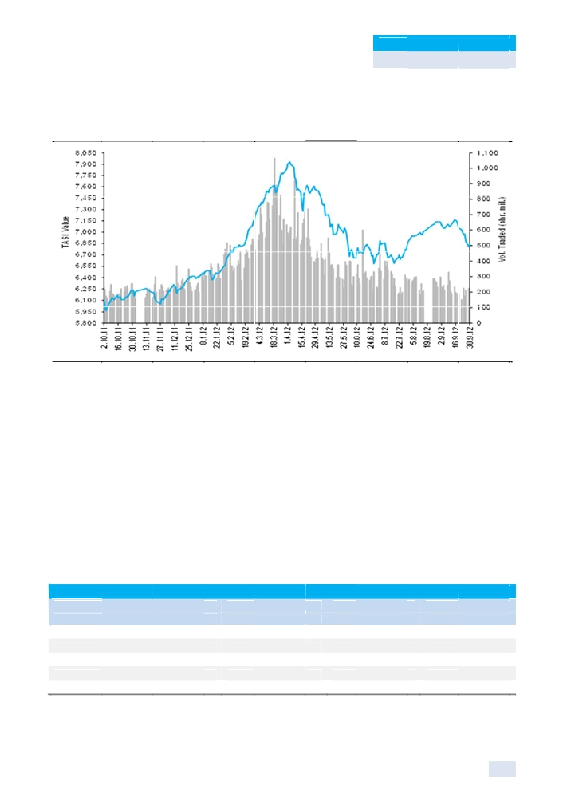

KAMCO Research

GCC E

additional USD 11 bn to the Rea l Estate De velopment Fund to in crease the
loans.

TASI 52 We ek Perform ance Relati ve to Volum e

Source: KAM CO Research
quity Marke ts Review

availability of housing

Saudi Arabia’s annual inflation eased to 3.8% in August, its lowest level iin almost three years,

although the monthly increase was the fastest in 10 months, data showed. Consumer price growth

in the Kingdom has been slowing gradually since peaking at 5.4% in February and March,

registering 4.0% in July. The month-on-month rate edged up to 0.4% in August from 0.3% in the

previous month, according to the data from the Central Department of Statisttics. Food costs, which

account for a quarter of Saudi consumer expenses, rose 0.9% in August, the fastest clip in a year,

although the annual rate fell to 3.3% from 4.0% in July. Monthly growth in rents, one of key factors

pushing living costs up in the past years, eased slightly to 0.1% in August, which was the smallest

rise since December 2007. On an annual basis, rental inflation decelerated to a 14-month low of

8.5% from 9.2% in July, the data showed, well below rates of over 20% in 2009 and 2008.

In other news, Saudi Arabia, Qatar and UAE are among the top 30 most competitive countries in

the world with Qatar leading the way in the Middle East region, at number 11, “The Global

Competitiveness Report 2012-2013” by the World Economic Forum showed. Saudi Arabia dropped

one place to rank number 18 with a score of 5.2 out of seven in this year’s annual report, from 17th

place in last year’s report.

Most Active Stocks for the Month

Volume Value Close

(000 shares) (000 SAR) (SAR)

Dar Al Arkan Real Estate Development Co. 591 ,672 5,809,748 8.95

Alinma Bank 350 ,097 4,780,533 12.95

ZAIN KSA 278 ,976 3,333,115 10.25

Emaar The Economic City 163 ,108 1,613,757 9.00

Saudi Integrated Telecom Company 157 ,774 4,604,754 24.95

Source: KAMCO Research

8

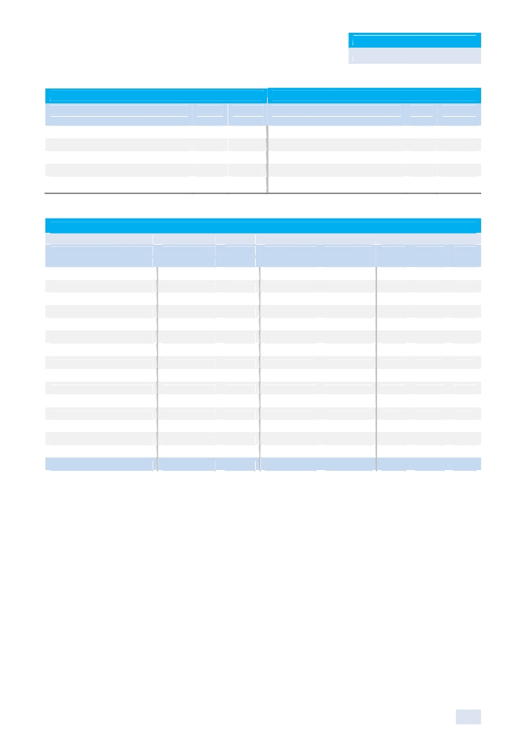

KAMCO Research
GCC Equity Markets Review

Best Return Performers
Close
(SAR)
Gulf General Cooperative Ins. Co. 77.25
Amana Cooperative Insurance 254.00
Saudi Arabian Cooperative Ins. Co. 77.00
Al Sorayai Trading & Industrial Group 31.90
AXA Cooperative Insurance Co. 49.40
Source: KAMCO Research

Worst Return Performers
M-T-M Close M-T-M
% Chg (SAR) % Chg
53.73% Al-Baha Investment & Develop. Co. 18.70 (26.09%)
45.14% Qassim Agriculture Co. 15.90 (22.82%)
27.27% Knowledge Economic City 14.40 (20.00%)
25.59% ZAIN KSA 10.25 (18.33%)
20.49% Saudi Integrated Telecom Company 24.95 (17.93%)

TADAWUL Sectors Performance

Monthly Trading Indicators Valuation Multiples

Market Cap M-T-M Volume Value P/E P/B Yield

Sectors (Mn SAR) % Chg (Mn Shares) (Mn SAR) (X) (X) (%)

Banks & Financial 316,873 (5.12%) 409.5 7,408.6 11.41 1.64 3.5%

Petrochemical Industries 443,694 (2.56%) 460.8 17,841.3 12.31 1.99 4.6%

Cement 69,272 (4.46%) 78.4 2,112.7 13.34 2.94 5.6%

Retail 26,374 (1.73%) 97.6 2,533.9 16.77 4.31 3.6%

Energy & Utilities 56,165 (0.51%) 47.4 640.5 21.75 1.05 5.3%

Agriculture & Food Industries 68,374 (1.37%) 278.0 10,004.2 18.05 3.21 2.2%

Telecommunication & I.T. 136,359 (3.95%) 579.3 11,198.4 11.14 1.83 4.6%

Insurance 41,972 4.01% 987.9 45,250.6 NM 4.41 1.1%

Multi-Investment 59,506 6.49% 302.8 6,857.2 77.03 1.94 1.0%

Industrial Investment 49,727 (4.89%) 126.2 4,756.1 23.33 1.76 1.7%

Building & Construction 20,576 (3.51%) 206.7 4,785.7 20.86 1.87 3.4%

Real Estate Development 54,716 (9.17%) 914.8 10,446.7 24.79 1.15 0.7%

Transport 9,983 (5.98%) 114.4 2,439.1 13.91 1.36 2.7%

Media & Publishing 5,194 (9.52%) 9.9 404.8 41.29 2.13 2.1%

Hotel & Tourism 8,200 (1.81%) 31.9 1,374.9 9.06 1.68 8.3%

Total Saudi Market 1,366,984 (3.13%) 4,645.7 128,054.8 14.02 1.86 3.72%
Source: KAMCO Research

9

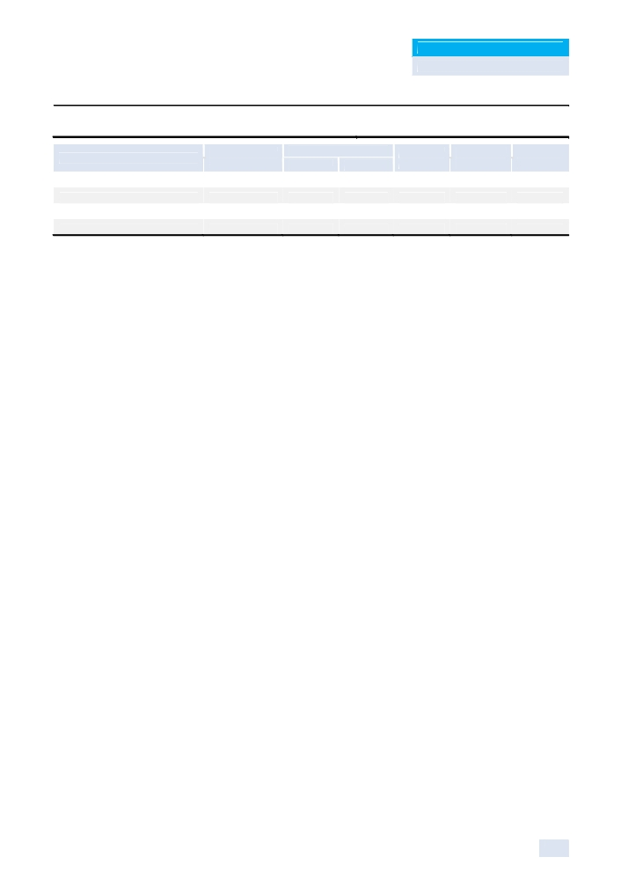

KAMCO Research
GCC Equity Markets Review

Kuwait Stock Exchange

Benchmarks’ Return

KSE Price Index
KSE Weighted Index
KSE 15 Index
KAMCO TRW Index
Market Review

Closing Sep-12
Value Point (%)
5,982.69 120.13 2.05%
417.97 17.79 4.45%
1,001.43 46.87 4.91%
2,650.36 77.30 3.00%

60 Day 90 Day YTD-12
(%) (%) (%)
4.59% 3.34% 2.90%
5.71% 3.90% 3.04%
4.62% 2.01% 0.14%
3.97% 2.81% 2.52%

The easing of the political deadlock coupled with government intervention in the market drove the
Kuwaiti Bourse to a 15 week high and outperformed its GCC peers to end as the best performing
market. Investor sentiment picked up during the month on hopes that a solution has been found for
the political and economic situation in the country. Accordingly, the KSE Weighted Index jumped
4.45% to 417.97 points, while the KAMCO TRW Index gained 3%, to close at 2,650.36 points and reverse its YTD-12 loss to record a 2.52% gain during the 9M-12. During the month of September 2012, the market capitalization of Kuwait Stock Exchanged grew 4.5% or around KWD 1.25 bn (USD 4.4 bn) to record KWD 29 billion (USD 102.8 bn) at the end of the month, driven by healthy increase in blue chips and majority of sectors including the Banking sector which added around KWD 465 million to its market cap and the Industrial and Telecom sectors which added KWD 244 mn and KWD 219 mn, respectively. Compared to August-12, trading indicators improved during September driven by the partial restoration of investor confidence in the stock market with volume traded increasing 86% to 6.1 bn shares from 3.3 bn shares in August-12; while value traded surged 125% to KWD 621 mn up from KWD 276 mn in August-12.

As the month began, the Kuwaiti bourse picked up slightly after reversing last month’s downfall as
investors opened fresh positions, lifting the measure to its highest level since July 4 to close at
5,891 points on Sep. 2. Investors bought undervalued stocks after the market slumped to an eight-
year low in Aug-12, but small-cap stocks drove the rebound. Market players feared that the rise
wouldn’t be sustainable unless blue-chips were part of the rise since the political instability in
Kuwait, a hamper to economic development, and lower than expected Q2-12 earnings of banks
had hit investor sentiment in recent months. Nevertheless, with foreign institutional investors
remaining on the side-lines, small-cap stocks were the biggest gainers due to retail investors who
typically speculate for short-term gains. The lack of local market drivers resulted in volatile
movements in the market as trading continued to be speculative. However, the pledged
government intervention improved market sentiment in Kuwait as investors believed there would
be a positive impact directly related to the market through increased liquidity and the return of
growth. Blue-chips surged by the end of the month, specifically banking stocks, as heavyweights in
the sector surged with Kuwait Finance House increasing 11.6% to close at KWD 0.770 while Gulf
Bank was up by 10% to end the month at KWD 0.440. National Bank of Kuwait ended the month
unchanged at KWD 0.990. Furthermore, as the month was nearing its end, the Kuwaiti Bourse hit
three-month high, extending gains boosted by government commitment to support the economy
and private sector.
In recent weeks the government’s attention has shifted towards solving the economic downturn
that the country is facing in the wake of the political upheaval that has hampered investment
sentiment and business activity. The order to find solutions came directly from the Amir as he
directed the government’s “economic group” to recommend reforms both in the short and long
terms. As a result of these orders, the Kuwait Investment Authority (KIA) has stepped up its activity
in the local bourse over the past two weeks through the implementation of the “National Portfolio”
which has seen the KSE Price Index reverse its YTD-12 losses to gains. KIA’s “National Portfolio”
received approval from Parliament in 2008, but had yet to be fully implemented, in order to provide

10

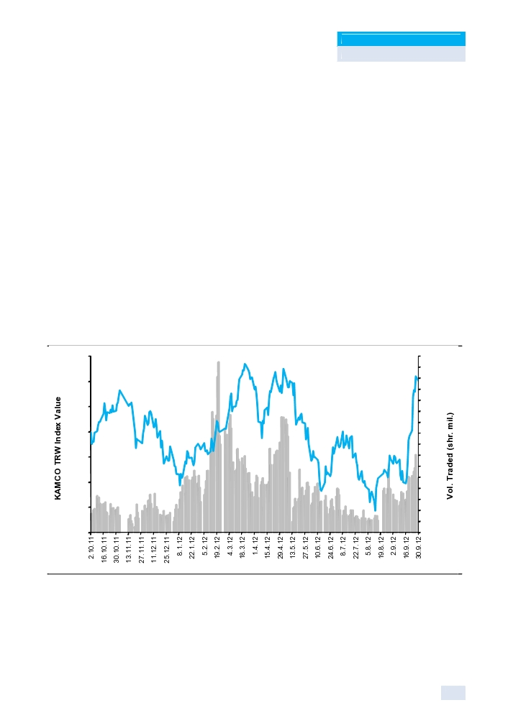

KAMCO Research
GCC Equity Markets Review

support for the local bourse and real estate market in the aftermath of the financial crisis. The KIA’s
“National Portfolio" created two funds to support the local economy, one worth KWD 1.5 bn slated
for investments in the local bourse, while the other worth KWD 1 bn slated for investments in the
real estate market. Recently, the Minister of Finance has indicated that the “National Portfolio’s”
has begun taking positions in potentially good investments as blue-chip and operational
companies’ price levels are attractive. Furthermore, the Minister revealed the intention of
government institutions to rent in the new commercial towers in Kuwait City in order to stimulate
the real estate sector. Currently, the fund to support the local bourse has used KWD 500 mn of the
available funds, while the real estate fund has not been used to place any notable investments in
the market. Therefore, the KIA has KWD 2 bn available to pump into the local economy, providing
ample room to further stimulate both the equity and real estate markets. In recent weeks, the
market has rebounded due to the government’s focus on utilizing the “National Portfolio” to support
the market in the short-term.
During the month, shareholders in Global Investment House approved a final plan to create new
special purpose vehicles (SPV) that will carry the company’s debt as part of the USD 1.7 bn debt
restructuring plan. Global, which is undergoing its second debt restructuring in three years, will
create at least two SPVs, one to hold company assets along with a debt of USD 1.3 bn and one
which will take part in a capital increase for the parent company and which will carry a debt
equivalent of USD 430 mn. According to the plan, Global will offer KWD 122.2 mn (USD 433.64
mn) of new shares to creditors, subject to creditor approval. The shareholders meeting also agreed
to write off losses worth KWD 31.1 mn against Global’s current share premium and a further KWD
77.1 mn from its existing paid-up capital.
KAMCO TRW Index 52-Week Performance Relative to Volume

2,675

2,650

2,625

2,600

2,575

2,550

2,525

2,500

Source: KAMCO Research
1,200
1,125
1,050
975
900
825
750
675
600
525
450
375
300
225
150
75
0

On the economic front, Kuwait’s inflation rate is expected to remain low in a range of 3%-4% y-o-y
in 2H-12 and 4% y-o-y on average in 2012 as the government’s price control measures on fuel and
food items through extensive subsidy system will prevent higher inflation in the future. Kuwait’s
consumer price index (CPI) inched up to 3.1% y-o-y in July-12 from 2.8% y-o-y in June-12 as food
prices (the second largest contributor of Kuwait’s CPI basket at 18.3%) rose to 6.6% y-o-y from
4.9% y-o-y during the same period. The overall inflation rose to 0.5% in July-12 from 0.2% in June-
12. Moreover, government announced earlier in the month that it would increase the portion of

11

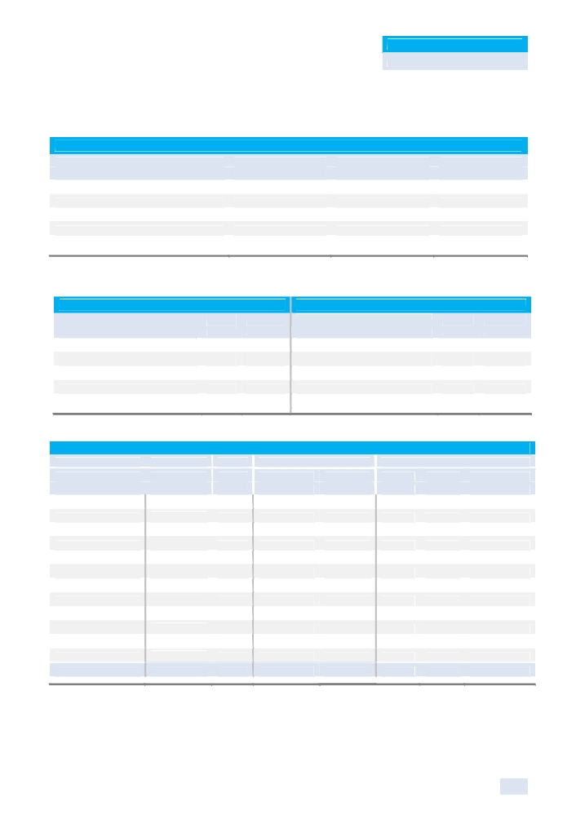

KAMCO Research
GCC Equity Markets Review

state revenue contribution to the Future Generation Fund (FGF) to 25% this fiscal year, up from 10%. The move is thought to be aimed at investing state money more efficiently.

Most Active Stocks for the Month
Volume Value Close
(000 shares) (000 KWD) (KWD)
National Ranges Co. 523,844 11,275 0.023
Gulf Finance House 499,679 18,715 0.036
Ithmaar Bank 423,341 20,817 0.048
Gulf Investment House 408,389 13,670 0.034
Manazel Holding Co. 385,790 12,138 0.037
Source: KAMCO Research

Best Return Performers Worst Return Performers
Close M-T-M Close M-T-M
(KWD) % Chg (KWD) % Chg
National International Holding Co. 0.053 73.77% Kuwait Finance & Investment Co. 0.077 (45.00%)
Kuwait Bus. Town Real Estate Co. 0.027 54.29% Kuwait Cable Vision Co. 0.037 (42.06%)
Munshaat Real Estate Projects Co. 0.041 30.65% Kuwait Reinsurance Co. 0.132 (32.65%)
Al Dar National Real Estate Co. 0.038 26.67% Zima Holding Co. 0.068 (30.61%)
Credit Rating & Collection Co. 0.036 26.32% Kuwait Packing Materials Co. 0.250 (23.08%)
Source: KAMCO Research

Sectors Performance
Monthly Trading Indicators Valuation Multiples
Market Cap M-T-M Volume Value P/E P/B Dividend Yield
(Mln KWD) % Chg (000 shares) (000 KWD) (X) (X) (%)
Oil & Gas 345 2.08% 82,251 4,943 NM 0.85 2.11%
Basic Materials 581 1.65% 22,267 6,526 12.03 0.94 6.69%
Industrials 2,563 10.54% 877,613 81,220 18.64 1.01 3.91%
Consumer Goods 739 12.07% 28,018 7,567 17.66 1.86 3.66%
Health Care 182 (1.03%) 2,315 925 19.44 2.19 2.60%
Consumer Services 730 4.03% 55,484 9,663 NM 1.80 1.23%
Telecommunications 4,516 5.10% 210,496 60,627 12.10 1.73 6.14%
Banks 13,799 3.49% 702,506 196,467 22.93 1.86 2.13%
Insurance 337 2.89% 774 198 15.39 0.87 4.08%
Real Estate 2,278 5.13% 1,412,440 75,562 NM 0.92 1.45%
Financial Services 2,844 2.85% 2,685,089 176,167 NM 0.70 1.82%
Technology 63 (6.80%) 11,604 912 NM 0.89 3.21%
Total Kuwaiti Market 28,976 4.49% 6,090,856 620,777 29.76 1.35 2.96%
Source: KAMCO Research

12
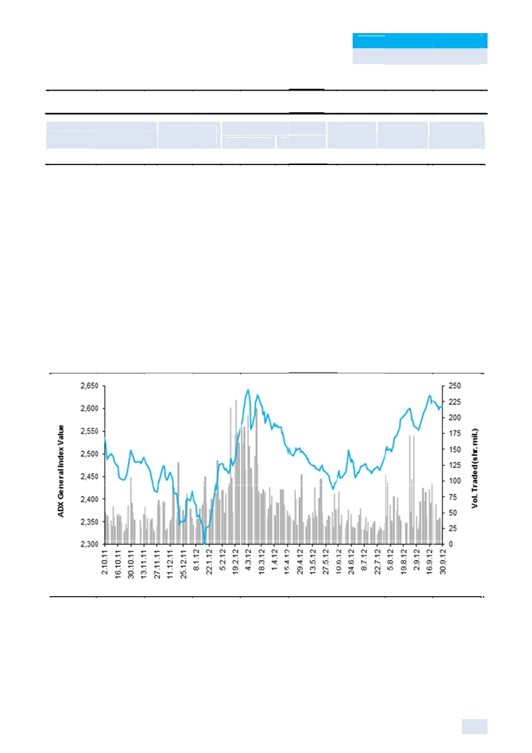

KAMCO Research

Abu D habi S ecuriti es Exc hange

Clos ing Sep-12
GCC E quity Marke ts Review

60 Day 90 Day YTD-12

Benchmark Return
ADX Genera l Index

Market R eview
Valu e P oint (%)
2,605 .41 43.80 1.71%
(%) (%) (%)
3.53% 5.98% 8.46%

The Abu Dhabi Securities Exchange, as measured by the ADX General Index, advanced 43.80

points to 2,605.41 to record a 1.71% increase marking the fourth consecutiive month of gains on

the back of positive 1H-12 earnings, strong oil prices, and improved investor sentiment towards the

local economy. Liquidity dropped during the month as the heavy buying on the real estate sector

from the past couple months cooled, with volume and value decreasing 21% and 8%, respectively,

to 1.1 bn shares and AED 1.63 bn (USD 444 mn). Total market capitalization increased 3.10% to

AED 290.17 bn (USD 79 bn) in September on the back of a 5.15% and a 2.46% increase in the

telecommunication and the banking sectors, respectively, to AED 114.2 bn (USD 31.09 bn) and

AED 125.83 bn (USD 34.26 bn); while the real estate sector also recorded an increase of 5.59% to

AED 9.4 bn (USD 2.55 bn). The ADX General Index’s 9M-12 return stands at 8.46% as the bourse

has recovered from last year’s slump with the local economy showing resilience and growth, while

the govern ment has managed successfull y with wel l-studied in terventions
revive busi ness activit y.

ADX Gener al Index 52 Week Perfo rmance Re lative to Vo lume

Source: KAM CO Research

The board of directors of the Sec urities and Commodit ies Authorit y (SCA) ha
and refor ms helping

s passed a number of

regulations, notable among them being the highly anticipated Market-maker Regulation, as well as

other related regulations, including regulations for Securities Borrowing and Lending, Short-selling

and Liquidity Provider. These regulations and legislations stress the need for disclosure and

transparency in transactions; prices to be determined based on normal interactions and successful

13

KAMCO Research
GCC Equity Markets Review

promotional efforts to attract savings and direct them to lucrative investment channels to ensure optimal allocation for individuals and the society.
The 13-article market-maker regulation, consists of definition of Market-Maker Regulation, rules governing the licensing of market-maker, responsibilities of license applicant concerning administrative and technical staff and internal supervision, licensing procedures, duration and renewal, rules for registration of foreign market-maker, market-maker’s responsibilities and tasks and facilities granted to market-maker. The Regulation also outlines the prerogatives of the SCA and the financial markets in supervising market-makers, as well as violations, penalties and license suspension and revocation.
The Advantages of the Market Maker to ADX & DFM can be identified as follows: - Provision of orders and offers for shares in the main market.
- Provision of continuous and real prices.
- Provision of the required quantities of securities, in the cases of purchase or sale. - Making the price through the introduction of orders and offers.

These regulations are designed to promote and enhance the capital market activities. It is expected that the implementation of the Regulations will start by the end of 2012, and that the AED 30 million limit prescribed by the Market Maker Regulations represents the minimum capital requirements.
The regulation for securities lending and borrowing regulates the temporary transfer of securities ownership from one party to another in accordance with a contract signed by the two parties and the rules outlined by the regulation, which also regulates the role of securities lending and borrowing agent, making it compulsory for the latter to have the approval of the SCA before practicing this activity after meeting the laid down requirements.
The regulation also outlines eligible cases and scopes of securities lending and borrowing, regulates other related issues like guarantee and the responsibilities of the lending and borrowing agent, the prerogatives of the SCA and the markets in supervising the lending and borrowing agent, as well as the powers vested in the SCA concerning the handling of violations committed by the lending and borrowing agent.
The Regulation for securities short-selling outlines situations when short-selling of securities can
be transacted and the types of securities allowed being involved in this transaction. It also
regulates the responsibilities of all parties involved in short-selling transactions, mandates the
disclosure of short-selling centers, regulates the responsibilities of the market and its supervisory
role in short-selling transactions and outlines the authority vested in the SCA regarding violations
and penalties.
In corporate news, a potential merger agreement between Abu Dhabi developers Aldar Properties and Sorouh Real Estate is expected to be announced "within a month," according to Sorouh’s managing director. Aldar has relied heavily on the government over the past two years for funding. Abu Dhabi has spent more than USD 10 bn on the company; equivalent to the amount it deployed to rescue Dubai from a bond default in 2009. The two companies had announced in March that they planned that they were studying the possibility of a merger, and subsequently moved towards the due diligence stage; the proposed merger is worth USD 13 bn.
Dana Gas is in talks with the Egyptian government to recover delayed receivables from its
operations in the North African country, according to Crescent’s Petroleum’s president. Crescent
Petroleum, the largest shareholder in Dana Gas with a stake of 20.1%., is optimistic that the
Sharjah-based natural gas producer can reach a “comfortable resolution” on its $920 million
Islamic bond maturing in October. Dana started facing problems last year after anti-government
protests in countries such as Egypt led to payment delays from government entities. It has also
faced payment issues in Iraq’s Kurdistan region. The company was owed AED 729 mn (USD 198.5

14
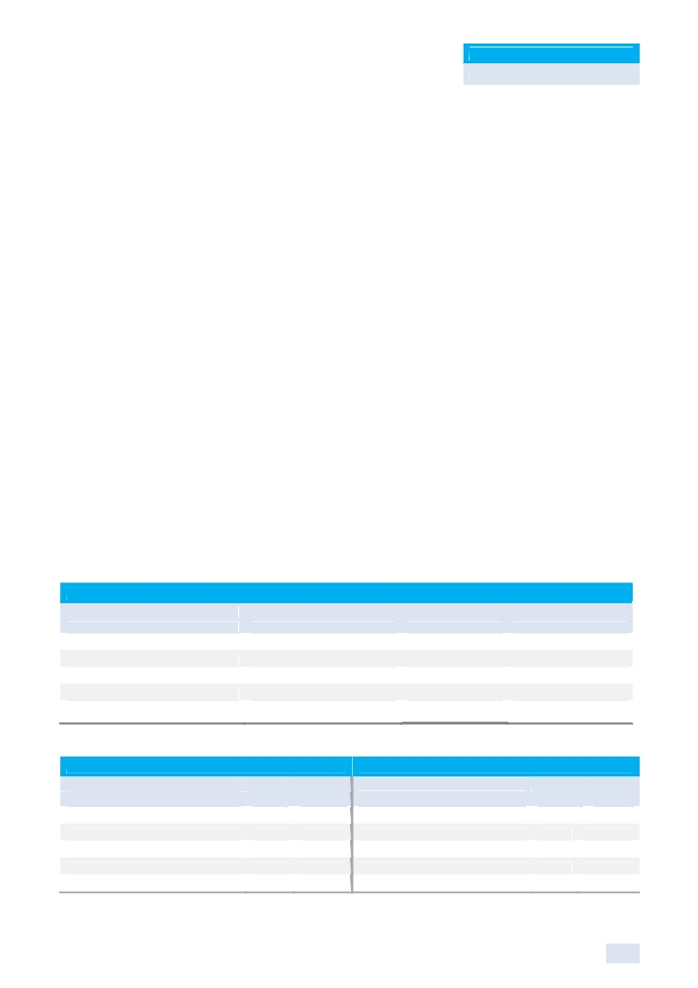

KAMCO Research
GCC Equity Markets Review

mn) in Egypt as at June 30, 2012, according to its half-year results. They received AED 431 million from Egypt during 1H-12.
First Gulf Bank (FGB) hired eight banks to arrange an USD 800 mn loan, making it the third Middle Eastern bank to borrow from the syndicated loan market since August. The three-year facility will be provided by Bank of Tokyo-Mitsubishi UFJ, Citigroup, Commerzbank, Deutsche Bank, HSBC Holdings, Mizuho Financial Group, National Bank of Abu Dhabi and Standard Chartered Bank. The loan will pay an interest margin of 130 basis points over the London interbank offered rate. The bank has a USD 825 million syndicated loan maturing in November 2012 signed in November 2007 that pays an interest margin of 27.5 basis points over Libor.
The National Bank of Abu Dhabi (NBAD) will continue to focus on organic growth to expand its
operations in the regional and international markets according to a senior official. The bank
currently operates in 13 countries on four continents, and is on track to make entries into Lebanon,
Iraq, South Sudan and India in the near future, while other markets like Morocco, Tunisia and
Algeria are under study. NBAD has an overseas network that stretches from Oman, Kuwait and
Bahrain in the GCC; Egypt, Libya and Sudan in Africa; UK, France and Switzerland in Europe;
Hong Kong, Shanghai, Malaysia and Jordan in Asia to Washington, DC in the United States.
On the economic front, Abu Dhabi’s real GDP is expected to expand by 3.9% in 2012 according to
the emirate's Department of Economic Development revising an earlier forecast for 5% growth.
The department announced the figure in its "Economic Horizons of Abu Dhabi 2012-2016" which
also foresaw an increased pace of growth of 5.7% annually between 2013 and 2016. It also
forecast growth of 5.5% this year in the non-oil sector of the emirate which sits on almost all the oil
wealth of the United Arab Emirates. Overall, UAE’s non-oil foreign trade grew 8% Jan-12 to AED
78.3 bn, compared to AED 72.3 bn in January 2011, on a strong surge in exports. Non-oil exports increased by AED 2.7 bn to AED 10.1 bn, growing by 30% y-o-y, primary statistics of the Federal Customs Agency revealed. Imports rose by 11%, raising non-oil imports to AED 52.1 bn in Jan-12; re-exports declined by AED 1.4 bn to reach AED 16.2 bn in the same month last year. The increasing growth of the exports reflects better quality and more competitiveness in UAE national products in international markets.

Most Active Stocks for the Month
Volume Value Close
(000 shares) (000 AED) (AED)
Sorouh Real Estate Co. 284,617 336,424 1.18
AL DAR Properties Co. 266,516 334,470 1.25
DANA GAS 205,133 85,832 0.42
Methaq Takaful Insurance Co. 56,364 61,469 1.05
Ras Al Khaimah Properties 43,786 15,456 0.34
Source: KAMCO Research

Best Return Performers Worst Return Performers
Close M-T-M Close M-T-M
(AED) % Chg (AED) % Chg
Qatar Telecom. Co. 115.00 13.86% National Takaful Co. (Watania) 0.98 (14.78%)
Commercial Bank International 0.95 13.10% Ras Al Khaimah White Cement 1.27 (12.41%)
Bank Of Sharjah 1.25 12.61% United Arab Bank 2.86 (10.63%)
DANA GAS 0.42 10.53% Al Buhaira National Insurance Co. 7.20 (10.00%)
Sorouh Real Estate Co. 1.18 9.26% Union Cement Co. 0.92 (8.91%)
Source: KAMCO Research

15
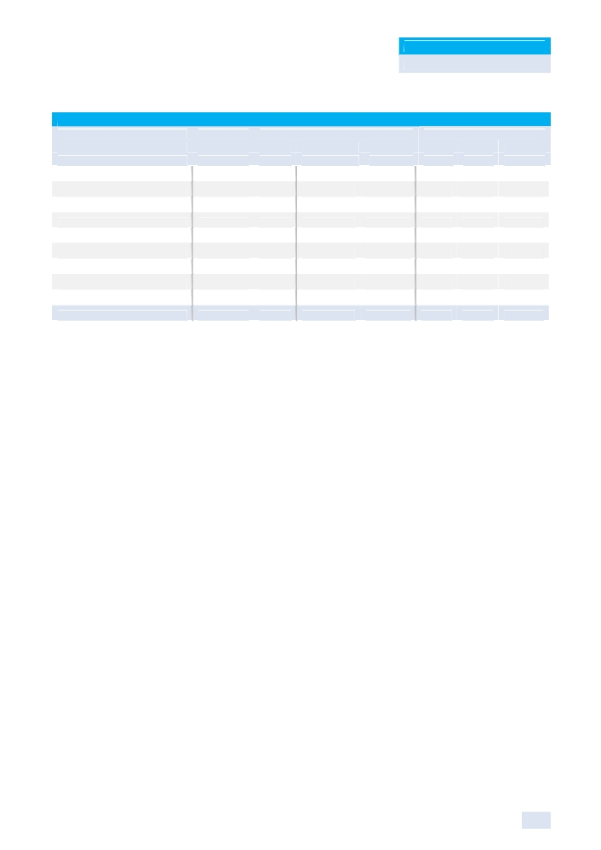

KAMCO Research
GCC Equity Markets Review

Sectors Performance
Monthly Trading Indicators Valuation Multiples
Market Cap M-T-M Volume Value P/E P/B Div. Yield
(Mln AED) % Chg (000 Shares) (000 AED) (X) (X) (%)
Banks 125,835 2.46% 76,806 358,251 7.65 1.01 4.66%
Investment & Financial Services 1,110 0.00% 9,848 5,455 7.57 0.49 8.55%
Real Estate 9,379 5.59% 622,296 695,062 5.42 0.50 4.54%
Energy 10,740 0.72% 214,695 98,472 5.89 0.68 5.80%
Consumer Staples 2,897 (1.57%) 6,449 12,586 24.79 1.09 0.38%
Industrial 8,558 (1.14%) 65,264 50,445 25.11 0.66 1.26%
Insurance 9,577 (3.18%) 67,803 99,440 35.05 1.35 2.77%
Telecommunication 114,178 5.15% 34,052 314,706 12.95 1.60 5.34%
Services 7,897 (0.10%) 7,950 19,841 6.72 0.53 4.50%
Total Market 290,169 3.10% 1,105,163 1,654,258 9.40 1.07 4.77%
Source: KAMCO Research

16
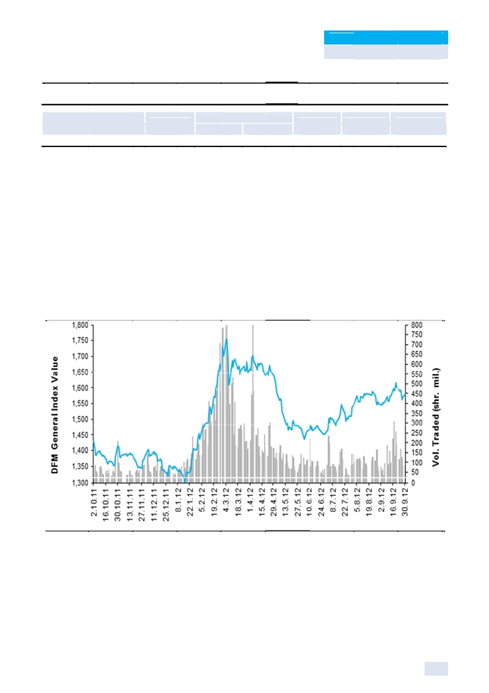

KAMCO Research
GCC Equity Markets Review

Dubai Financ ial Ma rket

Benchmark Return Closin g
Value Poi nt
DFM Genera l Index 1,578.7 9 30.97
Market R eview

Sep-12
6 0 Day 9 0 Day YTD-12
(% ) (%) (%) (%)
2.0 0% 2 .00% 7.80% 16.65%

The DFM General Index gained 2% to 1,578.79 to record the third consecutive month of gains and

lifting its YTD-12 return to 16.65%. The market’s performance was supported by the improving

economic fundamentals in the country as Dubai continues to shake off the efffects of the 2009 debt

crisis. Business activity continues to pick up in the Emirate due to the successful restructuring of

debt-strapped government related entities, along with a recovery in the real estate market and an

increase in foreign direct investment and non-oil exports. The bourse’s return was supported by

gains in the investment & financial, telecommunication, real estate, and banking sectors,

increasing 4.51%, 2..88%, 1.71%, and 1.16%, respectively. Total markett capitalization gained

1.46% to AED 173.2 bn (USD 48.1 bn) from last month’s AED 170.7 bn (USD 46.47 bn). Liquidity

surged during the month due to a return to normal trading following the summer season and

Ramadan, volume an d value inc reased 39 % and 37% , respectiv ely, to 2.72
3.07 bn, re spectively, over 37,47 1 transactio ns.

DFM Gener al Index 52 Week Perfo rmance Re lative to Vo lume

Source: KAM CO Research
In corpora te news, D rake & Sc ull Internati onal (DSI) has won a n AED 1.3
pipeline co nstruction contract in Iraq, inten ded to serv ice one of the world's
bn share s and AED

bn (USD 353.9 mn)
largest oi lfields. The

builder was awarded the contract for half of the value of the oil and gas project at the Zubair oilfield

as part of a joint venture with Sicim of Italy. The contract is the first big win for DSI's newly

established oil and gas operations. DSI's pipeline project is due for completion by July 2014 and

will generate about USD 300 mn in revenue for the company, according to the company's chief

executive. The Zubair field, near Basrah, is expected to produce 1.2 mn barrels of oil per day by

2017, according to official estimates.

17

KAMCO Research
GCC Equity Markets Review

Emaar Properties, has sold one of its hotel assets to an Abu Dhabi-based real estate firm, Eshraq Properties, for an undisclosed amount. Eshraq Properties said in a statement that it has acquired Nuran Marina, a serviced hotel apartment owned by Emaar and located in the up-market Dubai Marina area. Dubai's largest developer has looked to shift away from its home market where real estate prices have slumped by more than 60% in the aftermath of the debt crisis in 2009. The developer announced plans this month to build a new hotel in the Dubai's high-end Downtown area, its first major hotel project since the property crisis.
During the month, Tamweel announced that UAE home finance transactions in 2012 were likely to
be 30% higher than in 2011, surpassing AED 8 bn (USD 2.17 bn). Tamweel has seen a 26%
increase in home finance application in 1H-12 as compared to the same period last year.
Furthermore, the company announced that prices of UAE real estate that it has financed over the past 18 months have increased between 10-15%, with the most appreciation the strongest in mature and completed developments in Dubai and Abu Dhabi.
Limitless, the property arm of Dubai World, aims to complete a USD 1.2 bn debt deal with creditors by the end of September. The state-owned firm, which was hard hit by the financial crisis, has rolled over the Islamic debt facility, which it owes to a syndicate of banks, several times; the loan was originally due to mature in March 2010. The firm has proposed paying interest of 175 basis points over LIBOR under the new terms.
In economic news, Dubai attracted AED 16.5 bn in foreign direct investment (FDI) during 1H-12,
according to statistics compiled by Dubai FDI, the foreign investment office in the emirate's
Department of Economic Development (DED). 1H-12 saw 115 FDI projects being initiated in Dubai
by 113 companies, which accounted for 1.5% of total global FDI projects. Total FDI that flowed into
Dubai during January-June 2012 was 7% up from 1H-11. The presence of larger projects is the
most notable feature of the FDI inflow during 1H-12. Similar to the 1H-11, India, USA, UK, Saudi
Arabia, Qatar, Germany, Switzerland and France were on top among the source countries for FDI
into Dubai in 1H-12. The top 10 countries accounted for 83 projects, or 72% of the total, and their
combined investment of AED 15.5 bn was 94% of the 1H-12 FDI into Dubai. The UK and India
accounted for 29% of the FDI projects, mainly in business services. Almost 93.9% of the FDI
projects initiated in Dubai during 1H-12 are new investments, compared to 88% in 1H-11.
Moreover, almost 45% of the projects came from companies that had not previously had a project
recorded in Dubai. Average capital investment in the new projects was AED 149 mn, while average
capital investment for expansion was AED 56 mn. The sector-wise breakdown of new FDI
initiatives shows Real Estate, Leisure and Entertainment; Chemicals; Financial Services; Business Services; Food and Tobacco; Healthcare; Communications; and Metals as leading FDI industries during the 1H-12. The top ten sectors together attracted 77 projects worth AED 15 bn, representing 67% of the total projects and 93% of the net capital invested.

Meanwhile, apartments in Dubai have increased in value an average 4.9% since the beginning of
2012, and will continue to rise until the end of the year. According to the Dubai Land Department,
Dubai property transactions grew 21%to AED 63 bn (USD 17.15 bn) in the 1H-12, compared to
2H-12, without a seasonal slowdown during Ramadan. Dubai’s strengthening property market is a
reflection of the UAE’s improving economic performance. According to Dubai government
published figures, foreign investors buying real estate were responsible for acquisitions of AED
28.3 bn (USD 7.7 bn) in the 1H-12, up 36% from the same period last year. Prices are expected to
remain stable in 2013 as the additional supply will enter the market making an uplift or boom
unlikely.
In other news, Dubai’s passenger traffic climbed 6% from a year earlier in July, with monthly traffic surpassing 5 mn passengers for the first time according to Dubai Airports. During July, the airport handled 5.01 mn passenger up from 4.72 mn in July-11, while freight passing through Dubai International climber 6.2% to 204,510 tonnes.

18
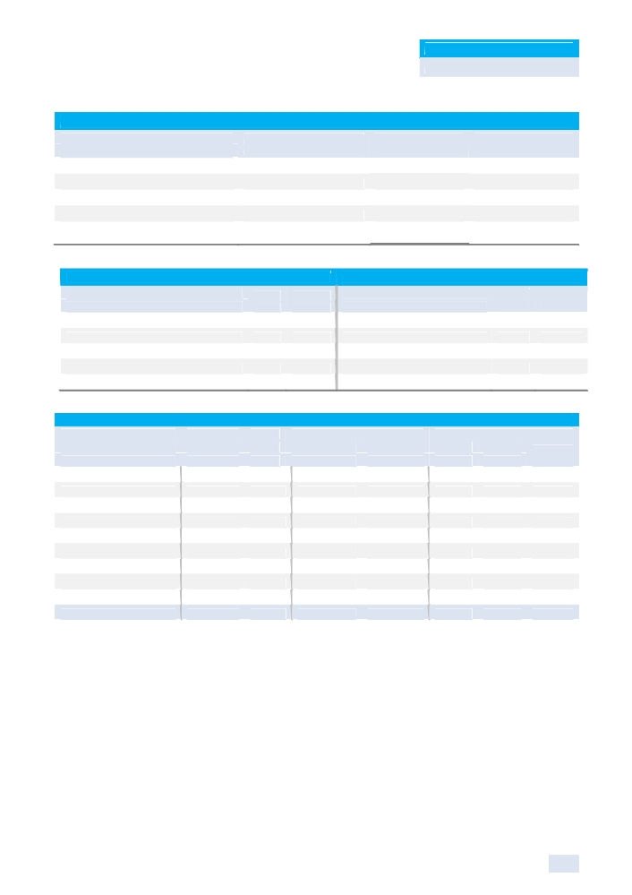

KAMCO Research
GCC Equity Markets Review

Most Active Stocks for the Month
Volume Value Close
(000 shares) (000 AED) (AED)
Drake and Scull International 353,755 301,886 0.825
Gulf Finance House 334,937 166,289 0.476
Gulf Navigation Holding 304,281 76,985 0.254
EMAAR Properties 239,557 833,228 3.480
Deyaar Development 208,132 77,453 0.360
Source: KAMCO Research

Best Return Performers Worst Return Performers
Close M-T-M Close M-T-M
(AED) % Chg (AED) % Chg
Al-Madina for Finance & Investment 0.800 25.59% Dubai National Insurance & Reins 2.070 (15.51%)
Ekttitab Holding Company 1.110 14.91% Arab Technical Construction Co. 2.520 (9.35%)
Dubai Islamic Insurance & Reinsurance 1.040 14.16% Al Mazaya Holding Co. 1.050 (7.08%)
Int'l Financial Advisors Co. 0.840 13.51% Gulf Finance House 0.476 (6.67%)
Al Salam Bank - Sudan 1.690 11.18% SHUAA Capital 0.600 (6.54%)
Source: KAMCO Research

Sectors Performance
Monthly Trading Indicators Valuation Multiples
Market Cap M-T-M Volume Value P/E P/B Dividend
(Mn AED) % Chg (000 Shares) (000 AED) (X) (X) Yield (%)
Banking 45,460 1.16% 610,427 667,354 11.80 0.61 5.30%
Consumer Staples 1,596 0.00% 1 298 11.28 1.71 2.26%
Investment & Financial 14,346 4.51% 353,627 284,118 NM 0.67 1.24%
Insurance 8,673 0.74% 107,541 83,320 21.09 1.20 2.36%
Materials 29,644 0.00% - - NM 3.14 0.24%
Real Estate & Construction 31,113 1.71% 968,345 1,469,535 16.72 0.66 2.99%
Telecommunication 16,720 2.88% 95,442 154,058 12.48 2.24 4.10%
Transportation 24,765 1.04% 451,341 242,007 51.21 1.23 1.14%
Utilities 844 4.92% 128,387 165,008 4.18 0.22 0.00%
Total Market 173,161 1.46% 2,715,112 3,065,698 25.48 0.90 2.77%
Source: KAMCO Research

19
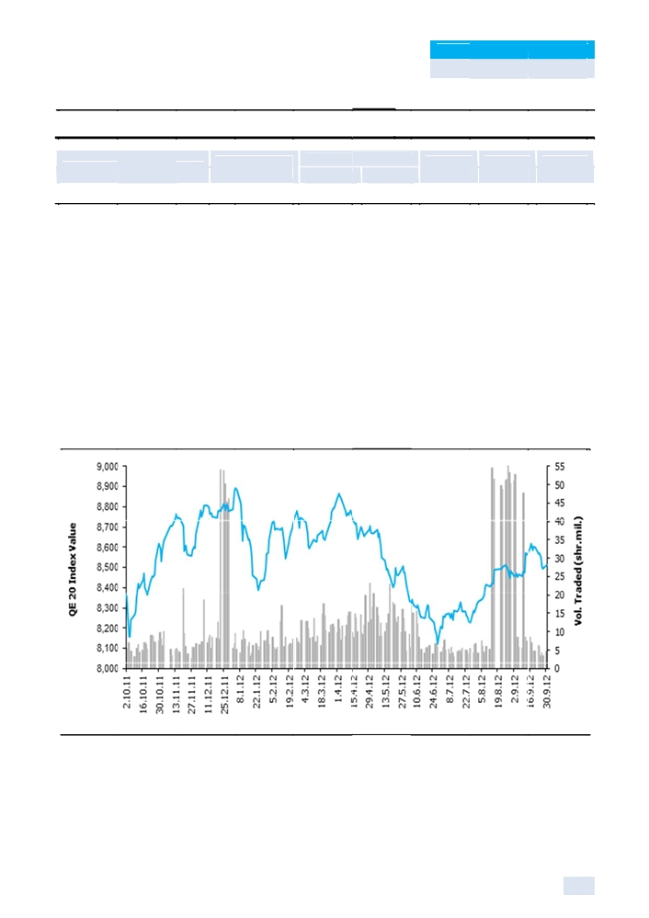

KAMCO Research

Qatar Excha nge

Benchmark Return

QE 20 Index
Market R eview

Closing
Value

8,510.21

Se p-12
Point (%)
26.57 0.31%
GCC E quity Marke ts Review

60 Day 90 Day YTD-12
(%) (%) (%)

2.32% 3.82% (3.06%)

The Qatar Exchange posted gains for the third consecutive month to increase 0.31% to 8,510.21 to

set the highest monthly close since April-12; however the bourse’s YTD-12 return remains negative

at a loss of 3.06%. The market performance was supported by increases in the heavyweight

Banking & Finance and Industrial sectors, along with a strong month for the Consumer Goods &

Services sector which jumped 6.36% in September. Liquidity plummeted in comparison to last

month as volume decreased 54% to 260 mn shares, while value traded decreased 44% to QAR

7.26 bn; however, transactions increased 19% to 70,948. Liquidity slumped on the back of the Real

Estate sector, which captured 75% of traded value last month, but saw its vallue traded plunge 62%

in September. Market volatility increased from the record low of 4.16% posted last month to 5.59%

reflecting a slight increase in risk appetite. The country’s strong underlying economic fundamentals

with real GDP forecasted by the IMF to grow at 6% per annum over the next six years promises

returns to investors starved for options amid the negative sentiment dominating the regional and

international markets resulted from the Euro-Zone crisis and a global economic deceleration.

QE 20 Index 52 Week Performance Relative to Volume

Source: KAMCO Research
Qatar National Bank received approval from Egypt’s central bank to start due diligence on the local
unit of Societe Generale ahead of a potential acquisition. NSGB said on August 30 that it had
entered talks with QNB about a sale of Societe Generale’s 77.2% stake in the Egyptian lender,
valued at EGP 16 bn (USD 2.6 bn) based on September closing price. QNB said in April it had a
five-year plan to make itself an “icon” in the Middle East and Africa by expansion and “diversifying
income sources.” As a result, QNB has decided to drop its interest in acquiring BNP Paribas’
Egyptian unit favouring Societe Generale’s assets due to its larger retail network. Furthermore,

20

KAMCO Research
GCC Equity Markets Review

QNB announced that it has increased its stake in UAE’s Commercial Bank International (CBI) to 40%, in line with its international expansion strategy; recent acquisitions by the bank include an increase of its stake in Iraq’s Mansour Bank to 51% and acquiring 49% in the Bank of Commerce & Development.
During the month, Ezdan Real Estate Co. held its ordinary and extraordinary general assembly
meetings that approved transforming into a holding company, “Ezdan Holding” and diversify its
investments through purchasing 15 companies from Tadawul Holding Group. The decision was
based on an assessment made by Commercial Capital and KPMG with the goal of meeting the
level of future challenges, by expanding its scope of business and diversifying sources of revenue.
Shareholders authorized the board to conclude the deal to purchase the companies from Tadawul
Holding and to obtain the required funds from banks to complete the acquisition of targeted
companies.
Barwa Bank has been chosen as a co-manager for Turkey’s first sukuk transaction worth USD 1.5
bn. The bank had earlier this year acted as co-lead manager for Dubai government’s USD 1.25 bn
sukuk issue, joint lead manager for Qatar’s successful USD 4 bn sukuk, the USD 800 mn five-year
sukuk for Islamic Development Bank and most recently USD 500 mn Emaar issue. The Turkish
government’s issue of a USD 1.5 bn Islamic bond, which drew heavy bids totalling about USD 7.5
bn from global investors, is a step towards bringing Turkey into the mainstream of Islamic finance,
potentially giving it access to billions of dollars in Islamic investment funds from the shariah-
compliant market.

Meanwhile, Doha Bank plans to raise its capital by 50% in Q1-13 to meet strategic business requirements according to a statement by the bank. Doha Bank’s board of directors approved plans for a capital hike at a meeting and will now seek approval from shareholders at an extraordinary general assembly, the bourse statement said. No details of how the bank plans to raise capital or the size and date of issue were provided in the statement, which said these would be disclosed after the necessary studies and approvals were in place.
In ratings news, Fitch has affirmed Ahli Bank’s long-term issuer default rating at ‘A-’ with a “stable”
outlook. It also confirmed the ‘BBB-’ rating in respect of the bank’s financial strength and ‘F2’ for
short-term IDR. Fitch factored in Ahli Bank’s solid profitability, adequate liquidity, sound
capitalization and the strong support by the sovereign authorities in Qatar and its strategic partner
Ahli United Bank. “Ahli Bank’s profitability ratios continued to improve in 2011 and still compare
reasonably well with its peers. The bank’s costs are well controlled, its loan quality remains sound
and its deposit base has proved historically stable, mitigating concentration risks”, Fitch said.
Furthermore, Moody’s released its annual credit report for Qatar highlighting regional geopolitical tensions as a tail risk which could escalate and disrupt Qatari exports. However, the agency said Qatar’s ‘Aa2’ government bond rating and stable outlook continue to be underpinned by hydrocarbon-driven high economic and government financial strengths. Qatar’s very high economic strength factors in the country’s strong economic growth and prodigious natural resource base, which make the economic prospects favourable and have generated an “exceptionally” high level of wealth, Moody’s said in its annual credit report.

On the economic front, Qatar's Q2-12 real GDP grew by 5% over the same period in 2011 according to the statistics authority GDP grew by 2.5% in the Q2-12 when compared to Q1-12, said the Qatar Statistics Authority release, citing preliminary data. The nominal Q2-12 GDP grew by 11.9% on the year, but dipped 1.1% on the quarter.
Qatar’s Central Bank (QCB) released its “Financial Stability Review 2011” showing that the easing
of supply-side factors has led to a growth in bank credit in Qatar, which reached QAR 404 bn in
Dec-11. The country’s banking sector recorded an average credit and deposit growth of 16.4% and

21

KAMCO Research
GCC Equity Markets Review

21.6% respectively during 2011. Credit to the public sector continued to be the major driver for the growth observed in overall credit. For example, credit to the public sector averaged around 20% during the year, following on the back of the very high growth of over 85% recorded in the previous year. The average growth in private sector credit, in contrast was lower at 15%, albeit higher than the previous year’s numbers. Foreign currency credit demand from both the public and private sectors increased substantially during the year.
Public sector institutions continue to account for a major share of aggregate bank credit followed
by real estate sector and consumer loan. The real estate sector recorded a year-on-year credit
growth of around 49%, while the growth in consumption credit was around 20%, as of December
2011. Taken together, these sectors contributed 63.4% of the total private sector credit. Credit to
real estate increased considerably during the first three quarters of the year, with some
moderation, primarily during the final quarter. The successful bid for the 2022 FIFA World Cup and
the ensuing wave of positive sentiments appears to have played a major role in the buoyant growth
in real estate sector.
The overall assets of banks in Qatar grew by 10.7% during the year up to August-12 to reach QAR
772.6 bn (USD 212.2 bn), compared to QAR 698 bn (USD 191.8 bn) as at year-end 2011. Asset
growth was driven mainly by the increasing loans that grew by 18.5% to QAR 479.7 bn (USD 131.8
bn) for the sector. Cross-border assets of some 10 Qatari banks totalled QAR 113.2 bn in 2011, up
28.5% from the previous year, according to the same report. A sizeable portion of the cross-border assets are in the form of customer credit last year; placement with foreign financial institutions also increased significantly during the year. Out of the 10 Qatari banks, only two have cross-border branch presence, while all the other banks conduct cross-border activities through their branches in Qatar with data showing that the banking sector in Qatar increased their cross-border exposure considerably in 2011. The aggregate cross-border exposure of the domestic banks indicates the banking sector in Qatar increased their exposure considerably in 2011. In terms of regional diversification, the GCC and other MENA region account for around 50% of the total cross-border assets, whereas the share of Europe is roughly 33%; In particular, cross-border assets in the UAE are the highest at around 22%.
Furthermore, Qatar’s central bank wants to keep interest rates low to support lending to the real economy, and also reported that local banks have low exposure to the debt crisis-stricken Eurozone. The QCB cut its overnight deposit rate by a combined 75 basis points in April and August 2011 to a current level of 0.75% to discourage banks from parking excess money at its accounts, support lending in the real economy and bring the rate closer to its US benchmark. The QCB also took several steps to drain excess money last year. In January-11 it issued a QAR 50 bn (USD 14 bn) bond directly to local banks, and in May and August, it launched monthly auctions of 91-, 182- and 27-day Treasury bills. As a result, available liquidity in Qatar’s financial system dropped to QAR 5.8 bn at the end of 2011 from QAR 73.2 bn a year before.
Meanwhile, central bank also announced that Qatar’s banks are in a position to meet the Basel III requirements on common equity capital ratios by 2012-end. This is due to the high level of common equity capital of the domestic banking sector, a Qatar Central Bank study has shown. The major highlights of the Basel III framework include higher and better-quality capital, better risk coverage, and introduction of two global liquidity standards. QCB said by end-2015, assuming a static scenario of capital, out of 10 local banks, one bank’s total capital ratio appears to decline below the prescribed total capital ratio of 10.625%

In other news, Qatar agreed to invest USD 8 bn over the next five years to build a port in the
Egyptian city of Port Said according to Egypt’s Prime Minister. Qatar also agreed to deposit USD
1.5 bn with Egypt’s central bank. The deposit is part of a USD 2 bn package announced last month and will be made in three monthly instalments to November-12.

22
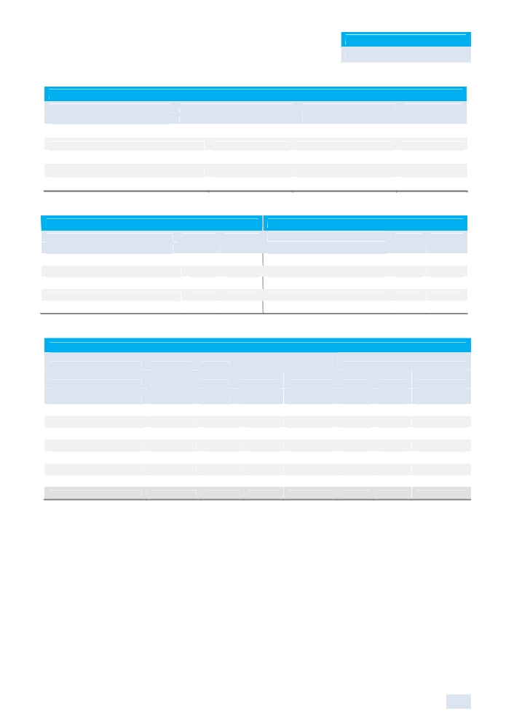

KAMCO Research
GCC Equity Markets Review

Most Active Stocks for the Month
Volume Value Close
(000 Shares) (000 QAR) (QAR)
Ezdan Holding Co. 138,472 2,857,312 19.70
Barwa Real Estate Co. 22,010 660,523 29.50
VODAFONE 10,776 97,745 9.10
Qatari German Co. for Medical Devices 8,996 121,702 14.75
Al Rayan Bank 7,822 212,325 27.05
Source: KAMCO Research

Best Return Performers Worst Return Performers
Close M-T-M Close M-T-M
(QAR) % Chg (QAR) % Chg
Qatari German for Medical Devices 14.75 22.92% Dlala Brokerage & Inv. Holding 41.10 (5.84%)
Qatar General Ins. & Reins. 54.80 15.37% Al Ahli Bank of Qatar 60.30 (5.78%)
Qatar Meat & Livestock Trading Co. 72.00 10.77% Medicare Group 38.80 (5.37%)
Qatar Cinema & Film Distribution 62.30 9.30% Zad Holding Co. 57.50 (4.96%)
Qatar Fuel Co. (Wokod) 286.00 8.87% Gulf Holding Co. 25.10 (3.65%)
Source: KAMCO Research

Sectors Performance
Monthly Trading
Indicators Valuation Multiples
Market
Cap M-T-M Volume Value P/E P/B Dividend
(000
Sector (Mn QAR) % Chg Shares) (000 QAR) (X) (X) Yield (%)
Banking & Finance 187,943 0.25% 35,650 1,597,350 11.69 1.91 4.20%
Consumer Goods 21,717 6.36% 18,909 811,610 13.84 2.32 3.14%
Industrial 117,450 0.66% 11,252 583,397 10.68 2.67 4.78%
Insurance 11,205 3.25% 1,291 65,944 12.51 1.60 3.95%
Real Estate 71,051 (2.11%) 171,892 3,700,744 13.46 1.40 1.11%
Telecom 41,487 (1.55%) 12,534 284,329 19.15 1.30 1.27%
Transport 17,266 (0.39%) 8,401 218,282 10.54 0.95 5.39%
Total Qatari Market 468,119 0.13% 259,929 7,261,656 12.12 1.80 3.60%
Source: KAMCO Research

23
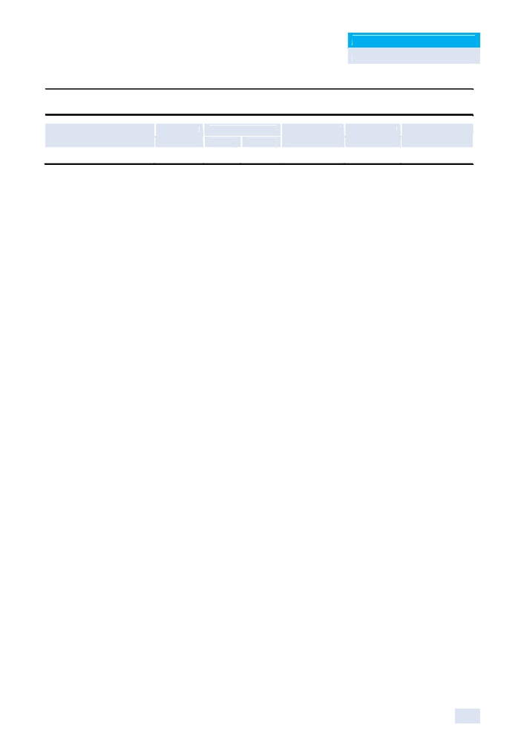

KAMCO Research
GCC Equity Markets Review

Bahrain Bourse

Benchmark Return

Bahrain All Share Index
Market Review

Closing Sep -12
Value Point (%)

1,087.33 1.01 0.09%

60 Day 90 Day YTD-12
(%) (%) (%)

(1.24%) (3.01%) (4.93%)

The Bahrain Stock Exchange snapped a four month losing streak after posting marginal gains of 0.09%
closing at 1,087.33.Trading indicators also increased in the Bahrain Bourse as the number of shares
exchanging hands totalled 40.55 mn shares, a rise of 121% from the previous month; spread over 804
deals with a total value traded of BHD 5.12 mn. The Investment sector captured the majority of market
trading at 67.1% and 47.7% of volume and value, respectively. Total market capitalization increased
0.23% to BHD 5.96 bn (USD 15.79 bn) in September on the back of a 4.42% increase in the market heavyweight ALBA to BHD 738.40 mn (USD1.95 bn). Whereas other market heavyweight Ahli United bank, inspite of good volume, remained unchanged and closed at USD 0.545. On the GCC front, regional indices finished on a positive note during September with KSE Weighted Index ending as the top gainer with an increase of 4.45% over the month while Dubai Financial Market and Abu Dhabi Securities Exchange followed suit with a gain of 2% and 1.71%, respectively. On the other hand, TASI All Share Index finished the month as the only loser with a 4.19% decline.

On the ratings front, Fitch Ratings has affirmed Ahli United Bank's (AUB) Long-term Issuer Default
Rating (IDR) at 'BBB+' and Viability Rating (VR) at 'bbb+'. The Outlook on the Long-term IDR is
Stable. The bank's VR reflects its solid operating profit despite the challenging
operating environment in some of its markets, sound liquidity and asset quality,
and the successful expansion of its franchise. Net income increased 5.9% YoY in 1H-12, reflecting
continued growth in net interest revenue, higher fee income and an increased contribution from an
associate.

In banking news Al Baraka Turk Participation Bank, which is a subsidiary banking unit of Al Baraka Banking Group B.S.C. announced its success in concluding the largest Islamic finance deal in history of Islamic banking in Turkey worth USD 450 mn with the participation of a group of major international banks. After the two successful deals for USD 240 mn in 2010 and USD 350 mn in 2011, Al baraka Turk has successfully concluded the year 2012 Murabaha Syndication facility in dual currencies with a breakdown of USD 293.2 mn and EUR124.5 mn for a total USD equivalent of USD 450 mn with the participation of 32 banks from 16 countries. In other banking news Bahraini mortgage lending doubled in the 1H-2012 as the government increased efforts to get more people to buy their own homes after protests in 2011 caused economic growth to slump. Home loans soared to BHD 702 mn (USD1.86 bn) in the six months through June, from BHD 355 mn a year ago, according to Central Bank of Bahrain.

In other corporate news Batelco has confirmed that it is currently holding talks with Cable & Wireless regarding their assets in Monaco& Islands. Cable & Wireless’ Monaco & Island assets operate in 12 markets. The deal is rumoured to be potentially worth USD 1 bn. Meanwhile Investcorp has acquired Archway Marketing Service, a US marketing logistics services company for approximately USD 300 mn. This is the company’s second summer acquisition as it has recently acquired Esmal glass, a Spanish supplier of intermediate products for the ceramics industry. Total value of both deals combined is approximately USD 550 mn. Whereas Market heavyweight ALBA has invested nearly USD 100 mn in providing new air ventilation louvers of two of its pot lines as an initiative to improve work condition for employees on a regular basis and in return increase productivity and enhance performance levels.

24

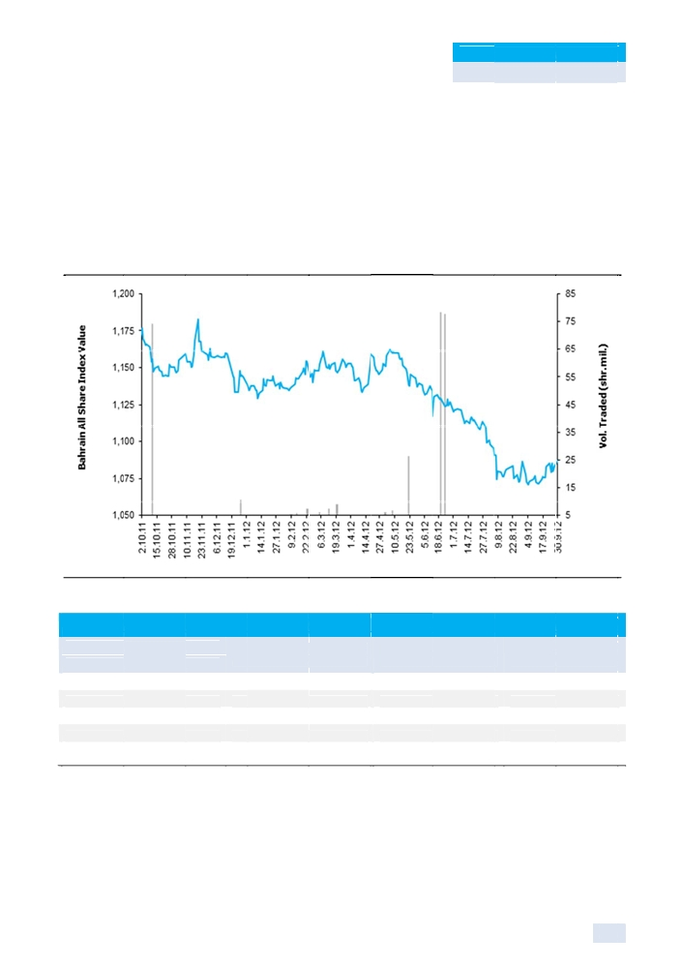

KAMCO Research
GCC Equity Markets Review

In economic news, Bahrain’s economic output fell in the Q2-12 after moderate growth in the
previous three months, as political unrest continued to weigh on the kingdom. Gross domestic
product, adjusted for inflation, dropped 1.3% quarter-on-quarter in April to June compared with
0.9% growth in the previous quarter, the figures Central Informatics Org showed. Output in the
hydrocarbon sector, which accounts for almost a third of Bahrain’s roughly USD 28 bn economy,
fell 7.7% during April to June after a 13.9% slide in the previous Q1-12. The construction sector
shrank 0.7% in Q2-12 after a 10..2% jump in Q1-12. However, continued polittical unrest in Bahrain,

with almos t daily clas hes betwee n young ac tivists and riot police, still appear
the econom y.

Bahrain All Share Inde x 52 week P erformance Relative to Volume

Source: KAM CO Research

Most Activ e Stocks fo r the Month
s to be taki ng a toll on

Volume Value Close

(000 shares) (000 BHD)) (BHD)

Ithmar Bank 23,893 1,530 0.170

Ahli United Bank (USD) 4,829 978 0.545

Al Salam Bank 4,088 164 0.040

Esterad Investment Co. 1,908 299 0.165

Bahrain Commercial Facilities 1,351 593 0.442

Source: KAMCO Research

25

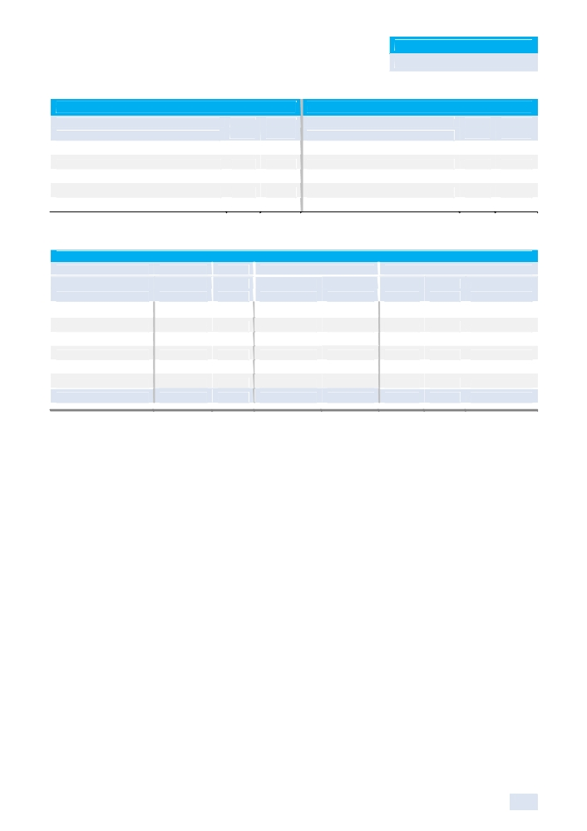

KAMCO Research
GCC Equity Markets Review

Best Return Performers Worst Return Performers
Close M-T-M Close M-T-M
(BHD) % Chg (BHD) % Chg
Bah. Ship. Repairing and Engineering Co. 2.200 10.00% Bahrain and Kuwait Insurance Co. 0.550 (9.84%)
Al Khaleej Commercial Bank 0.035 9.38% National Hotels Co. 0.410 (8.07%)
BANADER Co. For Hotels 0.059 7.27% Al Baraka Banking Group (USD) 0.840 (6.67%)
Esterad Investment Co. 0.165 5.77% National Bank of Bahrain 0.520 (2.80%)
Bahrain Commercial Facilities Co. 0.442 5.24% Bahrain Islamic Bank 0.088 (2.22%)
Source: KAMCO Research

Sectors Performance
Monthly Trading Indicators Valuation Multiples
Market Cap M-T-M Volume Value P/E P/B Dividend Yield
Sector (Mln BHD) % Chg (000 shares) (000 BHD) (X) (X) (%)
Commercial Banks 2,044 (0.55%) 9,928 1,415 12.38 1.07 5.06%
Investment 1,886 (0.05%) 27,207 2,440 9.38 0.62 2.00%
Insurance 152 (2.46%) 194 84 NM 0.86 2.56%
Services 941 0.15% 2,290 954 19.52 1.11 8.15%
Hotel & Tourism 180 (1.70%) 652 87 37.61 1.03 3.80%
Industrial 755 4.31% 280 139 5.23 0.90 12.74%
Total Bahraini Bourse 5,958 0.23% 40,552 5,120 10.88 0.85 5.45%
Source: KAMCO Research

26
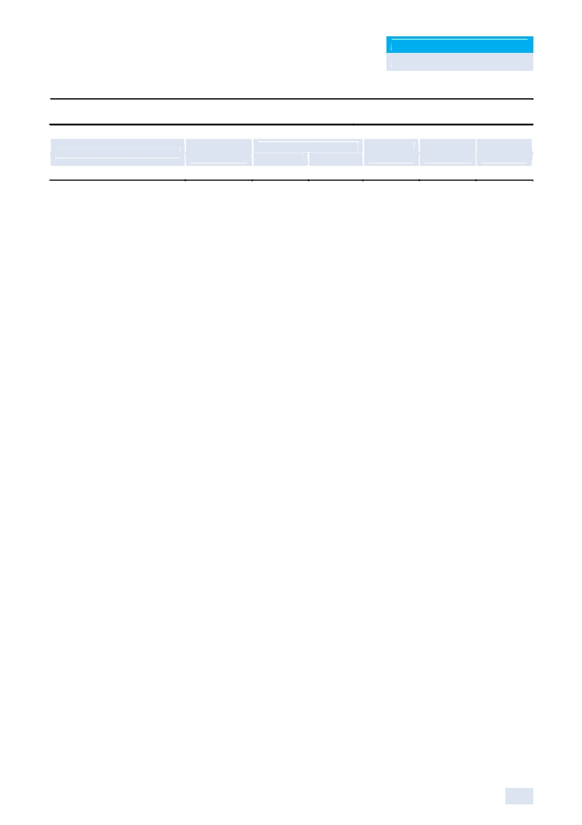

KAMCO Research
GCC Equity Markets Review

Muscat Securities Market

Benchmark Return

MSM 30 Index
Market Review

Closing Sep-12
Value Point
5,534.38 54.36

60 Day 90 Day YTD-12
(%) (%) (%) (%)
0.99% 1.97% (1.56%) (2.82%)

Extending last month’s gains, the MSM 30 Index increased 0.99% to close the month of
September at 5,534.38 points and narrowed its YTD-12 losses to 2.82% despite finding difficulty
amid scarce local market catalysts to help support the index higher. Corresponding to the gain
witnessed, trading indicators increased with volume rising 43% during the month to 419 mn shares
compared to 293 mn in Aug-12, while value traded was up 73% to OMR 107 mn versus OMR 62
mn in the previous month. Market heavyweight banking & investment sector was the sole loser
during the month as it shed 1.05% of its market cap to reach OMR 3.12 bn; while the industrial
sector rose 4% to OMR 1.23 bn and the services & insurance sector gained 2.26% to OMR 2.5 bn
from OMR 2.3 bn.
As the month began, the MSM 30 traded sideways with investors waiting for cues amid the lack of
local market catalysts. Investors saw weak regional and global economic data as raising the
prospect for more stimuli from central banks to underpin growth, while Europe kept hopes alive for
some progress in tackling its debt crisis. As a result, markets remained subdued as investors
continue to hold off on major moves. The MSM 30 index witnessed slight downfalls on the back of
investors booking their profits as they implemented a wait-and-see approach ahead of the release
of Q3-12 earnings. The Omani Bourse was pressured further to the downside during the month
after the MSM 30 Index broke the critical 5,600 mark on Sept. 10 spurring retail and foreign
investors to book profits.
Nevertheless, as global markets began to rally, gains supported sentiment in the Gulf region pushing the MSM 30 index higher to reach an 11-week high on Sept. 16 at 5,620.7 points. However, the gain witnessed wasn’t sustainable after investors booked recent gains, with many preferring to sit on cash until Q3-12 earnings season start next month. Increased interest from foreign and regional investors into Oman was evident with money flowing into blue-chips including Bank Muscat, Omantel and Renaissance Services; yet preference for liquidity dominated trading ahead of earnings season. Moreover, the unwinding of margin positions by investors as they sell to cover margin positions near the month's end dragged Oman’s bourse to a three week low on Sept. 27, taking the MSM 30 index to 5,529 points.
On the corporate front, Fitch Ratings has affirmed Bank Muscat's Long-term Issuer Default Rating
(IDR) at 'A-', Viability Rating (VR) at 'bbb', Short-term IDR at 'F2', Support Rating at '1' and Support
Rating Floor at 'A-'. The Outlook on the Long-term IDR is Stable. Bank Muscat’s IDRs, Support
Rating and Support Rating Floor reflect the extremely high probability of support from the Omani
authorities in case of need, given the government's strong supportive stance towards the domestic
system, the government's substantial stake in Bank Muscat and the bank's systemic importance as
the by far largest bank in Oman. Being driven by support, the bank's IDRs are sensitive to changes
in Fitch's perception of the willingness or ability of the state of Oman to support Bank Muscat. In
other news, Al Izz Islamic Bank, the second sharia-compliant lender being formed in Oman, has
launched an initial public share offer (IPO) for 40% of the bank, Oman's regulator said earlier
during the month. Al Izz is the second Islamic bank to seek a stock market listing in Oman since
the sultanate reversed its position last year as the only country in the Gulf Arab region not to permit
sharia-compliant banking. The bank, which counts Abu Dhabi state-fund Aabar Investments as a

27

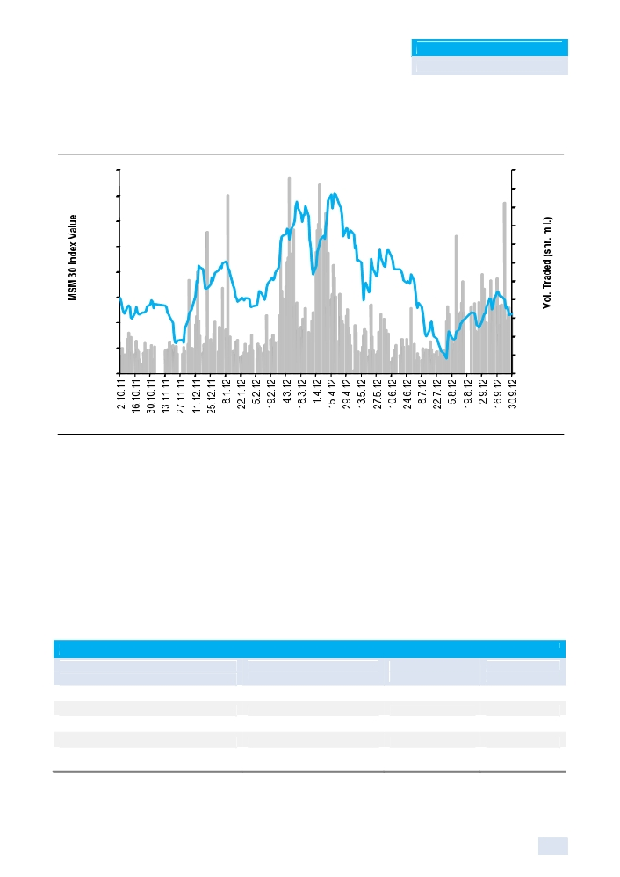

KAMCO Research
GCC Equity Markets Review

founding shareholder, aims to raise OMR 40 mn (USD 104 mn) through the offer which opened on Sept. 22 and will run for one month, the Omani Capital Markets Authority said.

MSM 30 Index 52 Week Performance Relative to Volume
6,100 55

6,000 50
45
5,900 40

5,800 35
30
5,700
25
5,600 20

5,500 15
10
5,400 5

5,300 0

Source: KAMCO Research
Meanwhile on the economic front, the much-awaited regulation for Islamic banks and window
operations of conventional banks will be announced through a Royal Decree at any time. The
Royal Decree is for amending certain clauses to incorporate Islamic banking business. Bank Nizwa
- the first Islamic bank in the country - and several other conventional banks are ready for starting
Islamic banking business. According to the draft Islamic banking framework of the Shariah board,
three should be experienced Islamic scholars and two should be from relevant field, either a
professional in Islamic law or Islamic accounting. CBO’s draft regulation also stipulated on
separate branches for Islamic banking as a window of operation for conventional banks. The draft
regulation also insisted on a 12% capital adequacy ratio, with a minimum paid up capital of OMR
10 million for starting window operations. Another major suggestion for window operation is that
funds can be pumped into Islamic line of business by a conventional parent bank, but Islamic
banking operation cannot transfer money for use in conventional banking.

Most Active Stocks for the Month
Volume Value Close
(000 shares) (000 OMR) (OMR)
Gulf Investment Services 38,047 3,393 0.086
Al Hassan Engineering 33,573 5,881 0.172
Oman Investment and Finance 24,920 4,791 0.184
Galfar Engineering 22,343 9,204 0.413
Global Finance Investment Co. 22,197 2,026 0.087
Source: KAMCO Research

28
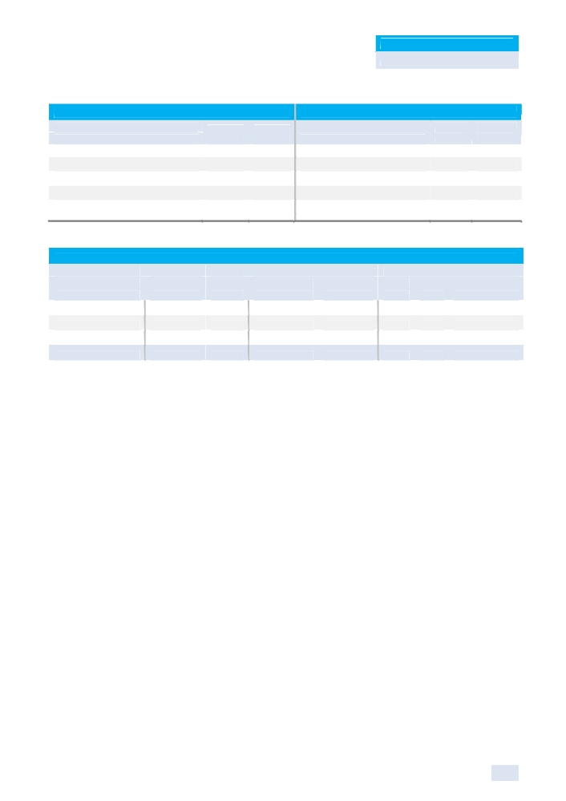

KAMCO Research
GCC Equity Markets Review

Best Return Performers Worst Return Performers
Close M-T-M Close M-T-M
(OMR) % Chg (OMR) % Chg
Al Hassan Engineering 0.172 13.16% Al Anwar Holding 0.122 (10.29%)
Sohar Power 1.547 12.35% Shell Oman Marketing 2.351 (7.59%)
Oman Investment and Finance 0.184 12.20% Dhofar Intl. Dev.& Invest. 0.350 (6.67%)
Galfar Engineering 0.413 11.92% OMINVEST 0.349 (6.43%)
Dhofar Cattlefeed 0.162 11.72% Bank Dhofar 0.374 (6.27%)
Source: KAMCO Research

Sectors Performance
Monthly Trading Indicators Valuation Multiples
Market Cap M-T-M Volume Value P/E P/B Dividend
Sector (Mln OMR) % Chg (000 shares) (000 OMR) (X) (X) Yield (%)
Banking & Investment 3,120 (1.05%) 224,117 45,075 10.17 1.23 3.16%
Industrial 1,234 4.00% 134,903 35,249 13.57 1.77 3.72%
Services & Insurance 2,450 2.26% 59,625 26,266 11.05 2.05 6.04%
Total Market 6,805 1.02% 418,644 106,591 10.98 1.54 4.30%
Source: KAMCO Research

29
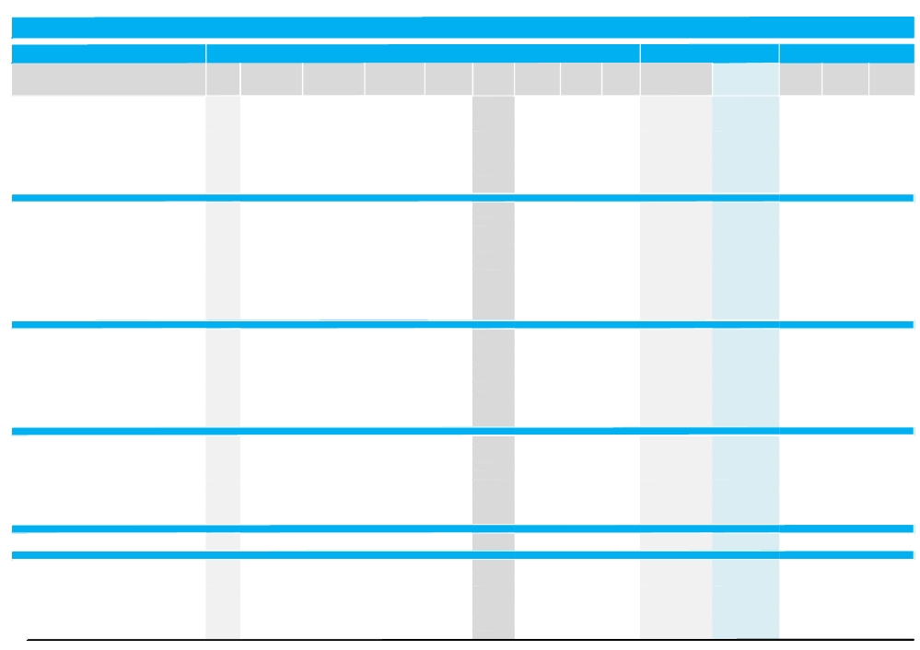

Saudi Stock Exchange Trading & Valuation Data Summary

Monthly Trading Indicators

Reuters Traded Volume Traded Value Avg. Traded

Market Cap.

Closing Price MTM Price
September-12

Month-End Valuation Indicators

Trailing P/E Trailing P/B Dividend

Company Name

▼ Riyad Bank
▼ Bank Al-Jazira
▼ The Saudi Investment Bank
▼ Saudi Hollandi Bank
▼ Banque Saudi Fransi
▼ The Saudi British Bank
▼ Arab National Bank
▼ Samba Financial Group
▼ Al-Rajhi Banking & Investment Group
▼ Al-Bilad Bank
▼ Al-Inma Bank
▼ Banks & Financial Sector
▼ Methanol Chemicals Co.
▼ National Petrochemical Co.
▼ Saudi Basic Industries Corp
▼ Saudi Arabia Fertilizers Co.
▼ National Industrialization Co.
▲ Alujain Corporation
▼ Arabian Industrial Development Co.
▼ Saudi Industrial Investment Group
▼ Sahara Petrochemical Co.
▼ Yanbu National Petrochemicals Co.
▼ Saudi International Petrochemical Co.
▼ Advanced Polypropylene Co.
▼ Saudi Kayan
▼ Rabigh Refining and Petrochemical Co.
▼ Petrochemical Industries Sector
▼ Hail Cement Co.
▼ Najran Cement Co.
▼ Arabian Cement Co.
▼ Yamamah Saudi Cement Co.
▼ Saudi Cement Co.
▼ The Qassim Cement Co.
▼ Southern Province Cement Co.
▼ Yanbu Cement Co.
▼ Eastern Province Cement Co.
▼ Tabuk Cement Co.
▼ Al Jouf Cement Co.
▼ Cement Sector
▼ Abdullah Al Othaim Markets Co.
▼ Mouwasat Medical Services Co.
▲ United Electronics Co.
▼ Saudi Automotive Services Co.
▼ National Agriculture Marketing Co.
▲ Fitaihi Holding Group
▼ Jarir Marketing Co.
▼ Aldrees Petroleum & Transport Co.
▼ Fawaz Abdulaziz Al-Hokair Co.
▼ Al Khaleej Training & Development Co.
▼ Retail Sector
▼ National Gas & Industrialization Co.
▼ Saudi Electricity Co.
▼ Energy & Utilities Sector
▲ Savola Group
▼ Food Products Co.
▼ Saudi Dairy & Foodstuff Co.
▼ AL-Marai Co.
▲ Anaam International Holding Grp. (suspended) ▼ Halwani Brothers Co.
▲ Herfy Food Services Co
▲ Saudi Airlines Catering Co.
▼ National Agriculture Development Co.
Ticker ('000 Shares) ('000 SAR)

1010.SE 7,162 165,491
1020.SE 7,124 193,667
1030.SE 2,630 43,023
1040.SE 1,279 34,273
1050.SE 4,740 150,367
1060.SE 2,424 76,814
1080.SE 2,189 60,575
1090.SE 3,192 148,223
1120.SE 20,828 1,523,178
1140.SE 7,886 232,434
1150.SE 350,097 4,780,533
4 09,550 7,408,578
2001.SE 35,038 539,388
2002.SE 12,366 275,406
2010.SE 123,152 11,268,681
2020.SE 2,516 469,956
2060.SE 13,681 444,189
2170.SE 26,793 473,142
2210.SE 114,102 1,867,563
2250.SE 8,292 194,233
2260.SE 36,120 502,763
2290.SE 11,212 516,406
2310.SE 10,186 200,850
2330.SE 6,072 163,518
2350.SE 47,141 648,534
2380.SE 14,154 276,660
4 60,826 1 7,841,290
3001.SE 11,518 233,473
3002.SE 37,733 813,089
3010.SE 2,930 154,191
3020.SE 4,445 203,074
3030.SE 1,183 105,053
3040.SE 1,115 85,777
3050.SE 375 37,852
3060.SE 1,543 114,974
3080.SE 1,195 62,920
3090.SE 1,214 30,036
3091.SE 15,189 272,294
78,439 2,112,733
4001.SE 729 66,401
4002.SE 1,403 72,400
4003.SE 432 39,693
4050.SE 24,706 482,255
4160.SE 20,084 628,532
4180.SE 38,552 666,629
4190.SE 512 79,384
4200.SE 6,287 234,525
4240.SE 1,250 118,082
4290.SE 3,674 146,022
97,628 2,533,923
2080.SE 2,393 51,200
5110.SE 44,969 589,279
47,362 640,480
2050.SE 5,147 197,746
2100.SE 20,390 565,977
2270.SE 1,325 83,367
2280.SE 7,823 539,030
4061.SE 32,251 2,717,419
6001.SE 5,677 254,038
6002.SE 413 42,073
6004.SE 5,319 394,034
6010.SE 3,215 101,543
Number of Deals
Price (SAR)* (SAR)
1,811 23.11 22.70
4,287 27.19 26.10
1,194 16.36 16.00
936 26.80 26.30
2,215 31.72 31.10
1,750 31.69 30.40
1,235 27.67 26.60
2,377 46.44 44.30
15,273 73.13 71.25
6,594 29.48 28.20
61,214 13.65 12.95
98,886
15,054 15.39 14.05
4,888 22.27 21.95
112,816 91.50 91.00
5,056 186.81 186.50
6,022 32.47 30.50
12,802 17.66 17.05
43,315 16.37 14.55
2,816 23.43 22.95
10,475 13.92 13.20
7,304 46.06 44.70
5,674 19.72 19.10
4,019 26.93 26.00
16,452 13.76 13.10
9,946 19.55 18.50
256,639
8,612 20.27 18.90
27,857 21.55 20.85
2,136 52.63 51.75
3,467 45.68 44.10
1,604 88.81 88.00
1,652 76.95 76.00
733 101.01 98.75
1,429 74.50 74.50
1,126 52.67 52.00
1,044 24.75 24.00
7,834 17.93 17.10
57,494
2,228 91.14 88.50
1,775 51.60 51.00
1,179 91.97 93.75
13,628 19.52 18.55
18,805 31.30 27.40
17,010 17.29 16.15
1,317 155.00 153.75
5,225 37.30 36.60
3,525 94.48 90.75
5,158 39.74 36.40
69,850
2,206 21.40 21.10
6,346 13.10 13.10
8,552
3,109 38.42 38.70
16,611 27.76 25.10
2,305 62.93 58.50
10,608 68.90 70.00
41,029 84.26 83.25
8,831 44.75 40.60
1,378 101.93 101.00
12,079 74.08 73.00
2,951 31.59 31.60
High (SAR) Low (SAR)
Change (%)
(2.37%) 23.35 22.70
(8.10%) 28.70 21.35
(4.19%) 16.80 15.50
(4.71%) 27.70 26.00
(5.47%) 32.80 32.00
(7.03%) 32.80 32.00
(6.67%) 28.80 25.80
(7.90%) 48.40 44.00
(3.39%) 74.50 71.00
(8.44%) 31.10 26.00
(5.82%) 14.05 12.10
(5.12%)
(10.22%) 16.25 13.10
(4.15%) 23.20 18.00
(1.09%) 95.25 84.75
(0.27%) 191.00 169.25
(9.23%) 34.00 30.00
1.79% 18.85 13.75
(14.66%) 17.35 12.65
(1.71%) 24.30 19.60
(7.37%) 14.35 12.50
(4.08%) 47.70 41.80
(2.80%) 20.20 17.55
(7.14%) 28.00 22.25
(9.34%) 14.55 12.20
(7.04%) 20.20 17.00
(2.56%)
(10.85%) 21.25 16.50
(6.71%) 22.45 20.45
(5.48%) 55.50 52.00
(6.77%) 47.60 44.10
(1.68%) 90.25 86.00
(1.30%) 78.00 77.75
(6.84%) 107.50 98.00
(3.25%) 77.75 77.00
(1.89%) 53.50 51.25
(2.64%) 25.00 23.25
(5.26%) 18.35 16.40
(4.46%)
(4.32%) 94.00 81.25
(2.39%) 53.00 44.70
1.90% 94.00 82.50
(1.59%) 21.25 15.50
(11.33%) 33.00 21.60
0.62% 18.70 12.75
(2.38%) 157.25 147.00
(1.61%) 39.70 33.00
(0.55%) 98.25 79.00
(3.45%) 41.80 32.50
(1.73%)
(4.74%) 22.30 20.50
(0.38%) 13.20 12.80
(0.51%)
1.84% 39.70 32.50
(12.24%) 29.50 20.35
(6.02%) 68.75 54.50
(2.78%) 72.00 60.00
13.27% 96.00 54.75
(6.67%) 47.00 35.20
1.25% 110.00 86.00
1.74% 77.00 59.25
(1.25%) 32.80 27.20
('000 SAR) ('000 USD)

34,050,000 9,079,501
7,830,000 2,087,885
8,800,000 2,346,538
10,438,470 2,783,439
28,114,956 7,496,909
30,400,000 8,106,221
22,610,000 6,029,002
39,870,000 10,631,415
106,875,000 28,498,433
8,460,000 2,255,876
19,425,000 5,179,715
3 16,873,426 84,494,933
1,694,430 451,823
10,536,000 2,809,445
273,000,000 72,795,996
46,625,000 12,432,650
20,401,882 5,440,203
1,179,860 314,612
1,869,966 498,630
10,327,500 2,753,849
5,792,094 1,544,473
25,143,750 6,704,631
7,003,333 1,867,453
4,263,870 1,136,969
19,650,000 5,239,712
16,206,000 4,321,362
4 43,693,685 1 18,311,809
1,850,310 493,389
3,544,500 945,148
4,140,000 1,103,939
8,930,250 2,381,269
13,464,000 3,590,203
6,840,000 1,823,900
13,825,000 3,686,464
7,822,500 2,085,885
4,472,000 1,192,468
2,160,000 575,968
2,223,000 592,767
69,271,560 18,471,400
1,991,250 530,971
2,550,000 679,963
2,250,000 599,967
834,750 222,588
274,000 73,063
888,250 236,854
9,225,000 2,459,865
1,098,000 292,784
6,352,500 1,693,907
910,000 242,653
26,373,750 7,032,613
1,582,500 421,977
54,582,368 14,554,498
56,164,868 14,976,474
19,350,000 5,159,716
502,000 133,859
1,901,250 506,972
28,000,000 7,466,256
907,425 241,967
1,160,000 309,316
3,030,000 807,956
5,986,000 1,596,179
1,896,000 505,572
(X) (X) Yield

10.05 1.10 5.73%
17.46 1.63 2.04%
12.12 1.01 3.13%
9.05 1.36 3.61%
9.48 1.32 1.93%
9.95 1.65 1.85%
10.00 1.32 3.76%
9.10 1.37 3.72%
13.46 3.08 4.56%
9.87 2.07 0.00%
33.19 1.20 0.00%
11.41 1.64 3.50%
16.77 1.10 0.00%
NM 2.20 0.00%
10.50 1.93 5.49%
11.49 5.81 6.97%
8.60 1.81 4.10%
25.74 2.01 0.00%
NM 1.37 0.00%
22.96 1.77 4.36%
40.16 1.09 0.00%
8.78 2.12 0.00%
9.90 1.28 6.54%
12.65 2.33 5.70%
NM 1.33 0.00%
NM 2.00 0.00%
12.31 1.99 4.56%
NM 2.00 0.00%
9.57 1.96 5.84%
5.01 1.27 5.80%
8.73 3.34 4.04%
23.69 6.91 7.39%
7.00 2.53 7.57%
21.64 4.70 6.33%
20.17 3.78 3.36%
28.18 3.84 6.73%
25.72 1.61 5.83%
0.00 0.00 0.00%
13.34 2.94 5.61%
13.92 3.31 0.00%
15.74 3.71 2.94%
16.10 5.83 2.67%
14.61 1.52 2.70%
25.45 7.77 0.00%
NM 1.42 0.00%
16.81 9.71 6.31%
11.58 2.54 4.55%
15.94 4.17 2.20%
15.88 2.77 1.10%
16.77 4.31 3.56%
10.87 1.49 4.74%
22.40 1.04 5.34%
21.75 1.05 5.33%
13.26 2.43 3.36%
65.79 2.40 0.00%
12.16 2.66 5.13%
20.94 4.08 1.85%
NM 6.63 0.00%
15.19 2.24 4.93%
18.40 6.28 2.97%
12.49 5.49 0.00%
18.97 1.78 2.37%

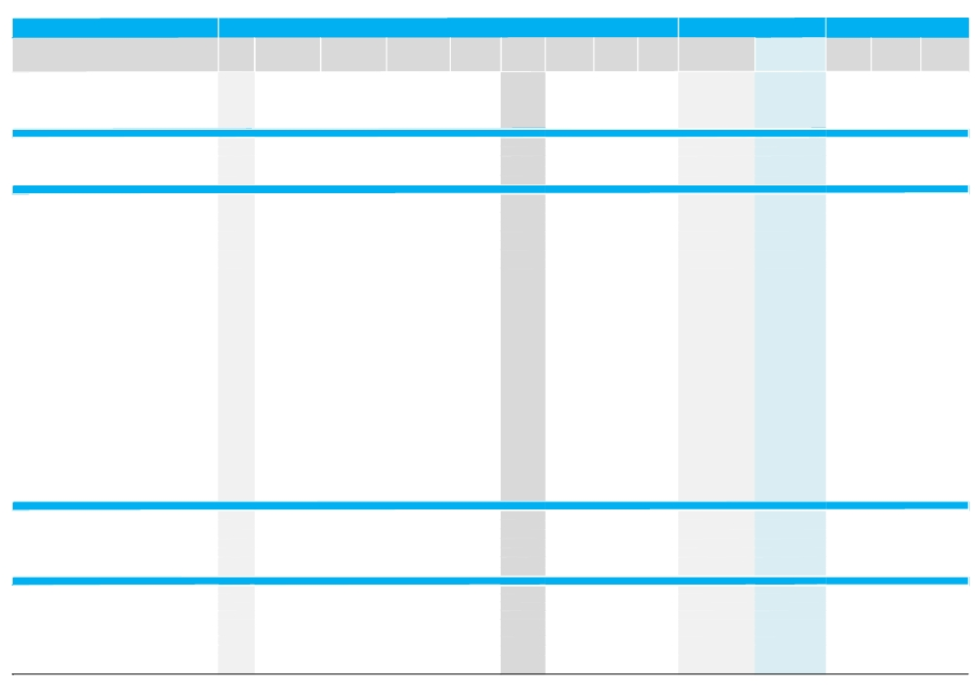

Reuters

Traded Volume Traded Value

Monthly Trading Indicators

Avg. Traded Closing Price

Market Cap.

MTM Price

Month-End Valuation Indicators

Trailing P/E Trailing P/B Dividend

Company Name

▼ Qassim Agriculture Co.
▲ Tabouk Agriculture Development Co.
▼ Saudi Fisheries Co.
▼ Ash-Sharqiyah Development Co.
▲ Al-Jouf Agriculture Development Co.
▼ Gizan Agriculture Development Co.
▼ Agriculture & Food Industries Sector
▼ Saudi Telecom
▼ Al-Etihad Telecom Co.
▼ ZAIN KSA
▼ Etihad Atheeb Telecommunication Co.
▼ Saudi Integrated Telecom Company
▼ Telecommunication & I.T. Sector
▼ The Co for Cooperative Insurance
▼ Malath Cooperative Insurance & Reinsurance Co. ▼ Mediterranean & Gulf Insurance & Reinsurance Co ▼ Saudi Fransi Cooperative Insurance Co.
▲ Saudi Iaic Insurance Co-operative Co.
▲ Saudi United Cooperative Insurance Co.
▼ Arabian Shield Cooperative Insurance Co.
▲ SABB Takaful
▼ Sanad Insurance & Reinsurance
▲ Saudi Arabian Cooperative Insurance Co.
▼ Saudi Indian Co. for Co- operative Insurance
▼ Gulf Union Cooperative Insurance Co.
▼ Al-Ahli Takaful Co.
▲ Al Ahlia Insurance Co.
▼ Allied Cooperative Insurance Group
▼ Arabia Insurance Cooperative Co.
▼ Trade Union Insurance Co.
▼ Al Sagr Co. for Cooperative Insurance
▼ United Cooperative Assurance Co.
▼ Saudi Re for Cooperative Reinsurance Co. (Saudi Re) ▼ BUPA Arabia for Cooperative Insurance
▲ Weqaya Takaful Insurance & Reinsurance Co.
▼ Al-Rajhi Company for Cooperative Insurance
▲ ACE Arabia Cooperative Insurance Co.
▲ AXA Cooperative Insurance Co.
▲ Gulf General Cooperative Insurance Company
▼ Buruj Cooperative Insurance Company
▼ Al Alamiya for Cooperative Insurance Company ▼ Solidarity Saudi Takaful co.
▼ Wataniya Insurance Company
▲ Amana Cooperative Insurance
▼ Saudi Enaya Cooperative Insurance Company
▼ Alinma Tokio Marine Co.
▲ Insurance Sector
▲ Saudi Arabia Refineries Co.
▼ Saudi Advanced Industries Co.
▼ Al-Ahsa Development Co.
▼ Saudi Industrial Services Co.
▼ Assir Trading, Tourism & Manufacturing Co.
▼ Al-Baha Investment & Development Co.
▲ Kingdom Holding Co.
▲ Multi-Investment Sector
▼ Takween Advanced Industries
▼ Basic Chemical Industries Co.
▼ Saudi Arabian Mining Co.
▼ Astra Industrial Group
▲ Al Sorayai Trading and Industrial Group Company ▼ Al Hassan Ghazi Ibrahim Shaker
▲ Saudi Pharmaceutical Indus Corp
▼ The National Co. for Glass Industries
▼ Filling & Packing Materials Manufacturing Co.
▼ National Metal Manufacturing & Casting Co.
Ticker ('000 Shares) ('000 SAR)

6020.SE 82,654 1,605,555
6040.SE 19,597 656,859
6050.SE 33,906 1,185,352
6060.SE 13,043 748,285
6070.SE 2,522 105,347
6090.SE 44,759 807,606
2 78,040 1 0,004,232
7010.SE 16,511 662,852
7020.SE 11,657 804,684
7030.SE 278,976 3,333,115
7040.SE 114,402 1,792,991
7050.SE 157,774 4,604,754
5 79,320 1 1,198,397
8010.SE 4,446 190,113
8020.SE 33,716 851,708
8030.SE 9,157 237,751
8040.SE 27,791 2,683,620
8050.SE 22,579 1,161,888
8060.SE 60,994 2,044,789
8070.SE 38,770 1,488,693
8080.SE 42,333 1,690,375
8090.SE 34,452 966,554
8100.SE 27,939 1,957,792
8110.SE 26,972 1,323,039
8120.SE 29,204 772,728
8130.SE 12,838 873,020
8140.SE 37,379 2,171,353
8150.SE 23,174 1,034,828
8160.SE 37,771 1,379,409
8170.SE 11,529 335,338
8180.SE 27,136 909,727
8190.SE 14,573 559,718
8200.SE 96,844 1,286,372
8210.SE 25,103 676,950
8220.SE 32,020 1,376,666
8230.SE 11,964 722,394
8240.SE 3,598 576,061
8250.SE 45,879 2,283,172
8260.SE 54,335 3,657,309
8270.SE 19,754 1,263,605
8280.SE 21,370 1,395,609
8290.SE 64,568 1,909,999
8300.SE 8,651 942,625
8310.SE 8,982 1,831,386
8311.SE 55,573 3,159,963
8312.SE 16,460 1,536,018
9 87,854 4 5,250,575
2030.SE 30,153 2,209,915
2120.SE 35,342 710,147
2140.SE 73,485 1,179,640
2190.SE 39,572 624,316
4080.SE 14,646 252,392
4130.SE 33,103 755,360
4280.SE 76,547 1,125,410
3 02,847 6,857,180
1201.SE 6,251 305,533
1210.SE 11,187 342,734
1211.SE 13,568 446,004
1212.SE 1,412 58,725
1213.SE 18,876 568,517
1214.SE 1,746 124,006
2070.SE 1,012 45,148
2150.SE 5,044 151,821
2180.SE 18,062 803,621
2220.SE 15,315 446,480
Number of Deals
Price (SAR)* (SAR)
42,904 19.43 15.90
17,713 33.52 31.20
30,340 34.96 30.10
16,695 57.37 51.25
2,865 41.77 43.10
20,718 18.04 16.00
2 30,136
6,223 40.15 39.70
7,041 69.03 67.75
58,128 11.95 10.25
45,189 15.67 13.45
103,653 NA 24.95
2 20,234
6,233 42.76 40.90
24,124 25.26 23.00
6,708 25.96 24.30
66,850 96.57 72.25
30,785 51.46 48.70
52,593 33.52 31.20
38,576 38.40 37.40
40,752 39.93 37.50
27,898 28.06 25.40
49,047 70.07 77.00
33,876 49.05 44.90
18,389 26.46 24.35
22,674 68.00 62.25
49,658 58.09 58.75
37,356 NA 37.60
36,831 36.52 35.90
9,650 29.09 27.50
23,905 33.52 30.80
17,815 38.41 35.00
27,975 13.28 11.80
19,356 26.97 25.70
36,531 42.99 41.60
16,506 60.38 56.00
20,630 160.09 157.25
61,970 49.76 49.40
79,033 67.31 77.25
28,829 63.97 57.00
35,940 65.31 61.50
44,452 29.58 26.00
26,959 108.96 95.25
68,274 203.90 254.00
72,173 56.86 47.50
42,821 93.32 83.50
1,175,169
41,914 73.29 68.25
18,667 20.09 18.50
27,845 16.05 15.05
16,437 15.78 15.05
6,330 17.23 16.55
30,121 22.82 18.70
28,445 14.70 14.45
169,759
10,216 48.87 49.40
10,354 30.64 28.10
8,820 32.87 31.30
3,338 41.58 39.50
15,996 30.12 31.90
2,550 71.02 69.50
1,231 44.61 44.20
4,600 30.10 28.30
19,657 44.49 40.60
11,346 29.15 27.10
High (SAR) Low (SAR)
Change (%)
(22.82%) 22.00 16.95
0.97% 35.90 24.60
(11.21%) 37.20 25.20
(7.66%) 60.25 42.30
9.67% 43.50 35.50
(8.57%) 19.35 14.15
(1.37%)
(2.46%) 40.90 35.80
(3.21%) 70.50 62.50
(18.33%) 12.80 7.65
(15.41%) 16.75 12.65
(17.93%) 33.50 17.60
(3.95%)
(6.83%) 44.70 41.90
(7.07%) 26.70 19.80
(6.54%) 26.60 24.55
(17.19%) 144.00 51.00
0.83% 55.75 34.00
2.97% 38.30 21.15
(9.00%) 41.10 28.20
4.17% 43.50 27.00
(4.87%) 30.00 20.90
27.27% 78.25 36.20
(0.88%) 52.75 36.30
(5.98%) 27.50 20.40
(3.49%) 73.25 55.25
19.17% 64.25 33.50
(32.56%) 57.50 24.00
(8.42%) 39.10 23.90
(4.84%) 29.90 23.20
(5.81%) 35.30 25.50
(8.62%) 41.30 31.40
(8.17%) 13.85 11.40
(1.15%) 29.00 21.95
2.46% 46.30 30.10
(4.27%) 63.75 47.40
2.78% 188.50 85.00
20.49% 57.00 31.60
53.73% 77.25 33.80
(7.69%) 69.50 45.10
(0.81%) 70.25 41.30
(10.03%) 31.50 20.35
(12.01%) 118.00 77.00
45.14% 292.00 32.80
(14.80%) 62.75 40.20
(13.25%) 99.00 66.75
4.01%
3.41% 79.25 50.00
(6.09%) 21.30 15.60
(2.59%) 17.15 12.25
(2.90%) 16.55 12.80
(4.34%) 17.70 15.15
(26.09%) 26.20 16.25
7.84% 16.80 11.50
6.49%
(4.08%) 52.25 39.40
(6.02%) 33.00 27.20
(7.40%) 34.10 29.00
(3.19%) 43.70 38.30
25.59% 34.00 21.40
(1.77%) 74.50 68.50
0.45% 46.00 40.00
(4.07%) 31.90 26.10
(7.31%) 46.80 35.30
(5.57%) 30.80 23.15
('000 SAR) ('000 USD)

795,000 211,988
624,000 166,391
1,611,479 429,704
384,375 102,494
1,077,500 287,318
800,000 213,322
68,373,779 1 8,232,005
79,400,000 21,172,169
47,425,000 12,645,971
4,920,997 1,312,194
2,118,375 564,869
2,495,000 665,297
136,359,372 3 6,360,499
3,067,500 817,955
690,000 183,990
1,944,000 518,371
1,445,000 385,312
487,000 129,860
624,000 166,391
748,000 199,456
1,275,000 339,981
508,000 135,459
770,000 205,322
449,000 119,727
535,700 142,845
1,037,500 276,651
587,500 156,658
752,000 200,522
718,000 191,456
687,500 183,323
616,000 164,258
700,000 186,656
1,180,000 314,649
1,028,000 274,118
832,000 221,854
1,120,000 298,650
1,572,500 419,310
988,000 263,452
1,545,000 411,977
741,000 197,589
1,230,000 327,982
1,443,000 384,779
952,500 253,986
8,128,000 2,167,347
1,900,000 506,639
1,670,000 445,309
4 1,971,700 1 1,191,838
1,023,750 272,985
799,200 213,108
737,450 196,643
1,023,400 272,892
2,091,736 557,766
280,500 74,796
53,549,999 14,279,214
5 9,506,035 1 5,867,403
1,482,000 395,178
772,750 206,055
28,952,500 7,720,242
2,927,647 780,663
957,000 255,186
2,432,500 648,631
3,466,938 924,466
849,000 226,388
466,900 124,500
761,838 203,146
(X) (X) Yield

NM 2.13 0.00%
24.52 1.66 1.60%
NM 4.21 0.00%
NM 5.45 0.00%
11.79 1.87 4.64%
NM 1.55 0.00%
18.05 3.21 2.22%
8.76 1.58 5.04%
8.55 2.51 4.80%
NM 1.40 0.00%
NM NM 0.00%
NM 2.66 0.00%
11.14 1.83 4.60%
8.79 1.66 8.56%
19.38 2.19 0.00%
8.98 1.86 8.23%
NM 8.92 0.00%
NM 6.48 0.00%
30.23 3.85 0.00%
NM 3.23 0.00%
NM 3.87 0.00%
NM 4.94 0.00%
52.63 10.97 0.00%
NM 10.52 0.00%
NM 3.69 0.00%
NM 7.75 0.00%
NM 17.23 0.00%
NM 58.07 0.00%
39.53 3.95 0.00%
NM 2.32 0.00%
16.70 2.28 0.00%
14.44 2.21 2.86%
NM 1.27 0.00%
10.07 2.01 0.00%
NM 6.92 0.00%
NM 10.76 0.00%
NM 10.47 0.00%
NM 5.62 0.00%
NM 11.32 0.00%
NM 8.90 0.00%
NM 8.95 0.00%
NM 3.12 0.00%
NM 11.10 0.00%
NM 33.34 0.00%
NM 4.75 0.00%
NM 8.35 0.00%
NM 4.41 1.05%
57.87 2.68 0.73%
NM 1.01 0.00%
NM 1.54 0.00%
42.86 1.37 0.00%
21.65 0.90 4.53%
NM 3.27 0.00%
NM 2.07 0.87%
77.03 1.94 0.95%
19.63 0.05 2.73%
12.92 2.02 3.56%
42.49 66.99 0.00%
12.37 0.17 4.43%
30.79 0.54 0.00%
12.41 5.11 5.04%
13.85 5.74 4.52%
14.15 0.27 7.95%
23.27 0.85 2.46%
NM 5.03 0.00%

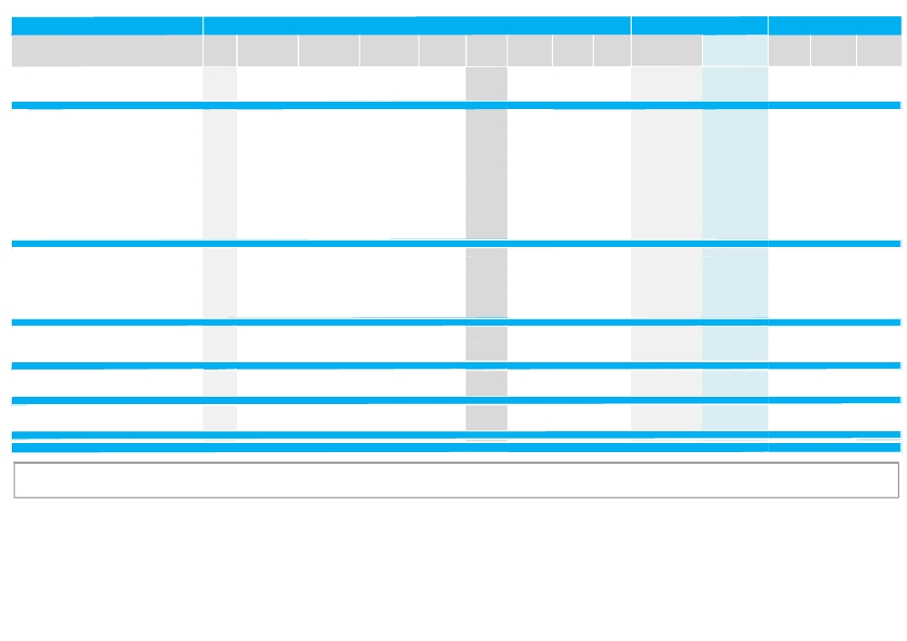

Company Name

▼ Saudi Chemical Co.
▼ Saudi Paper Manufacturing Co.
▲ Al-Abdulatif Industrial Group
▲ Saudi Industrial Export Co.
▼ Industrial Investment Sector

Monthly Trading Indicators

Reuters Traded Volume Traded Value Avg. Traded
Ticker ('000 Shares) ('000 SAR) Number of Deals Price (SAR)*

2230.SE 5,292 211,920 3,675 40.04
2300.SE 1,308 43,465 2,005 33.24
2340.SE 13,174 398,543 8,388 30.25
4140.SE 13,918 809,607 17,266 58.17
126,164 4,756,125 119,442

Closing Price MTM Price
High (SAR)
(SAR) Change (%)
39.00 (2.50%) 41.20
31.30 (7.40%) 34.20
29.10 0.69% 33.20
60.50 9.01% 61.75
(4.89%)

Market Cap.

Low (SAR) ('000 SAR) ('000 USD)

37.00 2,466,360 657,660
29.70 1,173,750 312,983
25.00 2,364,375 630,465
54.00 653,400 174,230
49,726,957 13,259,793

Month-End Valuation Indicators

Trailing P/E Trailing P/B Dividend
(X) (X) Yield

8.80 6.90 5.13%
11.38 0.81 4.47%
11.59 3.64 5.15%
NM 0.54 0.83%
23.33 1.76 1.65%

▼
═
United Wire Factories Company
1301.SE
Mohammad Al-Mojil Group 1310.SE
10,362 409,577 10,460
- - -
39.53 38.20 (4.02%) 41.60
NA 12.55 0.00% NA
37.10 1,241,500 331,048
NA 1,568,750 418,310
12.25 0.04 4.58%
NM 3.88 0.00%

▼ Saudi Steel Pipe Co. 1320.SE 7,710 196,015 6,615 25.42 24.00 (1.44%) 26.80 23.70 1,224,000 326,382 22.90 2.28 10.42%

▼ Abdullah A. M. Al-Khodari Sons Company 1330.SE 2,823 96,471 3,293 34.18 32.00 (8.05%) 36.10 31.90 1,700,000 453,308 10.46 2.18 1.25%

▼ Saudi Ceramic Co. 2040.SE 955 86,591 1,757 90.63 86.00 (9.23%) 94.25 85.25 3,225,000 859,953 14.57 4.45 2.71%

▼ National Gypsum Co. 2090.SE 4,649 138,696 5,052 29.83 27.70 (6.10%) 31.30 27.40 877,167 233,898 35.84 0.74 4.33%

▼ Saudi Cable Co. 2110.SE 30,897 518,596 13,367 16.78 15.90 (3.64%) 17.65 15.45 1,208,400 322,222 NM 2.58 0.00%

▼ Saudi Industrial Development Co. 2130.SE 52,506 1,007,772 26,249 19.19 17.00 (9.81%) 20.55 16.30 680,000 181,323 20.89 0.65 0.00%

▼ Saudi Arabian Amintit Co. 2160.SE 14,564 238,426 5,840 16.37 15.80 (2.17%) 16.80 15.40 1,824,900 486,613 14.20 5.00 7.91%

▲ Arabian Pipe Co. 2200.SE 22,297 588,258 13,689 26.38 25.40 12.64% 30.00 22.60 1,016,005 270,920 NM 0.67 0.00%

▼ Zamil Industrial Investment Co. 2240.SE 2,396 74,289 1,761 31.01 29.50 (3.28%) 32.20 29.20 1,770,000 471,974 22.45 2.42 5.08%

▲ Al-Babtain Power & Telecommunications Co. 2320.SE 9,849 274,544 7,405 27.88 26.30 0.77% 29.90 25.60 1,121,204 298,971 15.81 0.81 5.70%

▲ Saudi Vitrified Clay Pipes Co. 2360.SE 1,212 79,754 1,853 65.82 65.25 2.35% 69.00 61.50 978,750 260,986 12.17 1.70 4.60%

▲ Middle East Specialised Cables 2370.SE 41,690 913,567 22,599 21.91 22.40 5.91% 23.25 20.55 896,000 238,920 NM 3.81 0.00%

▼ Red Sea Housing 4230.SE 4,787 163,163 6,064 34.09 31.10 (8.80%) 36.50 30.60 1,244,000 331,715 14.50 4.51 2.41%

▼ Building & Construction Sector 206,694 4,785,720 126,004 (3.51%) 20,575,675 5,486,545 20.86 1.87 3.42%

▼ Saudi Real Estate Co. 4020.SE 6,631 178,476 3,133 26.92 25.40 (8.30%) 28.20 25.00 3,048,000 812,755 17.94 0.28 3.94%

▲ Taibah Holding Co. 4090.SE 4,613 110,616 2,418 23.98 23.50 2.62% 25.00 22.55 3,525,000 939,948 6.85 1.10 4.26%

▼ Makkah Construction & Development Co. 4100.SE 1,102 44,679 1,462 40.53 40.00 (0.74%) 41.90 39.30 6,592,640 1,757,941 25.22 2.03 0.00%

▲ Arriyadh Development Co. 4150.SE 18,646 429,504 8,010 23.03 23.40 5.88% 23.85 22.00 2,340,000 623,966 11.83 0.62 5.34%

▼ Emaar The Economic City 4220.SE 163,108 1,613,757 35,410 9.89 9.00 (10.89%) 10.25 8.80 7,650,000 2,039,888 52.21 5.10 0.00%

▼ Jabal Omar Development Co. 4250.SE 32,658 645,272 13,746 19.76 18.30 (11.38%) 21.05 18.20 17,008,020 4,535,223 NM 2.26 0.00%

▼ Dar Al Arkan Real Estate Development Co. 4300.SE 591,672 5,809,748 74,469 9.82 8.95 (10.05%) 10.25 8.75 9,666,000 2,577,458 8.47 1.07 0.00%

▼ Knowledge Economic City 4310.SE 96,341 1,614,625 32,296 16.76 14.40 (20.00%) 18.30 13.95 4,885,920 1,302,840 NM 0.31 0.00%

▼ Real Estate Development Sector 914,771 10,446,676 170,944 (9.17%) 54,715,580 14,590,019 24.79 1.15 0.72%

▼ The National Shipping Co of Saudi Arabia 4030.SE 39,928 727,700 11,127 18.23 17.40 (5.95%) 18.75 17.20 5,481,000 1,461,520 10.80 0.12 2.87%

▲ Saudi Public Transport Co. 4040.SE 65,743 1,089,896 22,774 16.58 16.75 0.90% 17.30 15.85 2,093,750 558,303 20.92 0.40 2.99%

▼ Saudi Transport & Investment Co. 4110.SE 7,957 583,295 13,403 73.31 67.50 (15.63%) 80.00 64.00 1,215,000 323,982 NM 0.87 0.00%

▼ United International Transportation Co. Ltd. 4260.SE 750 38,249 1,452 50.99 48.90 (6.41%) 53.00 48.30 1,193,160 318,159 10.57 7.77 3.83%

▼ Transport Sector 114,379 2,439,140 48,756 (5.98%) 9,982,910 2,661,963 13.91 1.36 2.66%

▼ Tihama Advertising & Public Relations Co. 4070.SE 1,616 150,605 4,242 93.20 81.75 (13.95%) 100.00 81.00 1,226,250 326,982 NM 0.17 0.00%

▼ Saudi Research and Marketing Group 4210.SE 4,398 107,820 4,893 24.52 23.05 (7.80%) 25.50 22.85 1,844,000 491,706 22.53 7.73 4.34%

▼ Saudi Printing & Packing Co. 4270.SE 3,911 146,416 5,975 37.43 35.40 (8.29%) 41.00 33.80 2,124,000 566,369 61.83 1.46 1.41%

▼ Media & Publishing Sector 9,925 404,840 15,110 (9.52%) 5,194,250 1,385,057 41.29 2.13 2.12%

▼ Al-Tayyar Travel Group Co. 1080.SE 6,144 402,523 9,392 65.51 63.75 (1.54%) 67.50 63.00 5,100,000 1,359,925 7.42 2.09 11.76%

▼ Saudi Hotels & Resort Areas Co. 4010.SE 3,961 111,989 3,216 28.27 27.40 (2.49%) 29.10 27.30 2,740,000 730,626 12.79 2.24 3.00%

▼ Tourism Enterprise Co. 4170.SE 21,800 860,351 25,086 39.47 35.50 (0.28%) 44.00 34.50 360,325 96,081 NM 0.15 0.00%

▼ Hotel & Tourism Sector 31,905 1,374,863 37,694 (1.81%) 8,200,325 2,186,633 9.06 1.68 8.32%

▼ Total Saudi Market 4,645,704 128,054,751 2,804,669 (3.13%) 1,366,983,873 364,508,984 14.02 1.86 3.72%

Source: Tadawul & Reuters
NM: Not Meaningful. N/A: Not Available, NA: Not Applicable, Trailing P/E is based on the net profit for TTM 1H‐12 and current market cap. If calculated P/E is negative or greater than 80, it is represented by NM. Trailing P/B is based on equity as at 30 Jun‐2012 and current market cap. Dividend Yield for individual stocks is based on Full Year 2011 Dividend per Share & month end closing prices, while the average for sectors is a weighted average based on market cap and total cash dividends.*Average Traded price for the month is calculated by dividing total traded value over total traded volume for the month. MTM: Month‐to‐Month price change for individual stocks is calculated based on the change in closing prices, while that for sectors and market are based on the change in market capitalization.

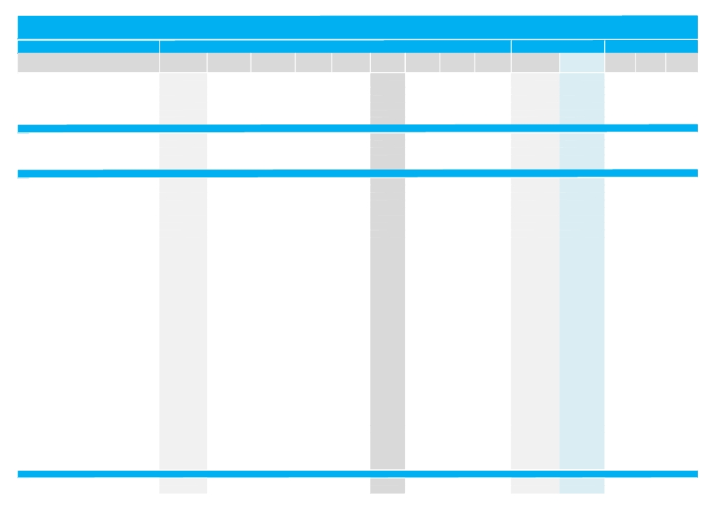

Kuwait Stock Exchange Trading & Valuation Data Summary

Monthly Trading Indicators

Reuters Traded Volume Traded Value Number of Avg. Traded Closing Price

Market Cap.

MTM Price
September-12

Valuation Indicators

Trailing P/E Trailing P/B Dividend

Company Name

▲ Contracting & Marine Services Co.
▲ IKARUS Petroleum Industries Co.
▲ Independent Petroleum Group
═ National Petroleum Services Co.
═ Aref Energy Holding Co.
▼ Gulf Petroleum Investment
▼ Burgan Co. for Drilling, Tdg. & Maintenance
▲ Oil & Gas Sector
▲ Kuwait Pipes Industries & Oil services
▲ Kuwait Foundry Co.
▲ Boubyan Petrochemicals Co.*
═ Al Kout for Industrial Projects Co.
▲ Qurain Petrochemical Industries Co.
▲ Basic Materials Sector
▲ Kuwait Cement Co.
▼ Refrigeration Industries & Storage Co.
▲ Gulf Cable & Electrical Ind. Co.
▼ Heavy Eng'g Ind. & Shipbuilding Co.
▲ Kuwait Portland Cement Co.
▲ Shuaiba Industrial Co.
▼ Metal & Recycling Co.
▲ ACICO Industries Co.
▼ Gulf Glass Manufacturing Co.
▼ Hilal Cement Co.
▼ Kuwait Packing Materials Co.
▲ Kuwait Building Materials Co.
▲ National Industries Building Materials Co.
▲ Equipment Holding Co.
═ National Co. for Consumer Industries
▼ Kuwait Gypsum Manufacturing & Tdg. Co.
═ Salbookh Trading Co.
▲ Agility (PWC Logistics)
▼ Educational Holding Group*
▲ National Cleaning Co.
▲ City Group Co.
▲ Kuwait & Gulf Link Transport Co.
▲ Kuwait Co. For Process Plant Const. & Cont. ▼ Human Soft Holding Co.
▲ Nafais Holding Co.
═ Safwan Trading & Contracting Co.
═ Gulf Franchising Co.
▲ National Ranges Co.
▲ Combined Group Contracting Co.
═ Mishref General Trading & Contracting Co.
▲ United Projects Group
▲ ALAFCO Aviation Lease & Finance Co.*
▲ Mubarrad Transport Co.
▲ KGL Logistics Co.
▲ Sharjah Cement Co.
▼ Gulf Cement Co.
▲ Umm Al-Qaiwain Cement Industries Co.
▲ Fujairah Cement Industries Co.
▼ Ras-Al-Khaimah for White Cement Co.
▲ Industrial Sector
▼ Kuwait Slaughter House Co.
═ National Slaughter Houses Co.
Ticker ('000 Shares) ('000 KWD)
MARI.KW 30 5
IKAR.KW 511 83
IPGK.KW 259 85
NAPS.KW 29 9
AREF.KW 738 61
GPIK.KW 80,643 4,693
ABAR.KW 40 7
82,251 4,943
PIPE.KW 8,905 948
KFDC.KW 346 98
BPCC.KW 8,566 4,652
ALKK.KW 0 0
ALQK.KW 4,450 828
22,267 6,526
KCEM.KW 2,015 787
REFR.KW 266 54
CABL.KW 2,945 3,149
SHIP.KW 3,060 536
PCEM.KW 3,306 2,963
PAPE.KW 2,697 515
MRCK.KW 1,279 157
ACIC.KW 780 177
GGMC.KW 59 41
HCCK.KW 13 3
KPAK.KW 38 9
KBMM.KW 46 11
NIBM.KW 198 65
EQUI.KW 28,913 3,517
NCCI.KW 0 0
GYPK.KW 20 3
SALB.KW 8,116 534
AGLT.KW 43,335 20,611
EDUK.KW 4,012 433
CLEA.KW 15,883 2,089
TTGC.KW 12 7
KGLK.KW 25,803 2,546
KCPC.KW 4,003 1,101
HUMN.KW 0 0
NAFA.KW 39 3
SAFW.KW 0 0
GFCI.KW 0 0
MAYA.KW 523,844 11,275
CGCK.KW 886 1,166
MTCC.KW 15,874 1,365
UPAC.KW 1,980 999
ALAF.KW 40,319 13,343
MBRD.KW 42,462 2,285
LOGK.KW 17,358 4,509
SCEM.KW 13,681 992
GCEM.KW 35,341 2,720
QCEM.KW 11,672 713
FCEM.KW 25,785 2,370
RKWC.KW 1,574 168
877,613 81,220
KSHK.KW 27 7
NSHK.KW 15 2
Deals Price (KWD)* (KWD)
13 0.160 0.174
61 0.162 0.166
42 0.329 0.345
3 0.325 0.325
103 0.083 0.085
2,023 0.058 0.055
24 0.175 0.176
2,269
387 0.106 0.108
66 0.285 0.300
269 0.543 0.550
0 NA 0.415
483 0.186 0.190
1,205
263 0.391 0.415
44 0.204 0.204
550 1.069 1.140
173 0.175 0.174
624 0.896 0.940
127 0.191 0.194
234 0.123 0.124
78 0.227 0.244
63 0.700 0.710
18 0.202 0.208
13 0.247 0.250
13 0.233 0.226
49 0.329 0.375
920 0.122 0.126
0 NA 0.102
13 0.136 0.138
401 0.066 0.065
1,188 0.476 0.520
20 0.108 0.102
733 0.132 0.144
12 0.577 0.580
1,134 0.099 0.098
316 0.275 0.280
2 0.270 0.270
64 0.088 0.090
1 0.590 0.590
0 NA 0.084
2,330 0.022 0.023
148 1.317 1.400
587 0.086 0.086
87 0.505 0.520
1,162 0.331 0.345
1,429 0.054 0.055
676 0.260 0.265
418 0.073 0.073
864 0.077 0.078
324 0.061 0.061
673 0.092 0.094
62 0.107 0.106
15,813
3 0.246 0.238
4 0.161 0.162
High (KWD) Low (KWD)
Change (%)
16.00% 0.174 0.142
1.22% 0.174 0.160
11.29% 0.345 0.310
0.00% 0.325 0.325
0.00% 0.086 0.080
(12.70%) 0.068 0.053
(7.37%) 0.188 0.168
2.08%
3.85% 0.110 0.102
3.45% 0.310 0.270
1.85% 0.560 0.530
0.00% NA NA
1.06% 0.194 0.180
1.65%
12.16% 0.415 0.360
(1.92%) 0.208 0.200
5.56% 1.160 1.000
(3.33%) 0.186 0.170
8.05% 0.960 0.860
5.43% 0.196 0.184
(1.59%) 0.132 0.108
11.93% 0.246 0.220
(5.33%) 0.840 0.620
(8.77%) 0.208 0.178
(23.08%) 0.295 0.242
2.73% 0.255 0.212
19.05% 0.375 0.260
6.78% 0.136 0.110
0.00% NA NA
(18.82%) 0.186 0.128
0.00% 0.068 0.059
23.81% 0.530 0.415
(1.92%) 0.114 0.099
18.03% 0.144 0.120
13.73% 0.580 0.490
10.11% 0.106 0.090
3.70% 0.300 0.255
(1.82%) 0.270 0.270
11.11% 0.094 0.081
0.00% 0.590 0.590
0.00% NA NA
9.76% 0.024 0.019
9.38% 1.420 1.200
0.00% 0.089 0.083
6.12% 0.520 0.490
11.29% 0.355 0.300
11.11% 0.060 0.049
7.72% 0.280 0.248
2.82% 0.078 0.069
(3.70%) 0.084 0.072
1.67% 0.064 0.059
11.90% 0.098 0.082
(1.85%) 0.116 0.106
10.54%
(4.80%) 0.250 0.238
0.00% 0.172 0.160
('000 KWD) ('000 USD)
(X) (X) Yield
36,168 128,309 22.69 0.84 0.00%
124,500 441,677 15.92 0.91 4.80%
52,526 186,343 NM 0.71 0.00%
18,723 66,422 11.38 1.44 7.01%
63,750 226,160 NM 1.02 0.00%
12,631 44,808 17.41 0.52 0.00%
36,894 130,886 21.09 0.70 0.00%
345,192 1,224,605 NM 0.85 2.11%
24,336 86,334 NM 1.30 0.00%
43,967 155,977 NM 0.92 0.00%
266,805 946,520 10.80 0.96 7.24%
36,603 129,853 9.24 1.68 8.43%
209,000 741,450 6.33 0.83 7.86%
580,711 2,060,135 12.03 0.94 6.69%
264,627 938,793 18.36 1.87 3.50%
18,237 64,698 NM 1.11 0.00%
239,321 849,019 17.45 1.58 6.40%
28,446 100,916 18.30 0.91 5.75%
85,450 303,142 13.84 1.41 6.91%
11,907 42,240 10.13 0.79 0.00%
10,237 36,317 NM 0.54 0.00%
60,704 215,356 22.16 0.77 1.94%
28,611 101,500 10.39 2.04 5.63%
14,535 51,563 20.60 0.93 7.21%
10,569 37,495 4.88 0.90 0.00%
6,468 22,946 20.79 1.34 2.23%
129,764 460,352 26.69 1.62 2.66%
17,186 60,971 NM 1.07 0.00%
9,180 32,567 NM 1.29 0.00%
4,140 14,687 15.37 0.90 5.06%
6,821 24,199 12.77 0.69 0.00%
544,355 1,931,160 20.61 0.61 5.52%
25,021 88,764 NM 0.86 0.00%
31,137 110,463 12.64 0.92 1.61%
65,545 232,527 NM 2.87 0.00%
25,899 91,879 NM 0.48 0.00%
18,524 65,718 10.02 1.10 3.30%
30,845 109,425 9.37 1.36 0.00%
37,917 134,514 23.13 0.78 0.00%
29,500 104,654 13.51 2.86 4.48%
2,730 9,684 3.59 0.83 0.00%
22,500 79,821 NM 0.78 0.00%
148,811 527,924 15.03 3.92 4.54%
17,200 61,019 9.37 0.61 0.00%
42,900 152,192 7.80 1.32 5.51%
269,021 954,382 6.80 1.75 2.90%
11,928 42,317 NM 0.48 0.00%
83,806 297,312 8.33 1.59 6.57%
40,366 143,203 NM 0.41 0.00%
64,046 227,209 NM 0.69 0.00%
22,143 78,555 21.03 0.59 8.69%
33,451 118,672 NM 0.47 0.00%
49,502 175,614 14.74 0.94 7.17%
2,563,351 9,093,769 18.64 1.01 3.91%
7,390 26,216 30.32 2.12 7.32%
4,679 16,598 8.21 1.23 0.00%

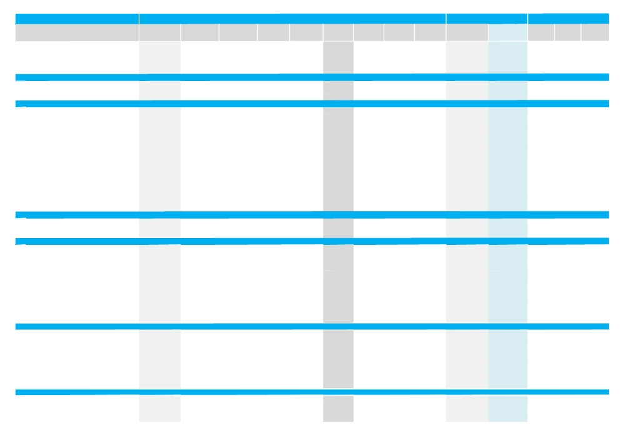

Company Name

▼ Palms Agro Production Co.
═ Livestock Transport & Trading Co.
▼ Danah Alsafat Foodstuff Co.
▲ Kuwait United Poultry Co.
▲ Kuwait Foods Co. (Americana)
▲ Consumer Goods Sector
▼ AL-Mowasat Healthcare Co.
▼ Advanced Technology Co.
═ Yiaco Medical Co.
▼ Health Care Sector
▲ Kuwait National Cinema Co.
▼ Kuwait Hotels Co.
▲ Sultan Center Food Products Co.
▼ Kuwait Cable Vision Co.
═ EYAS for Higher & Technical Education Co.*
▲ IFA Hotels & Resorts Co.*
▲ Oula Fuel Marketing Co.
▲ Kuwait Resorts Co.
▲ Jazeera Airways Co.
▲ Soor Fuel Marketing Co.
═ Future Kid Entertainment and R.E Co.
▼ Al-Nawadi Holding Co.
▲ Al Rai Media Group Co.
▼ Zima Holding Co.
▲ United Foodstuff Industries Group Co.
▲ Kout Food Group
▲ Consumer Services Sector
▲ Zain
▲ National Mobile Telecom Co.
▼ Hits Telecom Holding Co.
▲ Telecommunications Sector
═ National Bank of Kuwait
▲ Gulf Bank
═ Commercial Bank of Kuwait
▲ Ahli Bank of Kuwait
═ Ahli United Bank - Kuwait
▲ Kuwait International Bank
▲ Burgan Bank
▲ Kuwait Finance House
▲ Boubyan Bank
▲ United Gulf Bank
▼ Ahli United Bank - Bahrain
▲ Ithmaar Bank
▲ Banking Sector
▼ Kuwait Insurance Co.
═ Gulf Insurance Co.
▲ Ahleiah Insurance Co.
▲ Warba Insurance Co.
▼ Kuwait Reinsurance Co.
▲ First Takaful Insurance Co.
▼ Wethaq Takaful Insurance Co.
▼ Arab Insurance Group
═ Bahrain Kuwait Insurance Co.
▲ Insurance Sector
═ Al-Ahlia Holding Co.
▲ Sokouk Holding Co.
▲ Kuwait Real Estate Co.
▲ United Real Estate Co.
Monthly Trading Indicators

Reuters Traded Volume Traded Value Number of Avg. Traded Closing Price
Ticker ('000 Shares) ('000 KWD) Deals Price (KWD)* (KWD)
PAPK.KW 46 5 8 0.103 0.098
CATT.KW 2,183 412 192 0.189 0.184
DANK.KW 22,164 1,576 675 0.071 0.070
POUL.KW 0 0 2 0.159 0.160
FOOD.KW 3,582 5,565 523 1.554 1.600
28,018 7,567 1,407
MHCK.KW 6 1 6 0.181 0.186
ATCK.KW 26 17 39 0.661 0.640
YIAC.KW 2,283 907 179 0.397 0.410
2,315 925 224
KCIN.KW 135 117 24 0.865 0.930
KHOT.KW 1 0 13 0.154 0.168
SCFK.KW 33,035 3,551 1,122 0.107 0.108
KWTV.KW 274 11 38 0.040 0.037
EYAS.KW 0 0 0 NA 0.240
IFAH.KW 2,145 612 88 0.285 0.300
OULA.KW 738 201 451 0.273 0.280
MUNK.KW 222 10 14 0.046 0.046
JAZK.KW 8,805 3,829 587 0.435 0.460
SOOR.KW 1,095 244 340 0.223 0.226
KIDK.KW 40 4 5 0.108 0.110
ALNA.KW 65 7 16 0.113 0.110
ALRA.KW 8,843 1,028 868 0.116 0.114
ZIMAH.KW 11 1 2 0.092 0.068
UFIG.KW 1 0 17 0.227 0.236
KOUT.KW 74 47 8 0.626 0.630
55,484 9,663 3,593
ZAIN.KW 41,936 29,699 1,774 0.708 0.740
NMTC.KW 7,659 19,637 478 2.564 2.580
HITS.KW 160,901 11,290 3,017 0.070 0.066
210,496 60,627 5,269
NBKK.KW 83,994 80,465 1,548 0.958 0.990
GBKK.KW 22,756 9,301 622 0.409 0.440
CBKK.KW 49,333 32,981 346 0.669 0.710
ABKK.KW 81 50 30 0.616 0.640
BKME.KW 494 441 94 0.892 0.900
KIBK.KW 49,742 12,761 763 0.257 0.260
BURG.KW 19,818 10,050 595 0.507 0.510
KFIN.KW 32,859 23,648 2,054 0.720 0.770
BOUK.KW 6,314 3,851 602 0.610 0.620
UGBK.KW 128 20 14 0.153 0.164
AUBK.KW 13,646 2,082 339 0.153 0.154
ITHMR.KW 423,341 20,817 5,376 0.049 0.048
702,506 196,467 12,383
KINS.KW 13 4 3 0.305 0.305
GINS.KW 209 106 9 0.510 0.510
AINS.KW 87 38 21 0.431 0.470
WINS.KW 80 9 40 0.118 0.116
KWRE.KW 162 23 20 0.139 0.132
FTIK.KW 6 0 9 0.061 0.060
WETH.KW 55 2 110 0.042 0.038
ARIG.KW 161 15 11 0.091 0.091
BKIK.KW 0 0 0 NA 0.275
774 198 223
AINV.KW 0 0 0 NA 0.013
SHCK.KW 160,417 6,543 2,467 0.041 0.051
KREK.KW 33,651 1,660 551 0.049 0.050
UREK.KW 14,455 1,625 192 0.112 0.114

MTM Price
High (KWD) Low (KWD)
Change (%)
(7.55%) 0.106 0.098
0.00% 0.210 0.174
(5.41%) 0.077 0.068
6.67% 0.160 0.150
14.29% 1.640 1.360
12.07%
(2.11%) 0.188 0.178
(1.54%) 0.700 0.600
0.00% 0.415 0.390
(1.03%)
5.68% 0.950 0.850
(8.70%) 0.168 0.134
5.88% 0.114 0.102
(42.06%) 0.058 0.037
0.00% NA NA
3.45% 0.300 0.255
3.70% 0.290 0.260
1.10% 0.048 0.044
13.58% 0.465 0.400
0.89% 0.230 0.218
0.00% 0.110 0.104
(3.51%) 0.128 0.102
7.55% 0.126 0.102
(30.61%) 0.093 0.068
22.92% 0.280 0.192
1.61% 0.630 0.620
4.03%
7.25% 0.760 0.660
0.78% 2.580 2.540
(9.59%) 0.075 0.064
5.10%
0.00% 1.000 0.930
10.00% 0.445 0.385
0.00% 0.720 0.630
1.59% 0.640 0.580
0.00% 0.910 0.880
5.69% 0.270 0.244
7.37% 0.520 0.470
11.59% 0.780 0.670
3.33% 0.630 0.600
13.89% 0.164 0.144
(1.28%) 0.158 0.150
1.05% 0.053 0.046
3.49%
(6.15%) 0.305 0.300
0.00% 0.520 0.510
17.50% 0.470 0.395
3.57% 0.124 0.110
(32.65%) 0.148 0.128
20.00% 0.066 0.050
(18.48%) 0.050 0.038
(3.19%) 0.100 0.091
0.00% NA NA
2.89%
0.00% NA NA
25.93% 0.051 0.035
3.09% 0.051 0.049
1.79% 0.116 0.110
Market Cap. Valuation Indicators

Trailing P/E Trailing P/B Dividend
('000 KWD) ('000 USD)
(X) (X) Yield
5,135 18,217 10.54 0.62 10.19%
39,853 141,382 NM 0.97 0.00%
20,213 71,706 NM 0.49 0.00%
18,465 65,505 7.66 1.25 3.03%
643,200 2,281,823 14.72 2.26 3.95%
738,933 2,621,448 17.66 1.86 3.66%
18,005 63,874 76.45 0.97 0.00%
96,000 340,571 27.87 2.82 2.34%
67,650 239,996 11.95 2.21 3.66%
181,655 644,440 19.44 2.19 2.60%
93,989 333,435 17.94 2.07 4.47%
9,702 34,419 NM 1.67 0.00%
62,514 221,774 NM 1.57 0.00%
1,095 3,885 NM 0.76 0.00%
26,400 93,657 8.57 1.21 4.17%
136,165 483,059 NM 2.98 0.00%
96,932 343,876 24.87 2.20 0.00%
8,607 30,534 NM 0.53 0.00%
101,194 358,997 9.01 3.40 0.00%
79,010 280,297 17.62 1.73 0.00%
12,787 45,364 14.14 0.63 4.49%
14,056 49,867 8.63 0.93 5.51%
26,566 94,247 15.58 0.95 0.00%
6,800 24,124 NM 0.60 0.00%
7,871 27,923 26.27 1.49 2.10%
46,097 163,535 11.48 1.62 4.76%
729,784 2,588,990 NM 1.80 1.23%
3,167,637 11,237,539 11.05 1.96 7.97%
1,300,405 4,613,330 14.95 1.44 1.93%
47,581 168,797 NM 0.49 0.00%
4,515,622 16,019,667 12.10 1.73 6.14%
4,309,962 15,290,064 15.58 1.87 3.64%
1,158,558 4,110,113 46.15 2.63 0.00%
903,136 3,203,974 NM 1.68 0.00%
968,473 3,435,764 22.48 1.97 2.21%
1,064,907 3,777,876 32.33 3.82 1.43%
269,705 956,808 23.75 1.29 1.73%
787,933 2,795,280 13.96 1.70 1.79%
2,236,217 7,933,226 29.04 1.74 1.77%
1,083,954 3,845,445 NM 4.34 0.00%
134,542 477,304 NM 0.83 0.00%
728,673 2,585,046 8.28 0.88 5.73%
153,085 543,085 NM 0.95 0.00%
13,799,145 48,953,986 22.93 1.86 2.13%
59,182 209,955 12.48 1.27 6.39%
95,390 338,406 12.69 1.36 3.67%
89,080 316,022 12.00 1.12 4.95%
20,044 71,107 18.40 0.45 4.31%
23,520 83,440 11.78 0.62 0.00%
6,000 21,286 NM 0.64 0.00%
4,134 14,667 26.11 0.37 0.00%
20,020 71,023 NM 0.30 0.00%
19,663 69,755 8.87 0.93 6.11%
337,033 1,195,661 15.39 0.87 4.08%
10,766 38,194 NM 0.50 0.00%
23,562 83,589 NM 0.45 0.00%
45,336 160,833 13.19 0.42 0.00%
135,429 480,449 6.32 0.65 4.27%

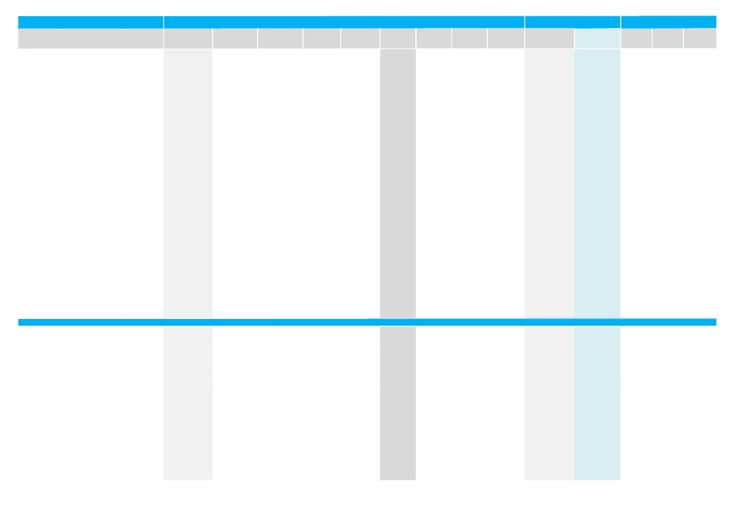

Company Name

▲ National Real Estate Co.
▲ Salhia Real Estate Co.
▼ Pearl of Kuwait Real Estate Co.
═ Tamdeen Real Estate Co.
▲ Ajial Real Estate Entertainment Co.
▲ Al Massaleh Real Estate Co.
▲ Arab Real Estate Co.
═ Union Real Estate Co.
▲ AL-Enma'a Real Estate Co.*
═ Mabanee Co.
▲ Injazzat Real Estate Development Co.
═ Investors Holding Group Co.
▼ International Resorts Co.
▲ The Commercial Real Estate Co.
▲ Sanam Real Estate Co.
▼ A'ayan Real Estate Co.
▼ Aqar Real Estate Investment Co.
▼ Kuwait Real Estate Holding Co.
▲ MAZAYA Holding Co.
▲ Al Dar National Real Estate Co.
▲ AL-Themar International Holding Co.
▲ Tijara Real Estate & Investment Co.
═ Al TAMEER Real Estate Investment Co.
▲ Arkan Al-Kuwait Real Estate Co.
▲ Al-Argan International Real Estate Co.
▲ Abyaar Real Estate Development Co.
▲ Munshaat Real Estate Projects Co.
▲ First Dubai For Real Estate Development
▲ Kuwait Business Town Real Estate Co.
═ Real Estate Asset Management Co.
▼ MENA Real Estate Co.
═ Al Mudon International Real Estate Co.
▲ Real Estate Trade Centers Co.
═ Kuwait Remal Real Estate Co.
▲ Mashaer Holding Co.
▲ Real Estate Sector
▲ Kuwait Investment Co.
▲ Commercial Facilities Co.
▼ Int'l Financial Advisors Co.
▲ National Investment Co.
▲ Kuwait Projects Co.(Holding)
▼ Coast Invest. & Development Co.
═ The Securities House Co.
═ Industrial & Financial Invest. Co.
▲ Securities Group
▼ International Finance Co.
▲ Kuwait Financial Centre
▲ Kuwait & M.E. Financial Investment Co.
═ Al-Aman Investment Co.
▲ First Investment Co.
▼ Al-Mal Investment Co.
▲ Gulf Investment House
▲ Bayan Investment Co.
═ Global Investment House
▲ Osoul Investment Co.
▼ Kuwait Finance & Investment Co.
Monthly Trading Indicators

Reuters Traded Volume Traded Value Number of Avg. Traded Closing Price
Ticker ('000 Shares) ('000 KWD) Deals Price (KWD)* (KWD)
NREK.KW 24,349 3,218 762 0.132 0.138
SREK.KW 8,796 2,875 346 0.327 0.345
PEAR.KW 10,607 304 513 0.029 0.029
TAMK.KW 1,619 362 100 0.224 0.224
AREC.KW 385 60 39 0.156 0.158
MREC.KW 96 8 18 0.080 0.087
ARAB.KW 47,950 1,790 859 0.037 0.040
UREC.KW 126 13 4 0.100 0.100
ENMA.KW 11,426 987 351 0.086 0.086
MABK.KW 7,078 7,954 522 1.124 1.160
INJA.KW 125,264 7,008 1,775 0.056 0.058
INVK.KW 32,282 592 408 0.018 0.018
IRCK.KW 40,761 1,555 807 0.038 0.038
TIJK.KW 68,613 5,070 910 0.074 0.076
SANK.KW 2,038 113 80 0.056 0.058
AYRE.KW 13,972 1,187 382 0.085 0.087
AQAR.KW 800 51 20 0.063 0.068
ALAQ.KW 117 5 29 0.046 0.053
MAZA.KW 13,685 1,014 490 0.074 0.077
ADNC.KW 195,923 6,188 2,889 0.032 0.038
THMR.KW 1,184 105 51 0.089 0.090
TIJA.KW 66,030 2,799 1,327 0.042 0.042
AMAR.KW 1,082 42 100 0.038 0.040
ARKK.KW 359 30 38 0.084 0.089
ARGK.KW 930 144 18 0.155 0.176
ABYR.KW 277,795 12,586 2,012 0.045 0.046
MUNS.KW 188,781 6,688 2,920 0.035 0.041
FIRST.KW 11,304 461 316 0.041 0.040
KBTK.KW 34,230 997 815 0.029 0.027
REAM.KW 0 0 0 NA 0.100
MENK.KW 4,292 149 274 0.035 0.035
ALMK.KW 0 0 0 NA 0.220
MARA.KW 7,971 380 470 0.048 0.045
REMAL.KW 0 0 0 NA 0.435
MASK.KW 4,071 1,000 332 0.246 0.250
1,412,440 75,562 23,187
KINV.KW 639 65 34 0.102 0.102
FACI.KW 2,939 948 165 0.323 0.330
IFIN.KW 164,643 6,465 1,930 0.039 0.039
NINV.KW 37,865 4,197 1,202 0.111 0.116
KPRO.KW 17,345 6,554 351 0.378 0.390
COAS.KW 44,615 1,761 993 0.039 0.039
SECH.KW 0 0 0 NA 0.130
IICK.KW 0 0 0 NA 0.029
SGCK.KW 141 17 25 0.123 0.140
IMCK.KW 31,866 2,293 1,242 0.072 0.066
MARKZ.KW 3,450 413 118 0.120 0.118
KMEF.KW 49 2 54 0.043 0.044
AMAN.KW 7,422 390 225 0.053 0.052
OLAK.KW 42,704 5,357 848 0.125 0.126
MALK.KW 44,605 1,656 918 0.037 0.037
GIHK.KW 408,389 13,670 4,308 0.033 0.034
BAYK.KW 19,761 715 880 0.036 0.038
GLOB.KW 0 0 0 NA 0.049
OSUL.KW 2,167 141 13 0.065 0.067
KFSK.KW 9,236 708 614 0.077 0.077

MTM Price
High (KWD) Low (KWD)
Change (%)
13.11% 0.140 0.118
23.21% 0.370 0.280
(9.38%) 0.031 0.027
0.00% 0.228 0.218
3.95% 0.164 0.150
11.54% 0.087 0.077
8.22% 0.040 0.033
0.00% 0.100 0.099
4.88% 0.089 0.083
0.00% 1.160 1.080
5.45% 0.063 0.051
0.00% 0.019 0.018
(1.30%) 0.041 0.036
10.14% 0.079 0.069
5.45% 0.060 0.053
(1.14%) 0.090 0.081
(4.23%) 0.068 0.058
(19.70%) 0.053 0.041
11.59% 0.079 0.067
26.67% 0.040 0.026
9.76% 0.090 0.082
5.00% 0.045 0.040
0.00% 0.043 0.037
8.54% 0.090 0.081
14.29% 0.176 0.154
3.41% 0.048 0.043
30.65% 0.041 0.028
1.28% 0.043 0.035
54.29% 0.050 0.027
0.00% NA NA
(2.78%) 0.037 0.032
0.00% NA NA
1.12% 0.052 0.040
0.00% NA NA
5.04% 0.260 0.232
5.13%
2.00% 0.104 0.098
8.20% 0.340 0.310
(6.10%) 0.042 0.037
7.41% 0.120 0.100
6.85% 0.390 0.360
(3.75%) 0.042 0.036
0.00% NA NA
0.00% NA NA
7.69% 0.146 0.104
(21.43%) 0.085 0.064
1.72% 0.124 0.114
10.00% 0.047 0.033
0.00% 0.055 0.051
5.00% 0.132 0.120
(6.41%) 0.041 0.036
1.49% 0.036 0.031
10.29% 0.039 0.033
0.00% NA NA
3.08% 0.067 0.062
(45.00%) 0.110 0.070
Market Cap. Valuation Indicators

Trailing P/E Trailing P/B Dividend
('000 KWD) ('000 USD)
(X) (X) Yield
112,359 398,606 NM 0.59 0.00%
172,742 612,822 21.85 1.40 4.30%
2,919 10,356 NM 0.80 0.00%
83,579 296,505 19.49 0.88 0.00%
27,871 98,876 NM 0.24 0.00%
20,502 72,733 14.04 0.47 7.36%
20,139 71,445 NM 0.30 0.00%
20,101 71,312 14.19 0.70 6.47%
38,746 137,456 31.87 0.71 0.00%
741,989 2,632,289 31.80 4.25 0.74%
20,048 71,121 NM 0.38 0.00%
19,260 68,327 NM 0.58 0.00%
5,870 20,826 NM 0.47 0.00%
139,446 494,699 NM 0.57 6.20%
7,087 25,141 NM 0.65 0.00%
34,439 122,176 10.47 0.47 0.00%
15,929 56,510 NM 0.72 0.00%
7,537 26,737 NM 0.61 0.00%
49,998 177,372 NM 0.60 0.00%
15,960 56,620 NM 1.04 0.00%
91,125 323,276 10.52 0.97 0.00%
16,147 57,285 NM 0.49 0.00%
9,600 34,057 NM 0.39 0.00%
19,684 69,830 24.39 0.78 0.00%
46,640 165,461 NM 0.70 0.00%
50,381 178,732 NM 0.48 0.00%
13,041 46,264 NM 0.51 0.00%
39,500 140,131 NM 0.86 0.00%
21,214 75,257 NM 0.33 0.00%
10,450 37,073 27.96 0.69 4.98%
6,878 24,399 NM 0.41 0.00%
22,000 78,047 NM 1.50 0.00%
5,198 18,439 NM 0.25 0.00%
110,055 390,432 16.73 2.38 0.00%
44,857 159,137 7.87 1.02 5.16%
2,278,383 8,082,813 NM 0.92 1.45%
56,228 199,473 20.99 0.54 0.00%
177,132 628,395 9.91 1.09 0.00%
27,720 98,340 NM 0.28 0.00%
101,641 360,582 NM 0.57 0.00%
521,264 1,849,241 17.07 0.92 4.51%
24,074 85,404 3.39 0.51 0.00%
88,400 313,609 1.78 1.65 0.00%
12,824 45,495 NM 0.56 0.00%
35,740 126,791 10.44 0.63 0.00%
30,737 109,044 NM 0.29 0.00%
62,693 222,412 NM 0.73 0.00%
11,608 41,180 NM 0.52 0.00%
10,217 36,246 NM 0.52 0.00%
82,035 291,028 10.45 0.89 0.00%
19,282 68,406 NM 0.44 0.00%
15,034 53,337 NM 0.80 0.00%
15,019 53,283 NM 0.47 0.00%
63,653 225,816 NM 29.98 0.00%
12,643 44,853 78.96 0.66 0.00%
26,294 93,280 NM NM 0.00%

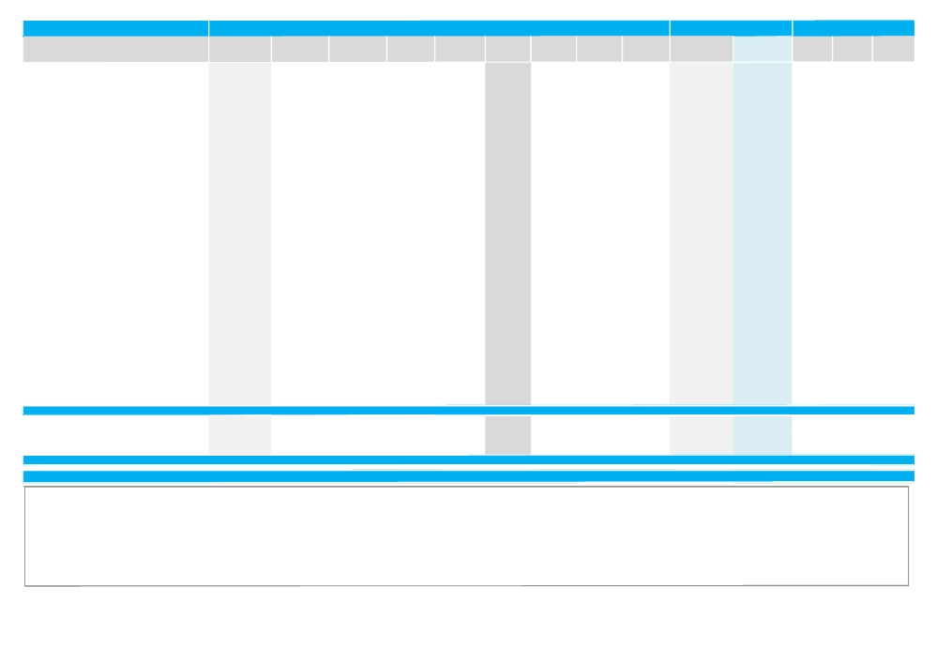

Company Name
▼ Kuwait Inv. Projects Asset Mgt Co.(KAMCO) ▲ National International Holding Co.
═ Housing Finance Co.
▼ Al Madar Finance & Investment Co.
▼ Al-Deera Holding
═ Al Safat Investment Co.
▼ Al Salam Group Holding Co.
▲ Ekttitab Holding Co.
▲ Al Qurain Holding Co.
▲ Al Madina For Finance & Investment Co.
▲ NOOR Financial Investment Co.
▲ Tamdeen Investment Co.
▲ Kuwait Bahrain International Exchange Co. ▼ Taiba Kuwaiti Holding Co.
▲ Kuwait Syrian Holding Co.
▼ Strategia Investment Co.
▼ Kuwait China Investment Co.
▼ Manafae Investment Co.
▲ Gulf North Africa Holding Co.
═ Amwal International Investment Co.
═ Alimtiaz Investment Co.
▲ Manazel Holding Co.
▲ National Industries Group
▲ United Industries Co.
▼ Boubyan Int'l Industries Holding Co.
═ Market Complex Co.
▲ Al-Safat Energy Holding Co.
▲ Arabi Holding Group Co.
═ Al-Safwa Group Co. (Holding)
▲ Privatization Holding Co.
▲ Credit Rating & Collection Co.
═ Jeeran Holding Co.*
▲ Egypt Kuwait Holding Co.
▼ Gulf Finance House
▲ Inovest
▲ Financial Services Sector
▲ Automated Systems Co.
▼ Al Safat TEC Holding Co.
▼ Future Communications Global Co.
▼ Hayat Communications Co.
▼ Technology Sector

▲ Total Kuwaiti Market
Source: Kuwait Stock Exchange
Monthly Trading Indicators

Reuters Traded Volume Traded Value Number of Avg. Traded Closing Price
Ticker ('000 Shares) ('000 KWD) Deals Price (KWD)* (KWD)
KAMC.KW 87 14 40 0.162 0.154
NIHK.KW 48 2 59 0.042 0.053
ISKN.KW 0 0 0 NA 0.039
MADR.KW 476 19 54 0.041 0.045
DEER.KW 24,161 773 754 0.032 0.032
SAFT.KW 0 0 0 NA 0.100
ALSALAM.KW 155,325 37,458 4,370 0.241 0.238
EKTT.KW 186,966 16,552 3,736 0.089 0.084
QURK.KW 1,304 35 46 0.027 0.025
MADI.KW 269,068 16,947 5,089 0.063 0.059
NOOR.KW 19,027 1,140 737 0.060 0.069
TAMI.KW 2,283 382 193 0.167 0.170
EXCH.KW 5 1 7 0.170 0.162
TAIBA.KW 9,000 500 16 0.056 0.051
KSHC.KW 3,975 118 131 0.030 0.032
STRAT.KW 2 0 2 0.090 0.089
KCIC.KW 2,190 119 156 0.054 0.056
MANFAE.KW 635 36 9 0.057 0.060
GNAH.KW 2,241 97 100 0.043 0.044
AMWA.KW 0 0 0 NA 0.100
ALIMTIAZ.KW 0 0 0 NA 0.073
MANK.KW 385,790 12,138 4,658 0.031 0.037
NIND.KW 67,077 13,655 1,690 0.204 0.218
UICK.KW 3,115 282 132 0.091 0.093
BIIHC.KW 2,739 141 156 0.051 0.052
SHOP.KW 0 0 0 NA 0.052
SENE.KW 36,934 2,148 996 0.058 0.060
AGHC.KW 5,076 594 248 0.117 0.120
SAFK.KW 0 0 0 NA 0.013
KPPC.KW 61,142 4,135 1,242 0.068 0.070
TAHS.KW 3 0 5 0.033 0.036
JEER.KW 0 0 0 NA 0.070
EKHK.KW 206 77 21 0.374 0.365
GFHK.KW 499,679 18,715 5,489 0.037 0.036
INOV.KW 108,697 4,737 1,831 0.044 0.045
2,685,089 176,167 45,887
ASCK.KW 21 9 43 0.414 0.455
SAFH.KW 6,086 359 96 0.059 0.061
FUTK.KW 268 42 31 0.155 0.148
HAYK.KW 5,228 502 362 0.096 0.090
11,604 912 532
6,090,856 620,777 111,992

MTM Price
High (KWD) Low (KWD)
Change (%)
(18.09%) 0.196 0.154
73.77% 0.059 0.029
0.00% NA NA
(12.75%) 0.048 0.031
(3.03%) 0.034 0.030
0.00% NA NA
(6.67%) 0.270 0.218
5.00% 0.097 0.080
13.64% 0.027 0.023
13.46% 0.070 0.052
18.97% 0.070 0.048
3.66% 0.174 0.158
1.25% 0.172 0.160
(15.00%) 0.075 0.048
12.50% 0.032 0.028
(6.32%) 0.090 0.089
(1.75%) 0.058 0.052
(4.76%) 0.062 0.053
3.53% 0.047 0.038
0.00% NA NA
0.00% NA NA
23.73% 0.037 0.026
11.22% 0.224 0.182
4.49% 0.094 0.089
(1.89%) 0.054 0.048
0.00% NA NA
3.45% 0.062 0.053
1.69% 0.122 0.110
0.00% NA NA
11.11% 0.074 0.058
26.32% 0.036 0.031
0.00% NA NA
4.29% 0.390 0.350
(12.35%) 0.041 0.035
1.12% 0.046 0.042
2.85%
3.41% 0.455 0.390
(3.17%) 0.062 0.059
(18.68%) 0.178 0.148
(16.67%) 0.110 0.089
(6.80%)
4.49%
Market Cap. Valuation Indicators

Trailing P/E Trailing P/B Dividend
('000 KWD) ('000 USD)
(X) (X) Yield
40,549 143,850 NM 1.02 0.00%
11,269 39,978 NM 0.31 0.00%
11,478 40,718 NM 0.88 0.00%
16,347 57,994 NM 0.89 0.00%
23,823 84,513 NM 0.46 0.00%
77,298 274,224 NM 0.73 0.00%
57,120 202,639 13.26 1.96 2.03%
19,204 68,130 18.59 0.83 0.00%
7,412 26,296 NM 0.37 0.00%
24,017 85,202 NM 0.38 0.00%
25,917 91,942 NM 0.81 0.00%
53,015 188,075 9.59 0.60 0.00%
7,484 26,552 10.57 1.27 6.79%
9,180 32,567 45.50 0.47 0.00%
9,450 33,525 NM 0.37 0.00%
15,644 55,497 NM 1.18 0.00%
44,800 158,933 NM 0.55 0.00%
12,053 42,759 NM 0.58 0.00%
6,600 23,414 NM 0.42 0.00%
18,055 64,053 NM 0.99 0.00%
82,754 293,579 23.24 0.34 13.52%
26,098 92,584 NM 0.73 0.00%
282,331 1,001,602 NM 0.54 0.00%
46,079 163,469 16.55 0.45 0.00%
15,600 55,343 NM 0.39 0.00%
13,849 49,132 NM 0.34 0.00%
36,183 128,362 NM 0.75 0.00%
16,299 57,824 9.99 0.76 0.00%
16,900 59,955 NM 0.98 0.00%
51,680 183,339 NM 0.52 7.09%
5,940 21,073 NM 0.33 0.00%
10,010 35,512 8.59 0.40 0.00%
306,342 1,086,784 10.53 1.56 3.81%
35,933 127,476 23.60 0.39 0.00%
12,893 45,739 NM 0.25 0.00%
2,843,843 10,088,847 NM 0.70 1.82%
18,218 64,631 4.76 1.61 5.49%
24,400 86,562 NM 0.68 0.00%
11,993 42,546 16.03 0.84 8.45%
8,100 28,736 NM 0.87 0.00%
62,711 222,475 NM 0.89 3.21%
28,976,363 102,796,836 29.76 1.35 2.96%

NM: Not Meaningful. N/A: Not Available, NA: Not Applicable, Trailing P/E calculated based on the net profit for TTM 1H‐12 and current market cap. If calculated P/E is negative or greater than 80, it is represented by NM.Trailing P/B is based on 30 June‐12 equity and current market cap .Valuation multiples (P/E, P/B and Dividend Yield) for companies that have not yet disclosed their financials for 31 Mar 2012 are still based on the FY‐11 earnings and equity figures as of 31 Dec 2011 while Dividend Yield is calculated
based on FY‐11 cash dividends. Dividend Yield for individual stocks is based on Full Year 2011 Dividends & current market cap, and Average for sector is a weighted average based on market cap. *Average Traded price for the month is calculated by dividing total traded value over total traded volume for the month. MTM: Month‐to‐Month price change for individual stocks is calculated based on the change in closing prices, while that for sectors and market are based on the change in market capitalization.
We have excluded financial results of the 10 companies that reported the highest losses while calculating the Price‐to‐Earning Multiple (P/E) for the aggregate market and their respective sectors.

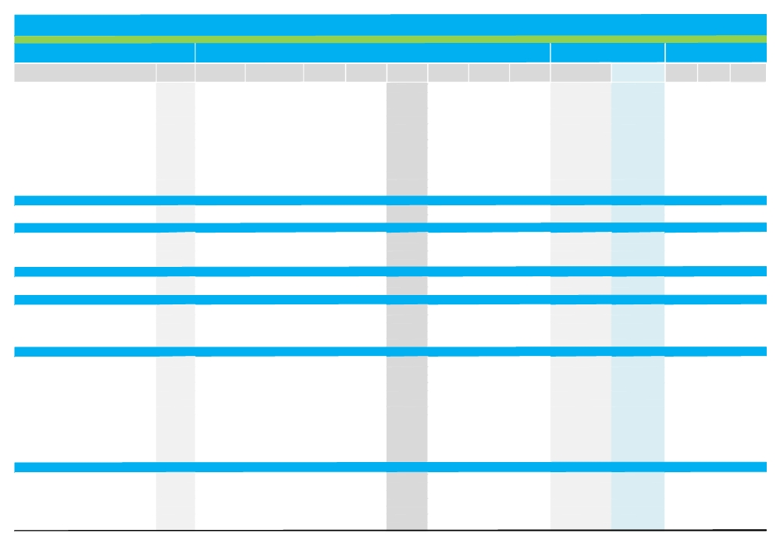

Abu Dhabi Securities Exchange Trading & Valuation Data Summary

Monthly Trading Indicators

Reuters Traded Volume Traded Value Number of Avg. Traded Closing Price

Market Cap.

MTM Price
September-12

Month-End Valuation
Indicators
Dividend

Company Name

▼ Abu Dhabi Commercial Bank
▲ Abu Dhabi Islamic Bank
▲ Bank Of Sharjah
▲ Commercial Bank International
▲ First Gulf Bank
▼ Finance House
▲ Invest Bank
▲ National Bank Of Abu Dhabi
▼ National Bank of Fujairah
▲ National Bank of Umm Al-Qaiwain
▲ National Bank of Ras Al-Khaimah
═ Sharjah Islamic Bank
▼ United Arab Bank
▼ Union National Bank
▲ Banks Sector
═ Oman & Emirates Inv. Holding Co.
═ Waha Capital Co.
═ Investment & Financial Services Sector
▲ AL DAR Properties Co.
▲ Eshraq Properties Co.
═ Ras Al Khaimah Properties
▲ Sorouh Real Estate Co.
▲ Real Estate Sector
▲ DANA GAS
▼ Abu Dhabi National Energy Co.
▲ Energy Sector
▼ AGTHIA Group
═ International Fish Farming Co.
═ FOODCO Holding Company
▼ Ras Al Khaimah Poultry & Feeding Co.
═ Gulf Livestock Company
▼ Consumer Staples Sector
▼ Arkan Building Materials Co.
═ Fujairah Building Industrial Co.
▲ Fujairah Cement Industries Co.
▼ Gulf Cement Co.
▲ Umm Al-Qaiwain Cement Industries Co.
═ Ras Al Khaimah Cement Co.
▲ Ras Al Khaimah Ceramic Co.
▼ Ras Al Khaimah White Cement
▲ Sharjah Cement Industrial Dev. Co. ▼ Union Cement Co.
▲ Abu Dhabi Ship Building Co.
▼ Abu Dhabi National Co. for Building Materials ▲ Gulf Pharmaceutical Co.
▼ Industrial Sector
▼ Al Buhaira National Insurance Co.
▼ Abu Dhabi National Insurance Co.
═ Al Fujairah National Insurance Co.
▼ Al Khazna Insurance Co.
═ Al Ain Al Ahlia Insurance Co.
═ Al Wathba Insurance Co.
═ Al Dhafra Insurance Co.
Ticker ('000 Shares) ('000 AED)
ADCB.AD 13,833 45,872
ADIB.AD 4,770 15,474
BOS.AD 12,442 14,498
CBI.AD 29 27
FGB.AD 16,071 157,964
FH.AD 2,198 6,580
INVB.AD 1,294 2,195
NBAD.AD 7,501 66,084
NBF.AD 22 109
NBQ.AD 3,957 6,454
RAKB.AD 843 3,514
SIB.AD 1,746 1,559
UAB.AD 612 1,878
UNB.AD 11,489 36,044
76,806 358,251
OEIH.AD 120 84
OILC.AD 9,728 5,371
9,848 5,455
ALDR.AD 266,516 334,470
ESHRAQ.AD 27,377 8,712
RPRO.AD 43,786 15,456
SOR.AD 284,617 336,424
622,296 695,062
DANA.AD 205,133 85,832
TAQA.AD 9,563 12,640
214,695 98,472
AGTH.AD 6,429 12,563
ASMK.AD 0 0
FOOD.AD 0 0
RAKP.AD 20 22
GLS.AD 0 0
6,449 12,586
ARKN.AD 5,302 4,170
FBI.AD 0 0
FCI.AD 259 246
GCEM.AD 489 475
QCEM.AD 15,800 12,484
RKCC.AD 40,490 29,352
RKCE.AD 1,766 1,982
RAKC.AD 140 200
SCID.AD 235 173
UCC.AD 93 85
ADSB.AD 9 9
BILD.AD 331 219
GPHI.AD 352 1,050
65,264 50,445
ABNI.AD 4,104 32,785
ADNI.AD 39 210
AFNI.AD 0 0
AKIC.AD 445 343
AAIC.AD 0 0
AWNI.AD 219 459
DHAF.AD 0 0
Deals Price (AED)* (AED)
370 3.32 3.25
157 3.24 3.26
174 1.17 1.25
2 0.92 0.95
1,770 9.83 9.99
12 2.99 2.86
17 1.70 1.65
310 8.81 9.10
1 4.94 4.94
13 1.63 1.97
18 4.17 4.40
39 0.89 0.89
12 3.07 2.86
219 3.14 3.04
3,114
8 0.70 0.70
141 0.55 0.54
149
3,694 1.25 1.25
265 0.32 0.33
325 0.35 0.34
3,186 1.18 1.18
7,470
1,523 0.42 0.42
176 1.32 1.28
1,699
152 1.95 1.95
0 NA 15.55
0 NA 1.56
2 1.10 1.10
0 NA 6.98
154
172 0.79 0.77
0 NA 2.01
2 0.95 0.95
29 0.97 0.96
7 0.79 0.80
430 0.72 0.69
56 1.12 1.19
4 1.43 1.27
6 0.74 0.74
5 0.92 0.92
5 1.06 1.09
13 0.66 0.66
16 2.98 3.00
745
4 7.99 7.20
4 5.41 5.40
0 NA 225.0
13 0.77 0.79
0 NA 39.00
4 2.10 2.10
0 NA 6.43
High (AED) Low (AED)
Change
(3.56%) 3.45 3.26
0.31% 3.31 3.09
12.61% 1.24 1.10
13.10% 1.05 0.84
4.72% 10.15 8.90
(1.38%) 3.00 2.90
1.85% 1.63 1.53
6.81% 8.87 8.31
(6.79%) NA NA
8.84% NA NA
7.32% 4.10 3.91
0.00% 0.91 0.85
(10.63%) 3.20 3.05
(4.70%) 3.30 2.93
2.46%
0.00% 0.75 0.70
0.00% 0.57 0.53
0.00%
4.17% 1.28 1.15
6.45% 0.32 0.29
0.00% 0.36 0.33
9.26% 1.11 1.04
5.59%
10.53% 0.42 0.38
(2.29%) 1.32 1.22
0.72%
(3.47%) 2.04 1.95
0.00% NA NA
0.00% NA NA
(4.35%) 1.15 1.13
0.00% NA NA
(1.57%)
(1.28%) 0.89 0.77
0.00% NA NA
5.56% NA NA
(4.95%) 1.05 0.93
2.56% 0.78 0.78
0.00% 0.71 0.68
7.21% 1.18 1.06
(12.41%) 1.55 1.45
2.78% 0.72 0.72
(8.91%) 1.01 0.85
1.87% 1.13 1.01
(2.94%) 0.73 0.65
0.67% 3.04 2.78
(1.14%)
(10.00%) NA NA
(3.74%) NA NA
0.00% NA NA
(1.25%) 0.85 0.80
0.00% NA NA
0.00% 2.10 2.00
0.00% NA NA
('000 AED) ('000 USD) P/E (X) P/B (X)
Yield
18,185,691 4,951,455 6.86 0.80 6.15%
7,708,941 2,098,929 6.48 0.90 7.49%
2,625,000 714,714 12.78 0.70 8.00%
1,273,014 346,606 8.46 0.68 0.00%
29,970,000 8,159,992 7.70 1.10 5.01%
865,150 235,556 12.81 1.69 6.99%
2,062,500 561,561 6.41 0.94 5.60%
35,258,482 9,599,897 9.18 1.25 2.44%
5,434,000 1,479,526 18.66 2.59 2.02%
3,152,000 858,201 9.86 0.97 7.61%
6,704,983 1,825,579 5.23 1.35 5.17%
2,158,695 587,752 7.79 0.49 6.74%
2,849,708 775,896 7.30 1.40 6.99%
7,586,700 2,065,646 4.86 0.57 4.93%
1 25,834,864 34,261,310 7.65 1.01 4.66%
85,313 23,228 3.55 0.52 0.00%
1,024,427 278,923 8.36 0.48 9.26%
1,109,740 302,151 7.57 0.49 8.55%
5,106,411 1,390,333 4.18 0.66 4.00%
495,000 134,775 NM 0.48 18.18%
680,000 185,145 6.25 0.19 0.00%
3,097,500 843,363 7.91 0.48 4.24%
9,378,911 2,553,615 5.42 0.50 4.54%
2,772,000 754,738 4.09 0.33 0.00%
7,968,000 2,169,463 6.95 1.08 7.81%
10,740,000 2,924,201 5.89 0.68 5.80%
1,170,000 318,558 11.51 1.10 0.00%
777,500 211,691 NM 1.00 0.00%
156,000 42,474 8.43 0.59 3.21%
95,040 25,877 NM 0.31 6.36%
698,000 190,046 NM 2.76 0.00%
2,896,540 788,647 24.79 1.09 0.38%
1,347,500 366,887 54.12 0.83 0.00%
254,265 69,229 NM 1.23 0.00%
338,072 92,048 NM 0.37 0.00%
788,253 214,619 NM 0.65 0.00%
290,400 79,068 10.35 0.59 8.75%
333,960 90,928 NM 0.45 0.00%
804,010 218,909 3.48 0.37 0.00%
593,090 161,482 11.83 0.85 7.87%
409,189 111,411 NM 0.32 6.08%
615,883 167,688 49.07 0.50 0.00%
231,071 62,914 NM 0.45 4.59%
198,000 53,910 NM 0.67 0.00%
2,354,060 640,945 13.18 1.46 0.00%
8,557,753 2,330,037 25.11 0.66 1.26%
1,800,000 490,090 NM 2.87 0.00%
2,025,000 551,351 14.08 1.02 6.48%
225,000 61,261 27.90 2.26 0.00%
323,900 88,189 33.16 0.52 0.00%
585,000 159,279 14.91 0.61 7.69%
378,000 102,919 12.74 0.90 3.17%
643,000 175,071 14.22 2.13 5.60%

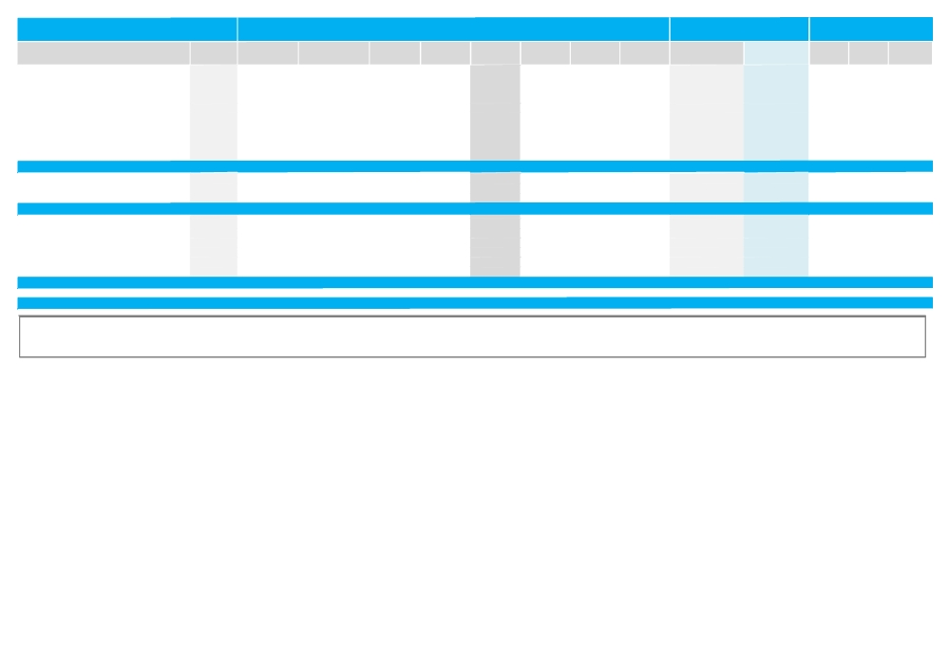

Reuters

Traded Volume Traded Value
Monthly Trading Indicators

Number of Avg. Traded Closing Price
Market Cap.

MTM Price
Month-End Valuation
Indicators
Dividend

Company Name
═ Emirates Insurance Co.
═ Green Crescent Insurance Co.
▲ Methaq Takaful insurance Co.
═ Ras Al Khaimah National Insurance Co.
═ Sharjah Insurance Co.
═ Abu Dhabi National Takaful Co.
═ United Insurance Co.
▼ Union Insurance Co.
▼ Insurance House P.S.C
▼ National Takaful Co. (Watania)
▼ Insurance Sector
▲ Emirates Telecom. Co.
▲ Qatar Telecom. Co.
═ Sudan Telecom. Co.
▲ Telecommunication Sector
▼ Abu Dhabi Aviation Co.
▲ Abu Dhabi National Hotels
▼ Emirates Driving Co.
═ Gulf Medical Projects
▲ National Corp for Tourism & Hotels ▼ National Marine Dredging Co.
▼ Services Sector

▲ Total Market

Source: Abu Dhabi Securities Exchange
Ticker ('000 Shares) ('000 AED)
EIC.AD 31 202
GCIC.AD 4,485 1,359
METH.AD 56,364 61,469
RAKN.AD 0 0
SIC.AD 0 0
TKFL.AD 0 0
UIC.AD 0 0
UNIN.AD 2,077 2,576
IH.AD 40 37
IH.AD 0 0
67,803 99,440
ETEL.AD 32,542 312,958
QTEL.AD 2 202
SDTL.AD 1,508 1,546
34,052 314,706
ADAV.AD 631 1,828
ADNH.AD 5,032 8,548
DRIV.AD 1,891 5,399
GMPC.AD 0 0
NCTH.AD 5 29
NMDC.AD 391 4,037
7,950 19,841

1,105,163 1,654,258
Deals Price (AED)* (AED)
4 6.50 6.50
68 0.30 0.29
1,170 1.09 1.05
0 NA 3.75
0 NA 5.00
0 NA 5.62
0 NA 2.00
1 1.24 1.24
3 0.92 0.90
0 NA 0.98
1,271
4,133 9.62 9.64
3 102.66 115.0
49 1.03 1.03
4,185
14 2.90 2.98
11 1.70 1.75
10 2.85 2.85
0 NA 2.00
2 5.60 5.60
16 10.32 10.35
53

18,840
High (AED) Low (AED)
Change
0.00% 6.50 6.50
0.00% 0.31 0.27
1.94% 1.12 0.98
0.00% NA NA
0.00% NA NA
0.00% NA NA
0.00% NA NA
(0.80%) NA NA
(5.26%) 0.95 0.95
(14.78%) 1.15 0.91
(3.18%)
1.47% 9.65 9.01
13.86% 106.00 101.00
0.00% 1.06 1.02
5.15%
(0.67%) 3.02 2.90
2.34% 1.76 1.67
(5.00%) NA NA
0.00% 2.00 1.98
0.72% 5.56 5.52
(1.43%) 10.50 10.20
(0.10%)

3.10%
('000 AED) ('000 USD) P/E (X) P/B (X)
Yield
877,500 238,919 9.07 1.17 0.09%
72,500 19,740 NM 0.94 0.00%
157,500 42,883 NM 1.82 0.00%
375,000 102,102 16.76 2.01 4.00%
687,500 187,187 59.07 3.41 2.00%
562,000 153,017 21.13 3.77 2.02%
200,000 54,454 NM 1.46 0.00%
410,365 111,731 NM 1.75 0.00%
108,000 29,405 55.59 0.88 0.00%
147,000 40,024 NM 1.07 0.00%
9,577,265 2,607,621 35.05 1.35 2.77%
76,182,227 20,742,287 12.48 1.89 7.26%
36,836,800 10,029,629 14.48 1.44 1.43%
1,158,650 315,468 6.72 0.22 2.80%
114,177,677 31,087,384 12.95 1.60 5.34%
1,204,969 328,079 5.14 0.69 5.03%
1,750,000 476,476 6.70 0.21 2.86%
255,891 69,672 6.66 0.79 7.02%
1,207,500 328,768 12.30 1.69 2.50%
1,120,000 304,945 11.37 2.05 7.37%
2,358,232 642,081 5.32 0.81 4.83%
7,896,592 2,150,021 6.72 0.53 4.50%

290,169,342 79,004,987 9.40 1.07 4.77%

NM: Not Meaningful. N/A: Not Available, NA: Not Applicable, Trailing P/E is based on the net profit for the TTM period ended June‐2012 and current market cap. If calculated P/E is negative or greater than 80, it is represented by NM. Trailing P/B is based on equity as at 30‐June‐2012 and current market cap. Dividend Yield for individual stocks is based on Full Year 2011 Dividend per Share & month end closing prices, while the average for sectors is a weighted average based on market cap and total cash dividends.*Average Traded price for the month is calculated by dividing total traded value over total traded volume for the month. MTM: Month‐to‐ Month price change for individual stocks is calculated based on the change in closing prices, while that for sectors and market are based on the change in market capitalization.

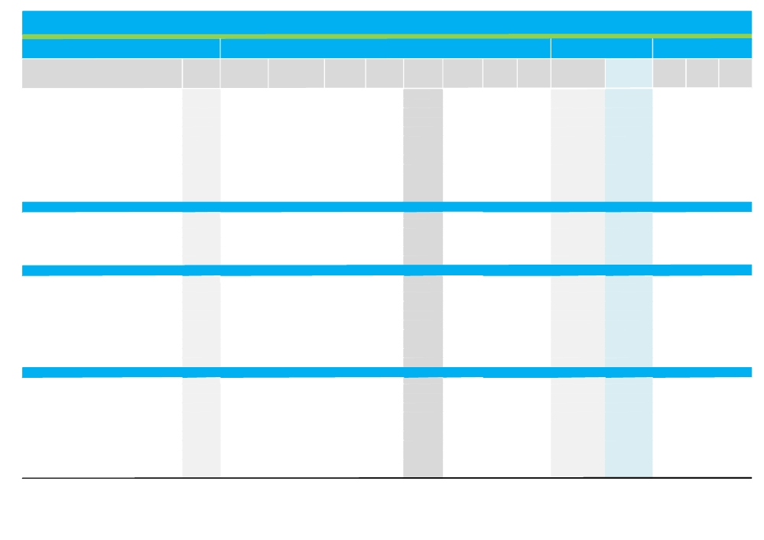

Dubai Financial Market Trading & Valuation Data Summary

Traded Volume Traded Value

Monthly Trading Indicators

Number of Avg. Traded Closing

Market Cap.

MTM Price
September-12

Month-End Valuation
Indicators

Trailing P/E Trailing P/B Dividend

Company Name Reuters Ticker

═ Arab Emirates Investment Bank AEIB.DU
▲ Ajman Bank AJBNK.DU
▲ Al Salam Bank - Sudan SSUD.DU
═ Amlak Finance AMLK.DU
▲ Commercial Bank of Dubai CBD.DU
▲ Dubai Islamic Bank DISB.DU
═ Emirates Islamic Bank EIB.DU
▼ Emirates NBD ENBD.DU
▼ Gulf Finance House GFH.DU
▲ Mashreq Bank MASB.DU
▼ Al Salam Bank - Bahrain SALAM.DU
▲ TAMWEEL TAML.DU
▲ Banking Sector

═ Dubai Refreshments Co. DRC.DU
═ Gulfa Mineral Water & Processing Industries Co. GULF.DU
═ Jeema Mineral Water JEEM.DU
═ United Foods Company UFC.DU
═ United Kaipara Dairies Co. UNIK.DU
═ Consumer Staples Sector

═ Al Firdous Holding PJSC ALFH.DU
▲ Al-Madina for Finance & Investment MADI.DU
▲ Dubai Financial Market DFM.DU
▲ Dubai Investment DINV.DU
▲ Ekttitab Holding Company EKTT.DU
▲ Gulf General Investment Co. GGIC.DU
═ Global Investment House GLOB.DU
▲ Int'l Financial Advisors Co. IFIN.DU
▼ SHUAA Capital* SHUA.DU
▲ Investment & Financial Sector

═ Alliance Insurance ALL.DU
▲ Dubai Islamic Insurance & Reinsurance Co. AMAN.DU
═ Arab Orient Insurance Co. AOIC.DU
═ Arab Insurance Group ARIG.DU
═ Arabian Scandinavian Insurance Co. ASCI.DU
═ Al Sagr National Insurance Co. ASNC.DU
▼ Takaful House DTKF.DU
▲ Dubai Insurance DINC.DU
▼ Dubai National Insurance & Reinsurance DNIN.DU
▲ Islamic Arabic Insurance Co. IAIC.DU
('000 Shares) ('000 AED) Deals

0 0 0
5,672 4,628 236
1,093 1,693 53
0 0 0
78,760 228,381 29
27,271 53,422 860
0 0 0
4,488 13,603 155
334,937 166,289 3,371
3 160 4
7,047 2,759 118
151,156 196,419 2,037
610,427 667,354 6,863

0 0 0
0 0 0
0 0 0
0 0 0
1 298 1
1 298 1

0 0 0
3,450 2,832 142
140,718 140,226 2,226
109,204 87,411 1,326
23,693 27,633 681
74,029 24,471 50
0 0 0
2 2 2
2,531 1,543 89
353,627 284,118 4,516

0 0 0
25,254 24,194 461
0 0 0
0 0 0
0 0 0
0 0 0
2,847 1,719 99
300 790 3
16 35 2
62,172 43,814 910
Price (AED)* Price (AED) Change (%) High (AED)

NA 950.000 0.00% NA
0.816 0.816 2.51% 0.800
1.549 1.690 11.18% 1.580
NA 1.020 0.00% NA
2.900 2.960 3.50% 2.860
1.959 1.980 1.54% 2.000
NA 0.680 0.00% NA
3.031 2.980 (1.65%) 3.100
0.496 0.476 (6.67%) 0.532
53.013 55.000 4.46% 52.650
0.391 0.415 (1.19%) 0.429
1.299 1.280 5.79% 1.290
1.16%

NA 12.250 0.00% 12.250
NA 2.870 0.00% NA
NA 6.050 0.00% NA
NA 5.600 0.00% NA
330.600 330.600 0.00% NA
0.00%

NA 0.700 0.00% NA
0.821 0.800 25.59% 0.681
0.997 0.975 3.07% 1.010
0.800 0.810 9.61% 0.780
1.166 1.110 14.91% 0.966
0.331 0.353 2.02% 0.346
NA 0.615 0.00% NA
0.752 0.840 13.51% NA
0.610 0.600 (6.54%) 0.650
4.51%

NA 383.500 0.00% NA
0.958 1.040 14.16% 0.970
NA 88.350 0.00% NA
NA 1.800 0.00% NA
NA 2.090 0.00% NA
NA 4.550 0.00% NA
0.604 0.580 (1.02%) 0.665
2.633 2.640 1.54% NA
2.217 2.070 (15.51%) NA
0.705 0.705 2.32% 0.750
Low (AED) ('000 AED) ('000 USD)
(X) (X) Yield

NA 522,522 142,268 18.88 2.15 0.95%
0.771 816,000 222,174 30.74 0.79 0.00%
1.320 185,900 50,615 0.94 0.23 21.74%
NA 1,530,000 416,576 NM 1.06 0.00%
2.820 6,033,522 1,642,759 7.69 0.94 6.44%
1.900 7,518,167 2,046,986 7.42 0.82 6.31%
NA 867,287 236,138 NM 0.36 0.00%
2.700 16,562,170 4,509,415 9.96 0.47 6.71%
0.474 224,098 61,016 NM 0.19 0.00%
52.650 9,299,234 2,531,921 10.81 0.74 3.64%
0.380 621,412 169,193 NM 0.32 0.00%
1.210 1,280,000 348,508 15.32 0.56 0.00%
45,460,311 12,377,570 11.80 0.61 5.30%

12.250 1,102,500 300,180 6.92 1.96 3.27%
NA 71,750 19,536 18.00 1.85 0.00%
NA 181,500 49,417 NM 4.47 0.00%
NA 140,000 38,118 7.20 0.87 0.00%
NA 100,007 27,229 NM 0.78 0.00%
1,595,757 434,480 11.28 1.71 2.26%

NA 420,000 114,354 NM 0.67 0.00%
0.630 300,867 81,918 NM 0.36 0.00%
0.945 7,800,000 2,123,722 NM 1.04 0.00%
0.723 2,892,020 787,416 21.58 0.35 6.17%
0.865 253,773 69,095 NM 0.84 0.00%
0.305 632,341 172,169 NM 0.51 0.00%
NA 802,822 218,586 NM 28.88 0.00%
NA 604,800 164,670 NM 0.46 0.00%
0.620 639,000 173,982 NM 0.56 0.00%
14,345,623 4,403,302 NM 0.67 1.24%

NA 383,500 104,416 9.44 1.15 3.91%
0.911 223,600 60,880 NM 1.63 0.00%
NA 357,818 97,424 1.62 0.33 20.96%
NA 396,000 107,820 NM 0.46 0.00%
NA 292,600 79,667 10.86 1.07 4.78%
NA 1,046,500 284,933 58.16 1.80 0.00%
0.530 58,000 15,792 NM 0.97 0.00%
NA 264,000 71,880 9.21 0.98 7.58%
NA 227,700 61,996 9.30 1.38 7.25%
0.653 853,050 232,262 26.17 0.53 0.00%

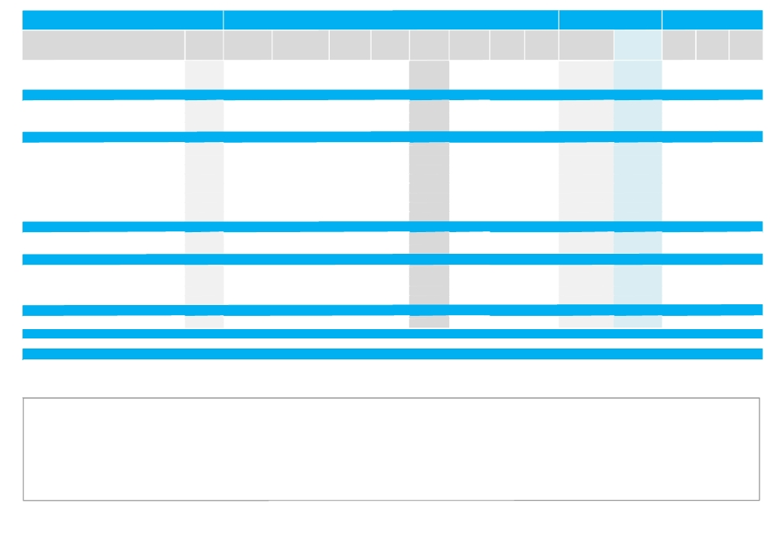

Company Name Reuters Ticker

▲ National General Insurance NGIN.DU
═ Oman Insurance Co. OIC.DU
▼ Takaful Emarat TKFE.DU
▲ Insurance Sector
═ ACICO Industries Co. ACIC.DU
═ National Cement Co. NCC.DU
═ National Industries Group Holdings NIND.DU
═ Materials Sector
═ Arab Heavy Industries AHI.DU
▼ Arab Technical Construction Co. ARTC.DU
═ Dubai Development Company DDC.DU
▲ Deeyar Development Co. DEYR.DU
▼ Drake and Scull International DSI.DU
▲ EMAAR Properties EMAR.DU
▼ Al Mazaya Holding Co. MAZA.DU
▲ Union Properties UPRO.DU
▲ Real Estate & Construction Sector
▲ Emirates Integrated Telecommunications Co. DU.DU
═ Hits Telecom Holding Co. HITS.DU
▲ Telecommunication Sector
▲ Air Arabia Co. AIRA.DU
▲ Gulf Navigation Holding GNAV.DU
▲ Arab International Logistics Co. ARMX.DU
═ Agility (PWC Logistics) WARE.DU
▲ Transportation Sector
▲ National General Cooling Co. (Tabreed) TABR.DU
▲ Utilities Sector

▲ Total Market

Source: Dubai Financial Market

Traded Volume Traded Value
('000 Shares) ('000 AED)

681 2,775
0 0
16,273 9,994
107,541 83,320
0 0
0 0
0 0
0 0
0 0
84,382 223,762
0 0
208,132 77,453
353,755 301,886
239,557 833,228
353 343
82,165 32,864
968,345 1,469,535
26,057 90,117
69,386 63,940
95,442 154,058
91,824 59,922
304,281 76,985
55,236 105,099
0 0
451,341 242,007
128,387 165,008
128,387 165,008

2,715,112 3,065,698
Monthly Trading Indicators

Number of Avg. Traded Closing
Deals Price (AED)* Price (AED)

10 4.075 5.830
0 NA 7.810
305 0.614 0.590
1,790
0 NA 5.250
0 NA 2.340
0 NA 21.700
0
0 NA 193.350
2,845 2.652 2.520
0 NA 2.240
1,346 0.372 0.360
4,268 0.853 0.825
7,048 3.478 3.480
34 0.971 1.050
793 0.400 0.391
16,334
1,048 3.459 3.520
1,358 0.922 0.872
2,406
1,260 0.653 0.660
1,955 0.253 0.254
714 1.903 1.940
0 NA 17.600
3,929
1,632 1.285 1.280
1,632

37,471
Market Cap.

MTM Price
Low (AED) ('000 AED) ('000 USD)
Change (%) High (AED)

7.37% 6.030 5.430 874,232 238,029
0.00% NA NA 3,607,221 982,145
(5.30%) 0.690 0.530 88,500 24,096
0.74% 8,672,721 2,361,339
0.00% NA NA 1,243,941 338,690
0.00% NA NA 839,592 228,597
0.00% NA NA 27,560,932 7,504,070
0.00% 29,644,466 8,071,358
0.00% NA NA 129,981 35,390
(9.35%) 3.080 2.740 3,955,770 1,077,045
0.00% NA NA 22,400 6,099
0.28% 0.399 0.326 2,080,080 566,348
(4.62%) 0.970 0.858 1,886,500 513,641
5.14% 3.510 3.260 21,197,510 5,771,488
(7.08%) 1.130 1.120 524,451 142,793
1.56% 0.408 0.382 1,316,441 358,430
1.71% 31,113,133 8,953,356
3.23% 3.670 3.200 16,091,429 4,381,245
(5.22%) 0.953 0.870 628,640 171,161
2.88% 16,720,068 4,552,406
0.15% 0.669 0.631 3,080,022 838,604
0.40% 0.257 0.241 420,370 114,455
9.60% 1.830 1.760 2,840,354 773,349
0.00% NA NA 18,424,326 5,016,428
1.04% 24,765,072 6,742,836
4.92% 1.320 1.210 843,601 229,689
4.92% 843,601 229,689

1.46% 173,160,751 48,126,336
Month-End Valuation
Indicators

Trailing P/E Trailing P/B Dividend
(X) (X) Yield

40.74 2.70 2.57%
52.51 2.44 1.16%
NM 0.97 0.00%
21.09 1.20 2.36%
NM 1.20 0.00%
14.27 0.52 8.55%
NA NA NA
NM 3.14 0.24%
5.29 0.66 12.93%
14.26 1.32 1.89%
NM 1.21 0.00%
NM 0.53 0.00%
10.12 0.70 3.46%
9.05 0.67 3.66%
NM 0.48 0.00%
NM 0.53 0.00%
16.72 0.66 2.99%
11.98 2.59 4.26%
NM 0.50 0.00%
12.48 2.24 4.10%
9.44 0.60 6.82%
NM 0.33 0.00%
12.33 1.49 2.58%
NM 1.57 0.00%
51.21 1.23 1.14%
4.18 0.22 0.00%
4.18 0.22 0.00%

25.48 0.90 2.77%

NM: Not Meaningful. N/A: Not Available, NA: Not Applicable, Trailing P/E is based on the net profit for the TTM period ended Q2‐12 and current market cap. If calculated P/E is negative or greater than 80, it is represented by NM. Trailing P/B is based on equity as of 30‐June‐2012 and current market cap. Dividend Yield for individual stocks is based on Full Year 2011 Dividend per Share & month end closing prices, while the average for sectors is a weighted average based on market cap and total cash dividends.*Average Traded price for the month is calculated by dividing total traded value over total traded volume for the month. MTM: Month‐to‐Month price change for individual stocks is calculated based on the change in closing prices, while that for sectors and market are based on the change in market capitalization.
We have excluded all the losses incurred by the Kuwaiti companies listed in DFM and Gulf Finance House while calculating the Price-to-Earnings Multiple (P/E) for the aggregate market and their respective sector.

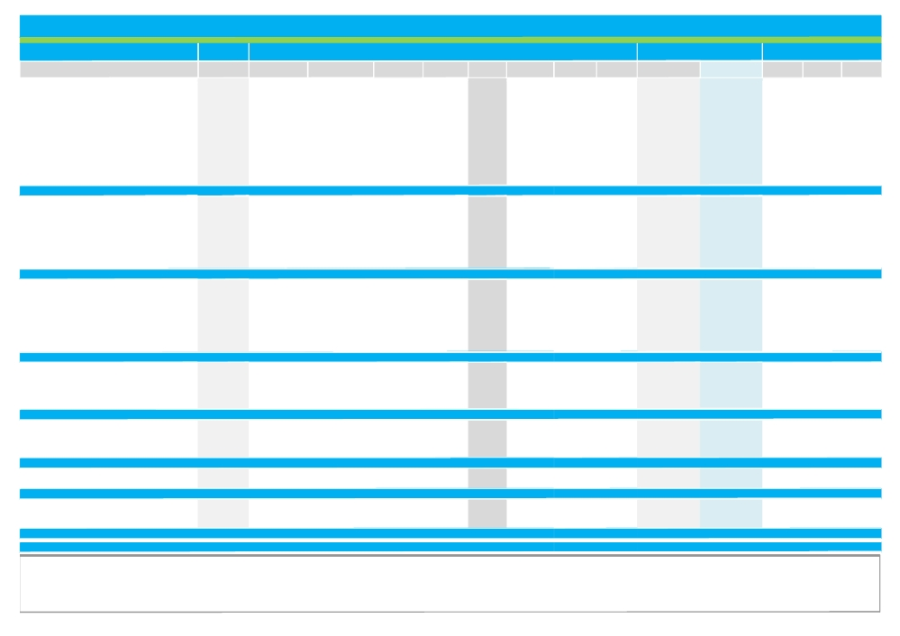

Qatar Exchange Trading & Valuation Data Summary

Monthly Trading Indicators

Traded Volume Traded Value Avg. Traded Closing

Market Cap.

MTM Price
September-12

Month-end Valuation Multiples

Trailing Trailing P/B Dividend

Company Name Reuters Ticker

▲ Qatar National Bank QNBK.QA
▼ Qatar Islamic Bank QISB.QA
▲ The Commercial Bank of Qatar COMB.QA
▼ Doha Bank DOBK.QA
▼ Al Ahli Bank of Qatar AABQ.QA
▲ Qatar International Islamic Bank QIIB.QA
▼ Al Rayan Bank MARK.QA
▼ Al Khaleej Commercial Bank AKCB.QA
▲ National Leasing Co. NLCS.QA
▼ Dlala Brokerage & Investment Holding Co DBIS.QA
▼ Qatar Oman Investement Company QOIS.QA
▲ Islamic Finance Securities IHGS.QA
▲ Banking & Finance Sector
▼ Zad Holding Co. ZHCD.QA
▲ Qatari German Co. for Medical Devices QGMS.QA
▲ Salam International Investment SIIS.QA
▼ Medicare Group MCGS.QA
▲ Qatar Cinema & Film Distribution QCFD.QA
▲ Qatar Fuel Co. (Wokod) QFLS.QA
▲ Qatar Meat & Livestock Trading Co. QMLS.QA
▼ AL MEERA CONSMR MERS.QA
▲ Consumer Goods & Services
▲ Qatar Industrial Manufacture QIMD.QA
▲ Qatar National Cement QNCD.QA
▲ Industries Qatar IQCD.QA
▼ Gulf Holding Co. KHCD.QA
▼ Qatar Electricity & Water Co. QEWC.QA
▲ Mannai Corporation Q.S.C MCCS.QA
▼ Aamal Company W.L.L AHCS.QA
▲ GULF INTERNATIONAL SERVICES GISS.QA
▲ Industrial Sector
▼ Qatar Insurance QINS.QA
▲ Doha Insurance DICO.QA
▲ Qatar General Insurance & Reinsurance QGIR.QA
▲ Al-Khaleej Insurance AKHI.QA
▼ Qatar Islamic Insurance QIIC.QA
▼ Insurance Sector
▼ United Development Co. UDCD.QA
▲ Barwa Real Estate Co. BRES.QA
▼ Ezdan Real Estate Co. ERES.QA
▲ Mazaya Qatar Real Estate Development Co. MRDS.QA
▼ Real Estate Sector
▼ Qatar Telecommunications (Q-Tel) QTEL.QA
▲ VODAFONE VFQS.QA
▼ Telecom Sector
▲ Qatar Navigation QNNC.QA
▼ Gulf Warehousing Co. GWCS.QA
▼ Qatar Gas Transport Co. QGTS.QA
▼ Transport Sector

▲ Total Market
Source: Qatar Exchange
('000 Shares) ('000 QAR)
2,201 298,212
1,023 79,498
4,103 304,894
2,389 134,099
226 14,257
582 30,221
7,822 212,325
1,451 25,331
4,551 221,132
443 18,991
5,984 73,191
4,875 185,197
3 5,650 1 ,597,350
200 11,694
8,996 121,702
2,235 30,263
1,266 51,628
4 222
726 204,800
5,365 371,862
117 19,438
1 8,909 811,610
106 5,870
324 34,190
1,829 258,080
3,794 97,188
561 75,701
14 1,386
1,393 22,528
3,231 88,455
1 1,252 583,397
296 20,807
95 2,762
28 1,372
815 37,629
58 3,376
1,291 65,944
6,812 128,314
22,010 660,523
1 38,472 2,857,312
4,598 54,595
1 71,892 3 ,700,744
1,758 186,584
10,776 97,745
12,534 284,329
1,196 72,749
1,239 50,774
5,966 94,759
8,401 218,282

2 59,929 7 ,261,656
Number of Deals
Price Price
2,785 135.46 135.80
1,053 77.75 77.00
2,474 74.32 74.50
2,008 56.13 55.30
175 62.99 60.30
642 51.88 52.20
4,469 27.15 27.05
410 17.46 17.20
2,600 48.59 47.90
493 42.87 41.10
1,676 12.23 11.91
3,271 37.99 37.75
2 2,056
352 58.56 57.50
2,721 13.53 14.75
1,022 13.54 13.54
1,086 40.79 38.80
12 61.38 62.30
2,462 282.08 286.00
5,390 69.31 72.00
436 165.45 163.80
1 3,481
114 55.53 55.50
244 105.51 105.00
3,123 141.11 140.70
2,502 25.62 25.10
937 134.85 133.50
40 100.65 99.00
565 16.17 15.92
1,786 27.37 28.15
9,311
315 70.38 70.00
97 29.15 30.60
19 49.71 54.80
715 46.19 45.80
107 57.76 56.50
1,253
2,058 18.84 18.20
7,424 30.01 29.50
2,788 20.63 19.70
1,664 11.87 11.80
1 3,934
2,462 106.16 105.50
2,813 9.07 9.10
5,275
1,343 60.83 60.70
1,412 40.97 40.15
2,883 15.88 15.75
5,638

7 0,948
High (QAR) Low (QAR)
Change (%)
1.27% 133.50 130.10
(1.28%) 78.10 75.40
2.48% 70.00 67.70
(2.98%) 57.30 53.50
(5.78%) 65.10 54.50
1.75% 50.00 47.90
(0.55%) 27.30 26.55
(2.82%) 17.28 16.45
1.38% 40.90 38.10
(5.84%) 44.95 34.00
(0.33%) 13.05 9.90
4.28% 28.70 26.00
0.25%
(4.96%) 60.00 46.00
22.92% 14.80 11.20
2.11% 14.69 13.70
(5.37%) 41.75 37.05
9.30% 73.30 61.20
8.87% 236.30 231.00
10.77% 46.00 42.70
(1.92%) 183.90 164.40
6.36%
0.91% 52.60 50.70
0.48% 106.70 103.00
1.59% 135.50 126.00
(3.65%) 26.60 24.07
(2.05%) 139.00 130.20
1.02% 97.00 85.80
(3.28%) 16.46 15.61
4.26% 26.20 25.10
0.66%
(0.43%) 74.10 70.80
5.88% 27.60 25.75
15.37% 47.00 40.50
0.11% 44.50 40.00
(3.09%) 67.00 54.30
(2.11%)
(3.04%) 18.11 17.50
4.61% 27.45 26.50
(3.43%) 20.40 18.60
0.85% 13.19 11.80
(2.11%)
(2.13%) 114.00 106.20
1.11% 9.37 8.85
(1.55%)
1.17% 63.70 59.50
(2.90%) 44.75 36.40
(1.13%) 15.80 15.45
(0.39%)

0.13%
('000 QAR) ('000 USD)
P/E (X) (X) Yield
95,023,258 26,100,228 11.57 2.20 2.68%
18,194,576 4,997,541 13.18 1.66 5.84%
18,434,755 5,063,511 9.25 1.33 8.05%
11,430,388 3,139,608 9.21 1.64 8.14%
6,761,138 1,857,095 16.12 2.44 0.00%
7,901,449 2,170,307 11.58 1.68 6.70%
20,287,500 5,572,408 14.15 2.29 4.07%
6,192,000 1,700,769 12.75 1.16 5.81%
2,370,102 651,001 10.36 1.93 4.87%
822,000 225,780 24.14 3.55 2.43%
375,165 103,047 25.64 1.20 4.20%
151,000 41,475 25.44 3.53 0.00%
187,943,330 51,622,770 11.69 1 .91 4.20%
752,161 206,598 8.10 0.59 0.00%
170,363 46,794 NM 0.86 0.00%
1,547,820 425,143 13.07 0.97 6.71%
1,091,991 299,939 25.29 1.46 2.84%
355,721 97,707 19.00 2.72 2.19%
14,864,850 4,082,958 12.23 3.02 2.80%
1,296,000 355,975 13.42 5.24 4.17%
1,638,000 449,913 18.57 6.81 4.27%
21,716,906 5,965,026 13.84 2 .32 3.14%
2,197,800 603,674 9.62 1.77 5.41%
5,155,562 1,416,089 11.26 2.31 5.71%
77,385,000 21,255,493 9.77 2.96 5.33%
3,120,602 857,142 30.62 1.61 1.99%
13,350,000 3,666,871 10.76 4.76 4.87%
3,387,226 930,376 10.91 2.51 5.56%
8,668,440 2,380,978 18.23 1.46 0.00%
4,185,136 1,149,540 11.48 1.76 4.20%
117,449,767 32,260,162 10.68 2 .67 4.78%
6,243,241 1,714,844 11.34 1.93 4.76%
716,040 196,676 9.69 1.54 0.00%
2,746,960 754,513 14.75 1.10 2.12%
651,716 179,008 9.95 1.19 6.55%
847,500 232,785 18.82 3.36 5.31%
11,205,456 3,077,825 12.11 1 .60 3.95%
6,137,495 1,685,798 1.71 0.61 0.00%
11,479,177 3,153,008 10.03 0.94 3.39%
52,254,185 14,352,761 NM 1.90 0.76%
1,180,000 324,113 24.10 1.09 0.00%
71,050,857 19,515,681 13.46 1 .40 1.11%
33,793,760 9,282,200 13.69 1.33 1.56%
7,693,140 2,113,090 NM 1.19 0.00%
41,486,900 11,395,290 19.15 1 .30 1.27%
6,951,680 1,909,432 9.36 0.67 5.77%
1,591,311 437,089 22.87 2.39 3.74%
8,723,057 2,395,980 10.60 1.21 5.40%
17,266,048 4,742,500 10.54 0 .95 5.39%

468,119,263 128,579,254 12.12 1 .80 3.60%

NM: Not Meaningful. N/A: Not Available, NA: Not Applicable, Trailing P/E is based on the net profit for the TTM period ended Q2‐2012 and current market cap. If calculated P/E is negative or greater than 80, it is represented by NM. Trailing P/B is based on equity as at 30‐June‐2012 and current market cap. Dividend Yield for individual stocks is based on Full Year 2011 Dividend per Share & month end closing prices, while the average for sectors is a weighted average based on market cap and total cash
dividends.*Average Traded price for the month is calculated by dividing total traded value over total traded volume for the month. MTM: Month‐to‐Month price change for individual stocks is calculated based on the change in closing prices, while that for sectors and market are based on the change in market capitalization.

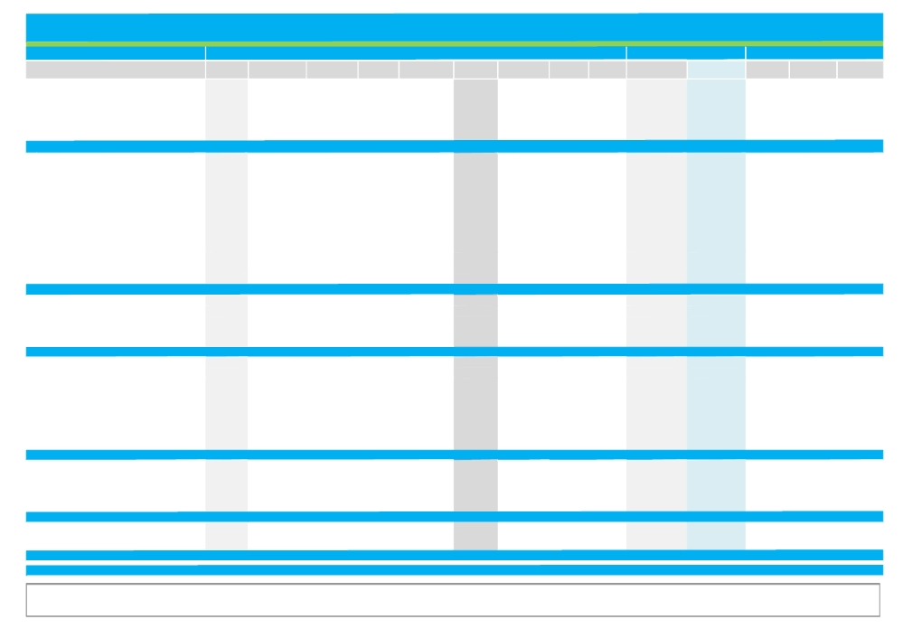

Bahrain Bourse Trading & Valuation Data Summary
Monthly Trading Indicators
Reuters Traded Volume Traded Value Number of Avg. Traded Closing

Market Cap.
MTM Price
September-12

Valuation Multiples
Trailing P/E Dividend

Company Name
═ Ahli United Bank (Price in USD)
▼ Bahrain Islamic Bank
═ Bank of Bahrain and Kuwait
▼ National Bank of Bahrain
═ Al Salam Bank
▲ Al Khaleej Commercial Bank
▼ Commercial Banks Sector
═ Inovest(Price in USD)
═ Arab Banking Corporation. (Price in USD)
▲ Bahrain Commercial Facilities Co.
═ Bahrain Middle East Bank
▼ Al Baraka Banking Group (Price in USD) ▲ Esterad Investment Co.
═ Gulf Finance House (Price in USD)
═ Investcorp Bank (Price in USD)
▲ Ithmar Bank (Price in USD)
═ Taib Bank (Price in USD)
═ United Gulf Bank
═ United Gulf Investment Corp
▼ Investment Sector
═ Al-Ahlia Insurance Co.
═ Arab Insurance Group (Price in USD)
▼ Bahrain and Kuwait Insurance Co.
▲ Bahrain National Holding Co.
═ Takaful International Co.
▼ Insurance Sector
▲ Bah. Ship. Repairing and Engineering Co.
═ Bahrain Car Park Co.
═ Bahrain Cinema Co.
▼ Bahrain Duty Free Complex
▲ Bahrain Mari. and Mer. Inter Co.
▼ Bahrain Telecommunications Co.
═ General Trading and Food Proc. Co.
▼ Nass Corporation
▲ Seef Properties
▲ Services Sector
═ Bahrain Family Leisure Co.
▼ Gulf Hotels Group
▲ Bahrain Toursim Co.
▲ BANADER Co. For Hotels
▼ National Hotels Co.
▼ Hotel & Tourism Sector
▲ Aluminum Bahrain Co.
═ Bahrain Flour Mills Co.
═ Delmon Poultry Co.
▲ Industrial Sector
▲ Total Market **
Ticker ('000 Shrs) ('000 BHD)
AUBB.BH 4,829 978
BISB.BH 132 12
BBKB.BH 436 167
NATB.BH 168 85
SALAM.BH 4,088 164
KHCB.BH 276 9
9,928 1,415
INOV.BH 0 0
ABCB.BH 0 0
BCFC.BH 1,351 593
BMEB.BH 0 0
BARKA.BH 55 18
EICB.BH 1,908 299
GFHB.BH 0 0
INVB.BH 0 0
ITHMR.BH 23,893 1,530
TAIB.BH 0 0
UGBB.BH 0 0
UGIC.BH 0 0
27,207 2,440
AAIC.BH 35 11
ARIG.BH 31 4
BKIC.BH 123 67
BNHB.BH 5 2
TAKA.BH 0 0
194 84
BSRC.BH 22 46
PARK.BH 0 0
CNMA.BH 8 7
DUTY.BH 299 208
BMMI.BH 443 274
BTEL.BH 806 327
GTFP.BH 1 0
NASS.BH 270 37
SEEF.BH 441 55
2,290 954
FMLY.BH 0 0
BHTL.BH 58 35
BTCB.BH 53 17
BANA.BH 526 29
NHTL.BH 15 6
652 87
ALBH.BH 273 137
BFMC.BH 2 1
DPCB.BH 5 1
280 139
40,552 5,120
Deals Price (BHD)* Price (BHD)
74 0.537 0.545
8 0.088 0.088
29 0.383 0.400
37 0.509 0.520
30 0.040 0.040
12 0.034 0.035
190
0 NA 0.225
0 NA 0.460
20 0.439 0.442
0 NA 0.066
10 0.849 0.840
20 0.157 0.165
0 NA 0.185
0 NA 797.0
266 0.170 0.170
0 NA 2.730
0 NA 0.234
0 NA 0.150
316
2 0.300 0.300
6 0.368 0.380
15 0.545 0.550
1 0.394 0.394
0 NA 0.290
24
9 2.061 2.200
0 NA 0.175
2 0.835 0.835
19 0.695 0.695
19 0.619 0.625
73 0.406 0.406
1 0.260 0.250
28 0.138 0.138
33 0.125 0.124
184
0 NA 0.105
7 0.612 0.620
6 0.312 0.320
2 0.055 0.059
2 0.410 0.410
17
71 0.501 0.520
1 0.380 0.366
1 0.260 0.252
73
804
High (BHD) Low (BHD)
Change (%)
0.00% 0.550 0.525
(2.22%) 0.088 0.088
0.00% 0.400 0.376
(2.80%) 0.540 0.500
0.00% 0.041 0.040
9.38% 0.035 0.033
(0.55%)
0.00% NA NA
0.00% NA NA
5.24% 0.442 0.420
0.00% NA NA
(6.67%) 0.855 0.840
5.77% 0.165 0.155
0.00% NA NA
0.00% NA NA
3.03% 0.180 0.160
0.00% NA NA
0.00% NA NA
0.00% NA NA
(0.05%)
0.00% 0.300 0.300
0.00% 0.380 0.380
(9.84%) 0.610 0.610
1.03% 0.394 0.394
0.00% NA NA
(2.46%)
10.00% 2.200 2.000
0.00% NA NA
0.00% 0.835 0.835
(0.71%) 0.700 0.690
4.17% 0.635 0.600
(0.98%) 0.410 0.400
0.00% 0.250 0.250
(0.72%) 0.140 0.137
1.64% 0.125 0.124
0.15%
0.00% NA NA
(0.80%) 0.625 0.600
3.23% 0.320 0.300
7.27% 0.059 0.055
(8.07%) 0.410 0.410
(1.70%)
4.42% 0.525 0.480
0.00% 0.366 0.366
0.00% 0.252 0.252
4.31%
0.23%
('000 BHD) ('000 USD) Trailing P/B (X)
(X) Yield
1,075,313 2,852,288 8.95 1.10 5.24%
82,691 219,340 NM 0.98 0.00%
340,542 903,296 20.90 1.37 6.25%
444,787 1,179,807 16.54 1.55 5.77%
59,883 158,840 NM 0.30 0.00%
40,396 107,150 5.69 0.34 0.00%
2,043,612 5,420,720 12.38 1.07 5.06%
24,303 64,465 11.07 0.36 0.00%
539,336 1,430,600 11.44 0.39 0.00%
72,201 191,514 9.25 0.91 7.92%
15,972 42,367 34.50 1.49 0.00%
321,273 852,183 11.58 0.69 9.47%
25,575 67,838 NM 0.61 0.00%
126,197 334,741 NM 1.02 0.00%
240,360 637,560 NM 0.61 0.00%
179,712 476,689 5.35 0.83 0.00%
115,645 306,750 64.81 9.37 0.00%
195,287 518,003 NM 0.92 0.00%
30,000 79,576 NM 0.87 5.33%
1,885,861 5,002,285 9.39 0.62 2.00%
18,566 49,246 NM 1.39 0.00%
31,517 83,600 NM 0.36 0.00%
39,325 104,310 32.15 1.38 4.13%
44,719 118,618 NM 1.14 5.08%
18,125 48,077 NM 2.56 0.00%
152,252 403,852 NM 0.86 2.56%
39,600 105,040 64.10 1.89 2.02%
12,306 32,641 NM 1.02 5.71%
45,994 121,999 36.31 1.48 5.99%
67,536 179,140 63.85 1.87 3.92%
83,198 220,684 24.75 1.70 4.80%
584,640 1,550,769 16.39 1.14 9.85%
20,169 53,498 NM 1.02 7.20%
30,360 80,531 11.11 0.58 10.87%
57,040 151,300 16.45 0.51 6.05%
940,842 2,495,601 19.52 1.11 8.15%
4,200 11,141 NM 0.93 0.00%
102,510 271,909 15.92 1.88 4.84%
23,040 61,114 NM 0.77 3.75%
8,850 23,475 NM 0.51 0.00%
41,000 108,753 NM 0.60 2.44%
179,600 476,392 37.61 1.03 3.80%
738,400 1,958,621 5.16 0.91 12.88%
9,089 24,108 16.84 0.53 5.46%
7,869 20,874 11.50 0.57 7.94%
755,358 2,003,602 5.23 0.90 12.74%
5,957,525 15,802,452 10.88 0.85 5.45%

** Excluding IPO Shares, Preferred Shares, Closed Companies, and Non-Bahraini Companies. Prices of Highlighted Companies are in USD, while Traded Value and Market Capitalization data is in BHD. 1 USD = 377 Bahraini Fils
Source: Bahrain Bourse
NM: : Not Meaningful. N/A: Not Available, NA: Not Applicable, Trailing P/E is based on the net profit for the TTM period ended 1H‐2012 and current market cap. If calculated P/E is negative or greater than 80, it is represented by NM. Trailing P/B is based on equity as at 30‐June‐2012 and current market cap. Dividend Yield for individual
stocks is based on Full Year 2011 Dividend per Share & month end closing prices, while the average for sectors is a weighted average based on market cap and total cash dividends.*Average Traded price for the month is calculated by dividing total traded value over total traded volume for the month. MTM: Month‐to‐Month price change for individual stocks is calculated based on the change in closing prices, while that for sectors and market are based on the change in market capitalization.

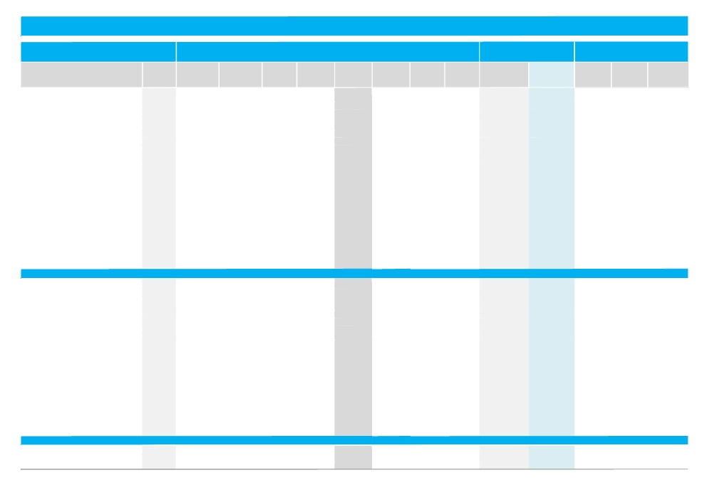

Muscat Securities Market Trading & Valuation Data Summary

Monthly Trading Indicators

Reuters Traded Volume Traded Value Number of Avg. Traded Closing

Market Cap.

MTM Price
September-12

Month-End Valuation
Indicators

Dividend

Company Name

▲ Bank Sohar
▼ Al Anwar Holding
▲ Al Omanyia Financial Services
▼ Al Sharqia Inv. Holding
▲ Ahli Bank
▼ Bank Dhofar
▼ Bank Muscat
▼ Dhofar Intl. Dev.& Invest. Holding ▼ Financial Services
═ The Financial Corporation
▼ Global Financial Investment Co. ▼ Gulf Investment Services
═ Muscat Finance Co.
═ Muscat National Holding
▲ National Bank of Oman
▼ Oman & Emirates Investment
▼ HSBC Bank Oman
▲ Dhofar Insurance
▲ Oman United Insurance
▼ OMINVEST
▲ ONIC. Holding
▲ Taageer Finance
▼ Transgulf Ind. Inv. Holding
▼ United Finance
▼ Banking & Investment
▲ Al Anwar Ceramic Tiles Co.
▲ Al Hassan Engineering
▼ Construction Materials Ind.
▼ Al Jazeera Steel Products Co.
▲ A Saffa Foods
▲ Dhofar Cattlefeed
═ Majan Glass
▲ Galfar Engineering
▲ Oman Refreshments
▲ National Aluminium Products
▼ Oman Fisheries Co.
═ Gulf International Chemicals
▲ Oman Cable Industry
▲ Oman Cement Co.
▲ Oman Chlorine
═ Oman Chromite
▼ Oman Flour Mills
═ Oman Packaging
▲ Raysut Cement
▼ Salalah Mills Co.
▼ Voltamp Energy
▲ Industrial
▲ ACWA Power Barka Co.
▲ Al Jazeira Services Co.
▲ Oman Investment & Finance Co.
Ticker ('000 Shares) ('000 OMR)

BKSB.OM 22,149 3,084
AITC.OM 20,329 2,685
AOF.OM 18,613 5,632
SINV.OM 1,646 176
ABOB.OM 5,048 844
BDOF.OM 690 262
BMAO.OM 21,756 12,120
DIDI.OM 3,012 961
FSCI.OM 1,826 123
FINC.OM - -
GFIC.OM 22,197 2,026
GIS.OM 38,047 3,393
MF.OM 6 1
MICO.OM - -
NBO.OM 19,960 5,366
OEIO.OM 9,417 1,085
OIB.OM 5,603 1,226
DICS.OM 2,030 361
OUIS.OM 10,125 1,819
OMAN.OM 2,360 852
ONIC.OM 6,145 1,664
TFC.OM 648 82
TGI.OM 7,528 650
UFIN.OM 4,983 663
2 24,117 4 5,075
AACT.OM 3,260 1,223
HEC.OM 33,573 5,881
CMI.OM 14,817 928
AJTM.OM 14,658 4,307
SPFI.OM 922 422
DCFI.OM 6,873 1,080
MGC.OM 1 0
GECS.OM 22,343 9,204
ORCI.OM 63 136
NAP.OM 13,725 3,117
OFCI.OM 13,323 1,448
GICI.OM 1,038 162
OCAB.OM 710 639
OCCO.OM 3,549 2,243
OCLO.OM 274 136
OCPP.OM 14.0 51
OFM.OM 456 224
OPCI.OM 645 129
RAYC.OM 2,063 2,805
SFM.OM 498 428
VOES.OM 2,097 685
1 34,903 3 5,249
AESB.OM 589 236
AJS.OM 5,278 1,594
OIFC.OM 24,920 4,791
Deals Price (OMR)* Price (OMR)

762 0.139 0.140
1,564 0.132 0.122
6 0.303 0.310
112 0.107 0.100
305 0.167 0.166
77 0.380 0.374
2,464 0.557 0.550
80 0.319 0.350
181 0.068 0.067
- NA 0.124
943 0.091 0.087
1,644 0.089 0.086
2 0.165 0.171
- NA 1.765
266 0.269 0.270
573 0.115 0.108
289 0.219 0.216
7 0.178 0.178
846 0.180 0.174
365 0.361 0.349
843 0.271 0.264
99 0.126 0.126
517 0.086 0.084
82 0.133 0.129
12,027
179 0.375 0.382
2,666 0.175 0.172
704 0.063 0.058
1,103 0.294 0.283
90 0.457 0.463
617 0.157 0.162
1 0.450 0.498
2,289 0.412 0.413
29 2.137 2.160
1,312 0.227 0.218
502 0.109 0.104
176 0.156 0.153
155 0.900 0.933
404 0.632 0.633
23 0.497 0.500
4 3.650 3.650
59 0.491 0.490
12 0.200 0.200
240 1.360 1.373
15 0.858 0.848
474 0.327 0.309
11,054
63 0.401 0.416
533 0.302 0.302
1,354 0.192 0.184
High (OMR) Low (OMR)
Change (%)

3.70% 0.142 0.135
(10.29%) 0.141 0.121
3.33% 0.310 0.305
(4.76%) 0.113 0.100
2.47% 0.171 0.162
(6.27%) 0.400 0.366
(0.54%) 0.570 0.545
(6.67%) 0.377 0.350
(5.63%) 0.072 0.065
0.00% NA NA
(5.43%) 0.095 0.086
(2.27%) 0.092 0.086
0.00% 0.165 0.163
0.00% NA NA
2.27% 0.272 0.265
(5.26%) 0.120 0.108
(3.14%) 0.225 0.215
4.09% 0.180 0.171
5.45% 0.189 0.167
(6.43%) 0.384 0.347
3.13% 0.278 0.260
1.61% 0.128 0.124
(4.55%) 0.091 0.084
(3.73%) 0.135 0.129
(1.05%)
4.37% 0.386 0.366
13.16% 0.192 0.157
(4.92%) 0.067 0.058
(4.07%) 0.304 0.277
2.89% 0.466 0.450
11.72% 0.166 0.145
0.00% 0.450 0.450
11.92% 0.439 0.369
10.71% 2.200 1.952
4.81% 0.237 0.211
(3.70%) 0.113 0.104
0.00% 0.160 0.152
6.63% 0.935 0.851
2.59% 0.652 0.614
2.04% 0.510 0.490
0.00% 3.650 3.650
(0.20%) 0.499 0.485
0.00% 0.200 0.200
3.16% 1.380 1.330
(3.09%) 0.875 0.845
(5.79%) 0.344 0.305
4.00%
8.90% 0.420 0.382
4.14% 0.315 0.285
12.20% 0.186 0.164
('000 OMR) ('000 USD) P/E (X) P/B (X)
Yield

140,000 363,499 7.81 1.06 5.71%
14,640 38,012 20.08 0.79 0.00%
60,611 157,370 11.79 1.69 5.13%
8,000 20,771 14.71 0.51 0.00%
199,815 518,804 9.35 1.50 0.00%
411,444 1,068,280 10.83 1.69 1.56%
1,121,181 2,911,056 8.71 1.25 3.45%
70,000 181,749 7.53 0.89 5.71%
4,355 11,307 NM 0.82 0.00%
8,684 22,547 NM 1.23 0.00%
19,953 51,806 8.05 0.53 0.00%
12,920 33,546 NM 0.82 0.00%
34,475 89,512 9.31 1.28 0.00%
8,825 22,913 9.55 0.59 4.25%
299,167 776,763 8.07 1.06 6.32%
13,163 34,175 6.12 0.77 0.00%
432,068 1,121,829 25.61 1.47 2.52%
35,600 92,433 NM 1.15 0.00%
17,400 45,178 6.32 0.82 4.31%
97,127 252,182 8.70 0.95 2.60%
45,784 118,874 13.07 0.90 1.89%
27,301 70,884 7.29 1.00 6.11%
5,618 14,585 NM 0.69 0.00%
32,252 83,739 10.82 0.96 7.75%
3,120,379 8,101,814 10.17 1.23 3.16%
78,091 202,757 12.94 2.69 3.74%
12,936 33,587 NM 0.96 8.72%
4,930 12,800 NM 0.60 0.00%
35,346 91,773 9.49 1.04 5.30%
51,046 132,536 12.15 2.83 2.47%
12,474 32,388 NM 0.32 3.09%
19,025 49,397 25.68 1.49 4.37%
136,290 353,866 23.65 1.56 2.91%
108,000 280,413 11.55 5.78 3.24%
7,319 19,002 9.02 1.07 9.17%
13,000 33,753 20.88 0.78 0.00%
3,213 8,342 11.28 1.22 9.80%
83,690 217,295 9.60 1.66 4.29%
209,442 543,801 14.46 1.40 4.74%
30,886 80,193 10.59 1.93 4.76%
10,950 28,431 23.23 2.55 5.48%
77,175 200,379 8.91 1.65 0.00%
6,487 16,843 5.30 1.27 7.50%
274,600 712,977 13.90 2.59 3.64%
40,842 106,044 12.30 2.09 4.72%
18,695 48,539 25.70 1.31 5.88%
1,234,437 3,205,116 13.57 1.77 3.72%
66,560 172,818 7.53 1.92 0.00%
33,739 87,600 8.09 1.67 2.32%
25,760 66,883 12.94 1.42 9.32%

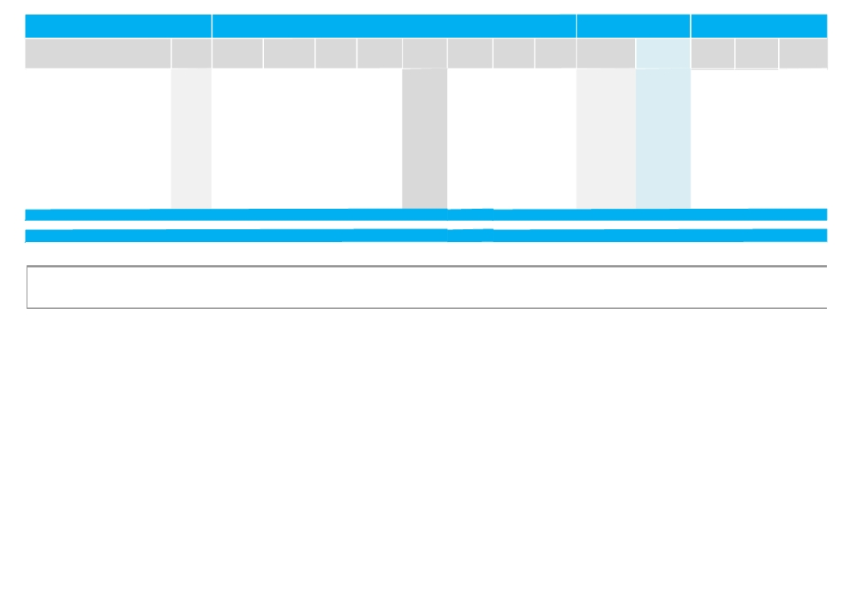

Reuters
Monthly Trading Indicators

Traded Volume Traded Value Number of Avg. Traded Closing
Market Cap.

MTM Price
Month-End Valuation
Indicators

Dividend

Company Name

═ Oman National for Eng. & Invest. Co.
═ Oman Holdings International Co.
▲ Al Maha Petroleum Products Marketing Co. ▲ Majan College
▲ Omani Qatari Telecom Co. (NAWRAS) ▼ Muscat Gases Co.
═ Oman Oil Marketing Co.
═ National Gas Co.
▲ Oman Telecom Co.
▲ Port Services Corporation
▲ Renaissance Services
═ Salalah Port Services
▼ Shell Oman Marketing
▲ United Power
▲ Sohar Power
▲ SMN Power Holding
▲ Services & Insurance

▲ Total Regular Market
Ticker ('000 Shares) ('000 OMR)

NELE.OM 9 3
OHII.OM 411 85
MAHA.OM 31 526
BAC.OM 24 7
NWRS.OM 12,275 5,910
MGMC.OM 10 8
BPO.OM 132 245
NGCI.OM 3 2
OTL.OM 3,593 4,813
PSC.OM 993 421
RSC.OM 10,368 5,356
SPS.OM 1.1 0.5
SHEL.OM 870 2,085
UPC.OM 24 25
SHPS.OM 85 123
SMNP.OM 8 34
59,625 26,266

418,644 106,591
Deals Price (OMR)* Price (OMR)

6 0.378 0.400
11 0.206 0.206
67 17.095 17.301
8 0.305 0.305
1,074 0.481 0.501
2 0.819 0.819
38 1.860 1.860
1 0.539 0.547
775 1.339 1.335
171 0.424 0.428
1,372 0.517 0.515
3 0.474 0.470
112 2.398 2.351
15 1.031 1.031
135 1.448 1.547
6 4.101 4.200
5,746

28,827
High (OMR) Low (OMR)
Change (%)
0.00% 0.399 0.370
0.00% 0.210 0.206
5.47% 17.350 16.450
3.39% 0.310 0.300
6.82% 0.517 0.466
(0.12%) 0.820 0.819
0.00% 1.870 1.860
0.00% 0.540 0.540
1.68% 1.360 1.315
3.88% 0.431 0.410
7.97% 0.540 0.480
0.00% 0.470 0.470
(7.59%) 2.538 2.350
0.10% 1.045 1.020
12.35% 1.550 1.369
3.70% 4.200 4.055
2.26%

1.02%
('000 OMR) ('000 USD) P/E (X) P/B (X)
Yield
28,000 72,700 13.23 1.43 3.00%
22,720 58,990 21.11 0.44 7.28%
119,377 309,953 12.36 3.32 4.91%
9,150 23,757 20.93 1.58 0.00%
326,123 846,752 7.27 2.01 7.58%
24,570 63,794 18.11 3.56 7.33%
119,970 311,493 14.78 3.50 3.33%
13,675 35,507 11.73 1.69 7.31%
1,001,250 2,599,666 8.97 2.09 7.49%
40,677 105,615 8.96 1.29 11.68%
145,279 377,205 NM 0.85 2.91%
84,525 219,462 10.16 2.10 3.19%
235,100 610,418 50.21 9.38 4.98%
26,963 70,007 26.10 1.49 13.58%
43,007 111,663 57.96 1.43 0.00%
83,847 217,702 15.13 44.86 3.43%
2,450,291 6,361,984 11.05 2.05 6.04%

6,805,106 17,668,914 10.98 1.54 4.30%

Source: Muscat Securities Market Website & Reuters
NM: Not Meaningful. N/A: Not Available, NA: Not Applicable, Trailing P/E is based on the net profit for TTM 1H‐12 and current market cap. If calculated P/E is negative or greater than 80, it is represented by NM. Trailing P/B is based on equity as at 30 Jun‐12 and current market cap. Dividend
Yield for individual stocks is based on Full Year 2011 Dividend per Share & month end closing prices, while the average for sectors is a weighted average based on market cap and total cash dividends.*Average Traded price for the month is calculated by dividing total traded value over total traded volume for the month. MTM: Month‐to‐Month price change for individual stocks is calculated based on the change in closing prices, while that for sectors and market are based on the change in market capitalization.



KAMCO Research
GCC Equity Markets Review

Disclaimer
This document and material contained herewith have been produced, complied, and issued by
KIPCO Asset Management Company KSC Closed (KAMCO). The Company has obtained the
information used in this document from sources it believes to be reliable, but the issuer does not
guarantee, neither its accuracy nor completeness, nor provides an independent verification of the
material contained therein. KAMCO may, from time to time to the extent permitted by law,
participate or invest in other financing transactions with the issuers of the securities, perform
services for or solicit business from such issuer and/or have a position or effect transactions in the
securities or options thereof. KAMCO may, to extent permitted by the applicable Kuwaiti law or
other applicable laws and regulations, effect transactions in the securities before this material is
published to recipients. The opinions and estimates expressed herein are those of the issuer and
subject to change at any time without any prior notice. Accordingly, no representation or warranty,
expressed or implied, is made as to and no reliance should be placed on the fairness, accuracy,
completeness or correctness of the information and opinions contained in this document. KAMCO
accepts no liability for any loss arising from the use of this document or its contents or otherwise
arising in connection therewith. This document should not relied upon or used in substitution for the
exercise of sound judgment. KAMCO shall have no responsibility or liability whatsoever in respect
of any inaccuracy in or omission from this or any other document prepared by KAMCO for, or sent
by KAMCO to any entity, and any such entity shall be responsible for conducting its own scrutiny,
investigation, and analysis of the information contained or referred to in this document and of
evaluating the merits and risks involved in the securities forming the subject matter of this or other
such document.
Opinions and estimates constitute KAMCO’s judgment and are subject to change without prior notice. Past performance is not an indicator of future results. This document does not constitute an offer or invitation to subscribe for or purchase any securities, and neither this document nor anything contained herein shall form the basis of any contract or commitment whatsoever. This document is not an offer to sell or a solicitation to buy any securities. It is being furnished to the reader solely for his/her information and may not to be redistributed inside Kuwait or by any jurisdiction outside Kuwait where this action is restricted by law. Entities who receive this report should make themselves aware of and adhere to any such restrictions. By accepting receipt of this report, the reader agrees to be bound by the foregoing limitations.
© KIPCO Asset Management Company KSC (Closed) 2012

